TERRA NOVA DEVELOPMENT / ARTICLE #089

Treasury Bank: A Unified Digital Credit Institution for a Nation in Good Standing
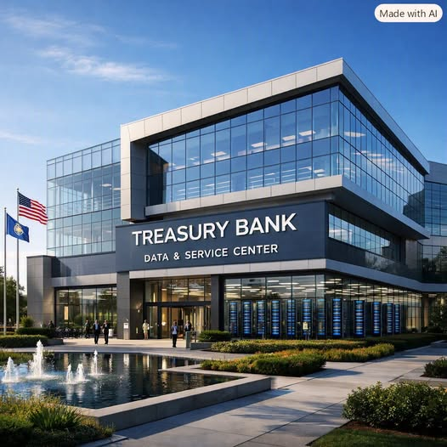
Treasury Bank represents a fundamental reimagining of how a modern nation provides financial access, credit, and economic opportunity to its citizens, businesses, and corporations. Built as a fully digital, zero-branch, single-center national bank, Treasury Bank serves as a public financial utility designed to empower responsible economic actors while offering a pathway for rehabilitation to those who have struggled under the traditional credit system. Its mission is simple and powerful: to provide fair, zero-percent credit and universal digital banking services to all individuals and enterprises in good standing — all under one roof.

A Digital-Only National Bank
Treasury Bank operates without physical branches, paper systems, or regional offices. Every function — account management, loan processing, identity verification, customer support, and payment services — is handled through a single operational data center supported by modern cybersecurity infrastructure. Citizens, businesses, and corporations interact with Treasury Bank exclusively through mobile apps and web portals, creating a streamlined, efficient, and accessible financial system.
This digital-only model eliminates the overhead associated with traditional banking, enabling Treasury Bank to offer zero-percent loans, fee-free checking accounts, and instant digital payments without relying on interest income or commercial profit. Treasury Bank is funded entirely through general government revenues, ensuring stability and allowing the institution to operate as a public good rather than a private enterprise.

Universal Accounts for Every Citizen
Every individual automatically receives a Treasury Bank Digital Account, registered under their Social Security number. This universal access ensures that no one is excluded from basic financial tools, regardless of their traditional credit standing. Even individuals with poor or nonexistent credit histories gain access to:
- Digital checking
- Debit card issuance
- Treasury Pay (instant payments)
- Direct deposit
- Digital statements
- Secure identity verification
This universal account system establishes Treasury Bank as the default financial identity for every citizen, forming the foundation for a modern, inclusive national financial infrastructure.

Digital Checking and Treasury Pay
Treasury Bank’s digital checking accounts are designed for simplicity, security, and universal access. The bank does not issue paper checks; instead, all payments occur through digital channels. Treasury Pay, the institution’s built-in instant payment system, allows users to send and receive money instantly using Treasury IDs, phone numbers, emails, or QR codes. Treasury Pay supports payments to individuals, businesses, corporations, and government agencies — all with zero fees.
Because Treasury Bank is centralized, transfers occur in real time without the delays associated with ACH, wire transfers, or interbank clearing. Treasury Pay also integrates directly with the Treasury Internal Credit Score (TICS), rewarding responsible financial behavior and flagging suspicious activity.

Dual Credit Score System: Fairness and Rehabilitation
Treasury Bank evaluates borrowers using a dual-score system that balances traditional financial history with Treasury-specific behavior.

1. Traditional Credit Score
Pulled from major credit bureaus, this score serves as a baseline indicator of past financial behavior. Treasury Bank uses much more lenient minimum thresholds than private lenders, ensuring that individuals and businesses with imperfect histories are not permanently excluded.

2. Treasury Internal Credit Score (TICS)
TICS is a proprietary scoring system ranging from 0 to 1000, built entirely from activity within Treasury Bank. It measures:
- On-time payments
- Account stability
- Treasury Pay behavior
- Fraud-free activity
- Loan completion
- Digital identity consistency
- Business or corporate compliance
TICS becomes the primary measure of good standing, allowing individuals and enterprises to rebuild their financial reputation through responsible behavior, even if their traditional credit score is low.

Loan Access and Qualification
Treasury Bank offers a comprehensive catalog of zero-percent loans for individuals, small businesses, corporations, and community development projects. Loan qualification requires passing two gates:

Gate 1 — Traditional Credit Score (Lenient Minimums)
- Citizens: 580+
- Small businesses: 600+
- Corporations: 630+

Gate 2 — Treasury Internal Credit Score
- Full access: TICS ≥ 700
- Conditional access: TICS 650–699
- Probationary access: TICS 600–649
- No credit access: TICS < 600
Even individuals who cannot borrow money still retain full access to Treasury Bank’s checking and payment systems, ensuring universal financial inclusion.

Loan Types and Limits
Treasury Bank offers structured loan categories for citizens, businesses, corporations, and digital-first enterprises. These include:
- Personal credit lines
- Home purchase loans
- Education loans
- Emergency stability loans
- Startup launch loans
- Working capital loans
- Equipment financing
- Corporate expansion loans
- Infrastructure development loans
- Innovation and R&D loans
- Digital business launch loans
- AI and automation loans
Each loan type includes defined limits, qualification thresholds, and default actions. Defaults are handled through digital remediation, restructuring, and standing adjustments rather than punitive interest or aggressive collections.

Default Management and Standing
Treasury Bank treats defaults as a managed public cost, funded through general government revenues. This allows the institution to avoid predatory practices and instead focus on rehabilitation and stability.
Default actions are tiered:
- Minor defaults trigger notifications and small TICS reductions
- Moderate defaults result in account freezes and restructuring
- Major defaults involve asset liens or arbitration
- Critical defaults lead to standing resets and loss of credit access
Even in default, individuals retain their Treasury Bank accounts and can rebuild their standing over time.

Government Funding and Public Purpose
Treasury Bank is funded entirely through general government revenues, including operational costs and anticipated loan defaults. This funding model transforms Treasury Bank into a public economic engine, not a profit-driven institution. It exists to:
- Stabilize households
- Empower small businesses
- Support corporate innovation
- Strengthen communities
- Accelerate national economic growth
Treasury Bank is a modern financial utility — a national infrastructure project designed to unify financial access, credit, and payments under one digital roof.

Security Assumptions
Treasury Bank’s digital infrastructure is protected by dedicated cybersecurity professionals using industry-standard and government-grade security measures. The institution assumes that modern encryption, identity verification, intrusion detection, and continuous monitoring are sufficient to safeguard accounts and transactions. Treasury Bank focuses on policy, access, and credit systems while relying on experts to maintain digital security.

Conclusion
Treasury Bank is a bold, modern reimagining of national financial infrastructure. By combining universal digital accounts, zero-percent loans, instant payments, lenient qualification standards, and a rehabilitative internal credit score, Treasury Bank creates a fair, inclusive, and forward-looking financial system. It replaces exclusion with opportunity, punishment with rehabilitation, and fragmentation with unity.
Treasury Bank is one bank, one standard, one digital roof — a national institution built to empower every responsible citizen, business, and corporation in the country.
Concept proposal: Treasury Bank is a proposed institution, not an existing U.S. government bank. Implementation would require legal authority, funding, privacy safeguards, accessibility provisions, cybersecurity design, and operational feasibility review.

