TERRA NOVA DEVELOPMENT | ARTICLE #090

IceMaster Buffalo: A Pilot Program for a Northern City on the Edge of Innovation
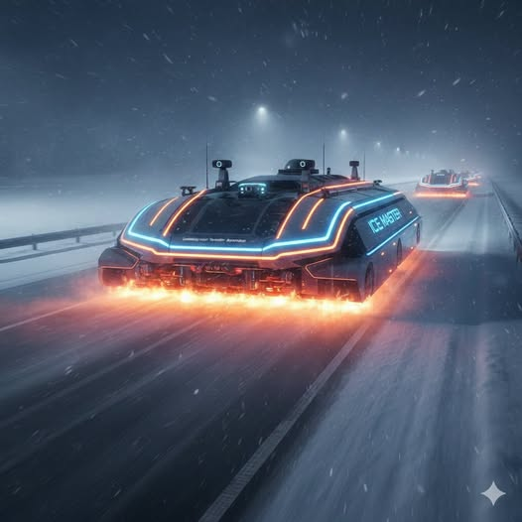
Buffalo, New York has always lived at the intersection of resilience and reinvention. Its winters are legendary—lake-effect snow measured not in inches but in feet, ice storms capable of paralyzing entire neighborhoods, and cold snaps that turn roads into glass. For decades, the city has relied on salt, plows, and manpower to fight a battle that grows more expensive every year. As climate volatility increases, Buffalo faces a new reality: storms are becoming more unpredictable, more intense, and more disruptive. The traditional tools are no longer enough.
The proposed IceMaster Pilot Program offers Buffalo a chance to lead the nation in a new era of winter-weather management. Conceived as autonomous electric platforms equipped with graphene-based thermal melt decks, IceMaster vehicles aim to clear ice without salt or blades, potentially reducing infrastructure damage. This is a technology-development proposal, not a claim that a working fleet has been validated or deployed.

A City Built for a Pilot Program
Buffalo is uniquely suited for a northern pilot because of its severe winter conditions, grid layout, wide arterials, and well-documented storm patterns. A controlled trial could evaluate autonomous routing and melt-path optimization alongside existing municipal storm-response teams.
The proposal aligns with objectives such as reducing salt usage, lowering infrastructure damage, improving storm response times, and protecting vulnerable communities. City participation, vehicle availability, and regulatory approvals would need to be secured.

The Technology Behind IceMaster
The IceMaster concept uses a heated graphene-composite melt deck intended to deliver controlled thermal output across road surfaces. Unlike plows that mechanically move snow, the proposed deck would melt ice through applied heat. Whether this can be done safely, fast enough, and within an electric vehicle’s energy budget remains to be demonstrated.
- Solid-state thermal plates with variable wattage
- AI melt-pathing to prioritize high-risk zones
- Storm-aware routing informed by real-time weather data
- Swarm coordination for multiple vehicles covering larger areas
The proposal envisions commercial EV chassis from potential partners such as Rivian, Ford Pro, or Polaris, with Terra Nova developing the melt deck, AI engine, and operational software. No partnership is asserted here.

Pilot Program Structure

Phase I: Core Deployment (Proposed Winter 2026–2027)
Ten proposed IceMaster units would be tested in high-priority zones, subject to prototype readiness, procurement, permissions, and safety validation:
- Downtown Buffalo
- Elmwood Village
- Kensington-Bailey
- The medical corridor
- Key arterials feeding the I-190 and I-90
The focus would be response time, measured ice-melt efficiency, electrical consumption, pedestrian and road-user safety, and coordination with existing crews.

Phase II: Neighborhood Expansion (Proposed Winter 2027–2028)
If Phase I demonstrates acceptable safety and performance, twenty additional units could extend trials to residential neighborhoods, school zones, and bus routes. Data from the initial trial would refine routing and fleet coordination.

Phase III: Full-City Integration (Proposed Winter 2028–2029)
Subject to results and funding, IceMaster could become one component of Buffalo’s winter strategy. A transition away from some salt use would be evaluated rather than assumed; the proposed 60% reduction is a target requiring field verification.

Economic and Environmental Impact
Road salt contributes to corrosion of vehicles and infrastructure, impacts roadside vegetation, and adds chloride to waterways. Reducing salt use could offer environmental and maintenance benefits, but an electrically heated melting system would also have energy, capital, and operational costs.
Proposed pilot targets—not verified forecasts—include:
- $4–6 million in annual road-repair cost reductions, if substantiated by municipal baseline and trial data
- Up to 60% less road salt use in covered operations
- Reduced corrosion damage to city and resident vehicles
- Reduced chloride runoff affecting the Niagara River and Lake Erie
- Faster treatment of hazardous ice on priority routes
A credible pilot should compare IceMaster with conventional plowing, brining, and salting under matched conditions, and report lifecycle emissions, cost per lane-mile, energy use, ice-clearing rate, and safety outcomes.

A Model for Northern Cities Nationwide
If the technology proves effective in Buffalo, lessons could inform pilots in Cleveland, Detroit, Milwaukee, Rochester, Syracuse, and Minneapolis. Replication should depend on independent evidence, local winter conditions, grid capacity, and municipal economics.

Conclusion
Buffalo has always been a city defined by its winters. The IceMaster proposal offers a chance to test whether autonomous electric thermal treatment can complement existing winter operations and reduce reliance on salt. A successful, carefully measured pilot could establish a model for other northern cities.
The ambition is clear: safer roads, less corrosion, and more resilient winter operations. The next step is rigorous engineering and real-world validation.
Project status: Concept proposal. Graphene melt-deck performance, autonomy, costs, projected savings, deployment dates, and municipal participation are not established facts.

