TERRA NOVA DEVELOPMENT • ARTICLE #082

Medicare for All: A Business Case for Universal Health Care
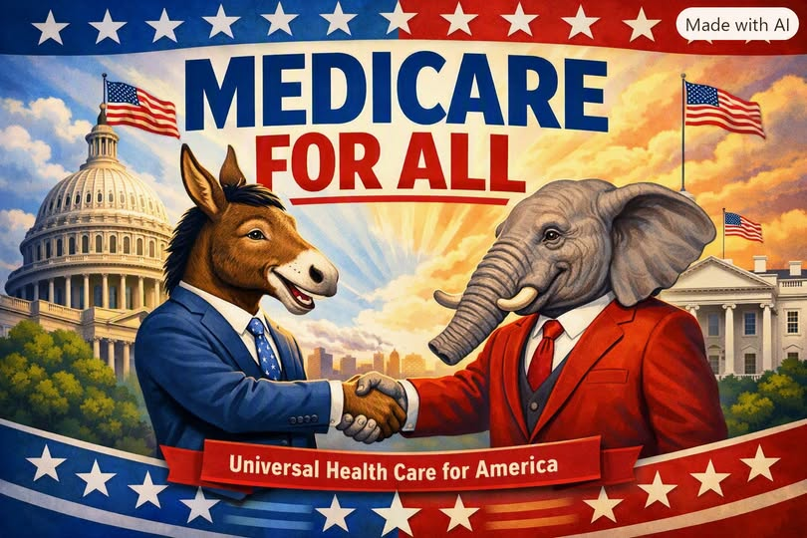

Introduction: Beyond Ideology
For decades, Medicare for All has been framed as an ideological battle between socialism and free-market principles. Yet when stripped of rhetoric, the issue is a balance sheet problem. On practical grounds—cost, competitiveness, efficiency, and workforce vitality—the case for a single-payer system is compelling. Business leaders, accustomed to solving fiscal challenges, should recognize that the current system is bleeding American enterprise.

Part I: The Healthcare Tax Nobody Talks About
Employer-sponsored coverage costs businesses $15,000–$20,000 per employee annually before productivity begins. Small businesses suffer disproportionately, facing higher deductibles and thinner protection. This burden crowds out wages, stunts hiring, and limits innovation. Wellness programs and HR optimizations cannot fix a structurally fragmented system that spends more per capita than any nation while leaving millions uninsured.

Part I–A: Hidden Indirect Costs
Beyond premiums, employers face hidden costs from presenteeism, absenteeism, and stress-related illness. Presenteeism alone drains $4,000–$6,000 per employee annually. Chronic conditions like diabetes add billions in indirect costs. These losses—often invisible in spreadsheets—represent a structural tax on workforce performance. Universal coverage would reduce these burdens by ensuring consistent access to preventive care, improving productivity and lowering hidden costs.

Part I–B: The Deflationary Effect
The current system is structurally inflationary. Since 1999, premiums have risen 342%, far outpacing wages and general inflation. Fragmented negotiations and profit-driven incentives guarantee perpetual cost escalation. Medicare for All, by contrast, creates monopsony power—unified bargaining leverage that can discipline prices. This structural redesign enables genuine deflation in healthcare costs, expanding consumer purchasing power and easing wage suppression. No tweak to the current system can replicate this effect.

Part II: The Global Competitiveness Crisis
Foreign competitors in Canada, Germany, and the UK operate under systems where governments absorb healthcare costs. U.S. firms face a healthcare surcharge their rivals do not, resulting in thinner margins and reduced investment. This arithmetic disadvantage suppresses wages and capital investment, leaving American businesses structurally less competitive.

Part III: The Trillion-Dollar Efficiency Argument
Administrative waste consumes staggering sums. Duke Medical Center employs 1,600 billing clerks; Toronto General Hospital, under single-payer, employs seven. A Yale study projects Medicare for All would reduce U.S. health expenditures by $1.04 trillion annually, even after expanding coverage. Savings come from streamlined administration, Medicare-aligned provider payments, and drug price negotiation. For businesses, this is not a new tax but a replacement of a larger, inefficient cost.

Part IV: Unlocking Entrepreneurship
Job lock suppresses labor mobility and innovation. Millions remain tethered to jobs for insurance, stifling entrepreneurship. Universal coverage decouples health care from employment, enabling workers to take risks, start businesses, and pursue meaningful work without catastrophic exposure. This fosters a dynamic, meritocratic labor market that benefits both workers and employers.

Part V: Bipartisan Recognition of Dysfunction
Congressional hearings in 2026 revealed bipartisan outrage at insurer practices. Executives faced grilling over consolidation and claim denials, underscoring systemic dysfunction. Business leaders, judged by outcomes rather than ideology, can reframe the debate. Their credibility on fiscal matters positions them to champion Medicare for All as the efficient, competitive solution.

Conclusion: The Math Has No Party
Medicare for All is not socialism—it is fiscal pragmatism. American businesses spend vastly more per employee on healthcare than global competitors. Administrative waste drains hundreds of billions. A single-payer transition projects $1 trillion in annual savings. The numbers are clear. Business leaders who embrace Medicare for All will define a legacy of honesty and efficiency, advancing both national interest and enterprise vitality.
Editorial note: This advocacy essay retains the author’s supplied estimates, comparisons, and characterizations. They have not been independently fact-checked; actual outcomes depend on legislation, financing, and implementation.

