TERRA NOVA DEVELOPMENT | ARTICLE #083

A National Energy Mission: Solar + New Battery Technologies Across America’s Existing Infrastructure
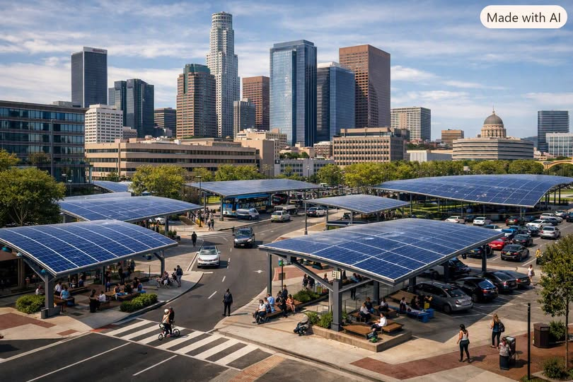
America’s future depends on abundant, reliable, affordable energy — not for one group, not for one ideology, but for everyone. Energy is the great equalizer. It powers the skyscraper boardroom and the street-corner shelter. It fuels the factory, the hospital, the stadium, the school, the home, and the hope of every person who lives here.
And right now, the greatest opportunity in front of us is the combination of innovative solar deployment and next-generation battery technologies — applied not to new land, but to the infrastructure we already share.
This is not a partisan project. This is a national project.

Solar Without Land Battles: Using the America We Already Built
The fastest way to scale solar is to stop fighting over land and start using the surfaces already woven into our daily lives. America is covered in untapped solar real estate:

Waterways & Canals
Solar canopies over canals reduce evaporation, protect water quality, and generate power for nearby communities. Floating solar on reservoirs and retention ponds adds massive generation capacity without touching land.

Rural Two-Lane Roads
These roads stretch for tens of thousands of miles across the country. Solar canopies or roadside arrays can power rural towns, farms, and critical infrastructure without disrupting agriculture or scenery.

Urban Roads
Certain wide boulevards, medians, and elevated roadways can host solar structures that provide shade, reduce heat, and generate clean electricity for dense neighborhoods.

Playgrounds & Parks
Solar shade structures can protect children from heat while powering nearby schools, recreation centers, and community facilities.

Stadiums & Arenas
These are enormous structures with vast roof surfaces and parking lots — perfect for solar canopies and integrated solar roofing. Stadiums can become energy hubs for entire districts.

Public Buildings (Mandated Solar Integration)
Schools, libraries, fire stations, police departments, city halls, and federal buildings can all be required to integrate solar into roofs, facades, and parking areas. This alone would create one of the largest distributed energy networks in the world.

Highways, Rail Corridors, Airports
Linear solar arrays along transportation corridors can generate gigawatts of power without acquiring a single acre of new land.
Solar becomes shade, cooling, water protection, building material, and infrastructure enhancement. It becomes something every community can support because it doesn’t take anything away — it only adds.

The Battery Revolution Makes Solar a 24/7 Resource
Solar’s greatest limitation has always been intermittency. But new battery technologies — now entering commercial deployment — change everything:
- Solid-state batteries
- Sodium-ion batteries
- Iron-air batteries
- Zinc-hybrid systems
- Advanced flow batteries
These systems are cheaper, safer, longer-lasting, easier to manufacture, less dependent on rare minerals, and capable of storing massive amounts of energy.
With these batteries, solar becomes baseload power — reliable day and night. Utilities can depend on it. Industries can trust it. Communities can rely on it.
Solar + storage is not “alternative energy.” It is primary energy.

Abundant Energy Benefits Every American
Massive clean energy expansion is not a partisan victory — it’s a national advantage.

For CEOs and Corporations
- Lower operating costs
- Stable long-term energy prices
- Reduced grid outages
- More competitive manufacturing
- Freedom from fuel volatility

For Middle-Class Families
- Lower utility bills
- More stable neighborhoods
- Cleaner air and quieter cities

For the Homeless and the Poor
- Cheaper public services
- More resilient shelters
- Expanded access to cooling and heating
- Lower municipal costs that can be redirected to social support

For Rural America
- New revenue streams
- Energy independence
- Infrastructure upgrades

For Urban America
- Reduced grid strain
- Lower heat-island effects
- More shaded public spaces
Clean energy is not a luxury. It is a universal benefit.

A National Project That Unites Instead of Divides
America has a history of building big things together:
- The interstate highway system
- The national power grid
- Rural electrification
- The space program
- The internet backbone
None of these were partisan. They were American.
A nationwide push for solar + next-gen batteries — deployed across waterways, roads, playgrounds, stadiums, and public buildings — can be the next great unifying project. A project that says:
- Every American deserves abundant energy.
- Every American deserves opportunity.
- Every American deserves a future that works.
This is not about left or right. It’s about forward.

Conclusion
The combination of innovative solar deployment and breakthrough battery technologies gives America a once-in-a-century chance to build an energy system that is abundant, clean, reliable, affordable, non-partisan, and universally beneficial.
We don’t need more land. We don’t need more division. We need more energy — and the will to build it together.
Editorial note: This is a proposed national energy strategy. Battery technologies differ in commercial maturity, cost, safety, and storage duration; some deployment sites require land, engineering, environmental review, or regulatory approval.

