TERRA NOVA DEVELOPMENT | ARTICLE #084

Solar Cowsheds — Complete Product Description
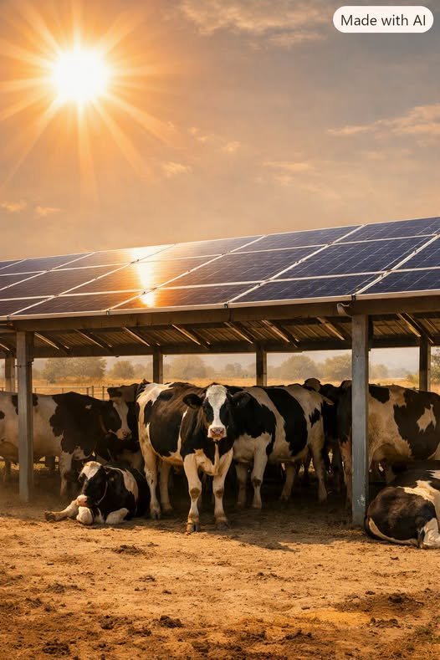

A Dual-Purpose Farm Structure
Solar Cowsheds are modular, plug-and-play livestock shade systems that generate clean solar power while protecting animals from extreme heat. Built for ranchers, homesteaders, dairies, and small agricultural operations, Solar Cowsheds combine rugged construction with simple installation so that a skilled handyman can assemble them without specialized crews or heavy equipment.

Modular, Pre-Engineered Construction
Each Solar Cowshed is made from pre-engineered components that bolt together like a heavy-duty kit. The posts and beams arrive pre-cut and pre-drilled, with all hardware included. The roof frames snap into place using standardized brackets, and the solar panels mount onto pre-aligned rails that require no custom fabrication. This modular approach eliminates guesswork and dramatically reduces installation time.

Solar Power and Electrical Connections
The solar panels on top of each canopy generate reliable electricity that can power fans, pumps, lighting, refrigeration, or feed back into the grid. Wiring is handled through a plug-and-play harness: panels connect with MC4 plugs, cables run through conduit hidden inside the posts, and everything terminates in a single junction box. A licensed electrician only needs to complete the final connection, while the handyman handles the physical build.

Scalable for Farms of Different Sizes
Solar Cowsheds are designed to scale. A single module can shade a small herd, while multiple modules can be linked together to cover larger pens, loafing areas, or feeding zones. The system grows with the operation — add more bays as the herd expands or as energy needs increase. Each canopy is engineered for high wind resistance, efficient rain runoff, and maximum shade coverage during peak heat hours.

Animal Welfare and Heat Protection
Beyond energy production, Solar Cowsheds dramatically improve animal welfare. Livestock experience less heat stress, better weight gain, improved milk production, and lower mortality during extreme temperatures. The shade structure reduces water demand for cooling and creates a safer, more comfortable environment for animals year-round.

Rural Resilience and Farm Economics
Solar Cowsheds also support rural resilience. They lower energy bills, reduce reliance on diesel generators, and create new revenue opportunities through net-metering or battery storage. Because they use existing livestock areas, they generate power without removing land from agricultural use.

Conclusion: A Candidate for National Support
This is practical, modern farm infrastructure — simple to install, easy to maintain, and built to last. Solar Cowsheds deliver shade for the animals, power for the farm, and stability for rural communities. They are exactly the kind of innovation that deserves federal support to accelerate adoption nationwide.
Development note: Solar Cowsheds are described here as a proposed product concept. Structural engineering, electrical permitting, utility interconnection, livestock safety, site conditions, and measured animal and energy outcomes must be evaluated before commercial deployment. Net-metering availability varies by utility and jurisdiction.

