  - TERRA NOVA DEVELOPMENT, INC. | ARTICLE 016

Robots Building Homes for Everyone
  - A future of safer construction, greater productivity, and housing within everyone’s reach
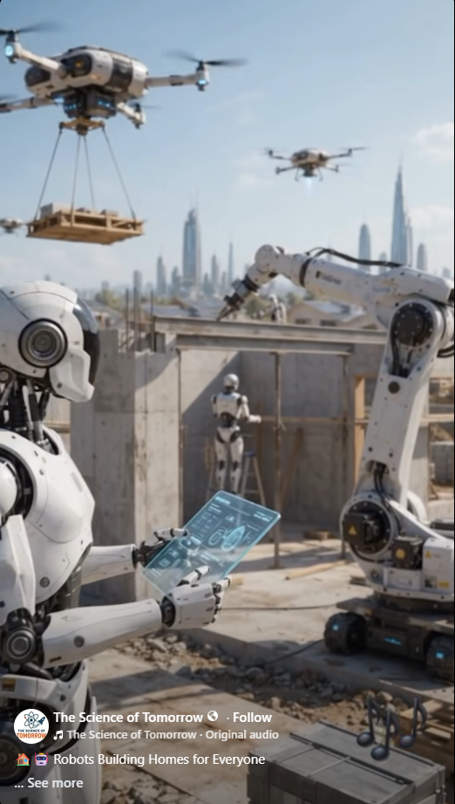
Concept illustration shared from The Science of Tomorrow; the scene is a vision of possible future construction, not evidence of an operating fully autonomous building site.

Imagine a Different Construction Site
Imagine robotic crews working day and night to build homes: machines preparing sites, positioning structural components, carrying materials, and inspecting progress. Human engineers, tradespeople, and inspectors would direct the work, solve complex problems, and verify that every home is safe. The goal is not simply faster construction. It is making dignified housing available to more people.

The Opportunity Before Us
Housing costs reflect many constraints: land, financing, infrastructure, permitting, materials, and labor. Robotics could reduce some construction costs and delays, especially for repetitive tasks. Automated fabrication, robotic masonry, concrete printing, and factory-built components already offer pieces of this future, though no single machine can independently deliver a complete code-compliant home.

Working Twenty-Four Hours a Day
Machines may operate extended shifts on suitable tasks, subject to maintenance, noise restrictions, weather, power, safety oversight, and local rules. Coordinated schedules could let factory fabrication continue while site teams prepare utilities and foundations. The advantage is better orchestration, not an assumption that every job can run without interruption.

Safer Work for Human Beings
Robots could take on particularly hazardous work: lifting heavy loads, working near unstable structures, handling certain high-temperature processes, or inspecting dangerous locations. Humans remain essential for design, judgment, craftsmanship, quality assurance, emergency response, and accountability. A responsible transition should include training and pathways into new technical roles.

A Standardized, Scalable Housing System
Terra Nova could explore a library of adaptable, accessible house designs, manufactured components, coordinated robotic equipment, and transparent cost tracking. Designs would accommodate different climates, sites, building codes, family sizes, and accessibility needs. A pilot program could compare robotic and conventional approaches using actual cost per completed home, schedule, defects, energy use, and worker safety.

The Real Obstacle Is Access
Even if robots lower construction costs, homes will not automatically become affordable. Land prices, financing, zoning, utilities, insurance, and ownership arrangements matter. Public-interest housing models, community land trusts, nonprofit developers, and long-term affordability agreements could help ensure productivity gains translate into lower housing costs rather than merely higher margins.

Building for Everyone
Imagine neighborhoods with durable homes, shared gardens, walkable services, and community spaces—built with the assistance of advanced technology and managed for the benefit of residents. Robots are tools. The human decision is how to deploy them and who shares in the benefits. Terra Nova’s challenge is to connect technological abundance with practical access.

A Call to Build
Begin with one demonstration community. Invite builders, robotics researchers, housing advocates, local governments, tradespeople, and residents to design a transparent pilot. Measure what works, publish what fails, improve the system, and replicate it where it genuinely helps. We already have remarkable tools. We can choose to use them to build a world where everyone has a place to call home.
There is no them. There is only us. We are one.
Terra Nova Development, Inc. • Concept and vision article 016

