Terra Nova Give & Take: The Engine of an Economic Revolution
  - Terra Nova Development | Give & Take Initiative
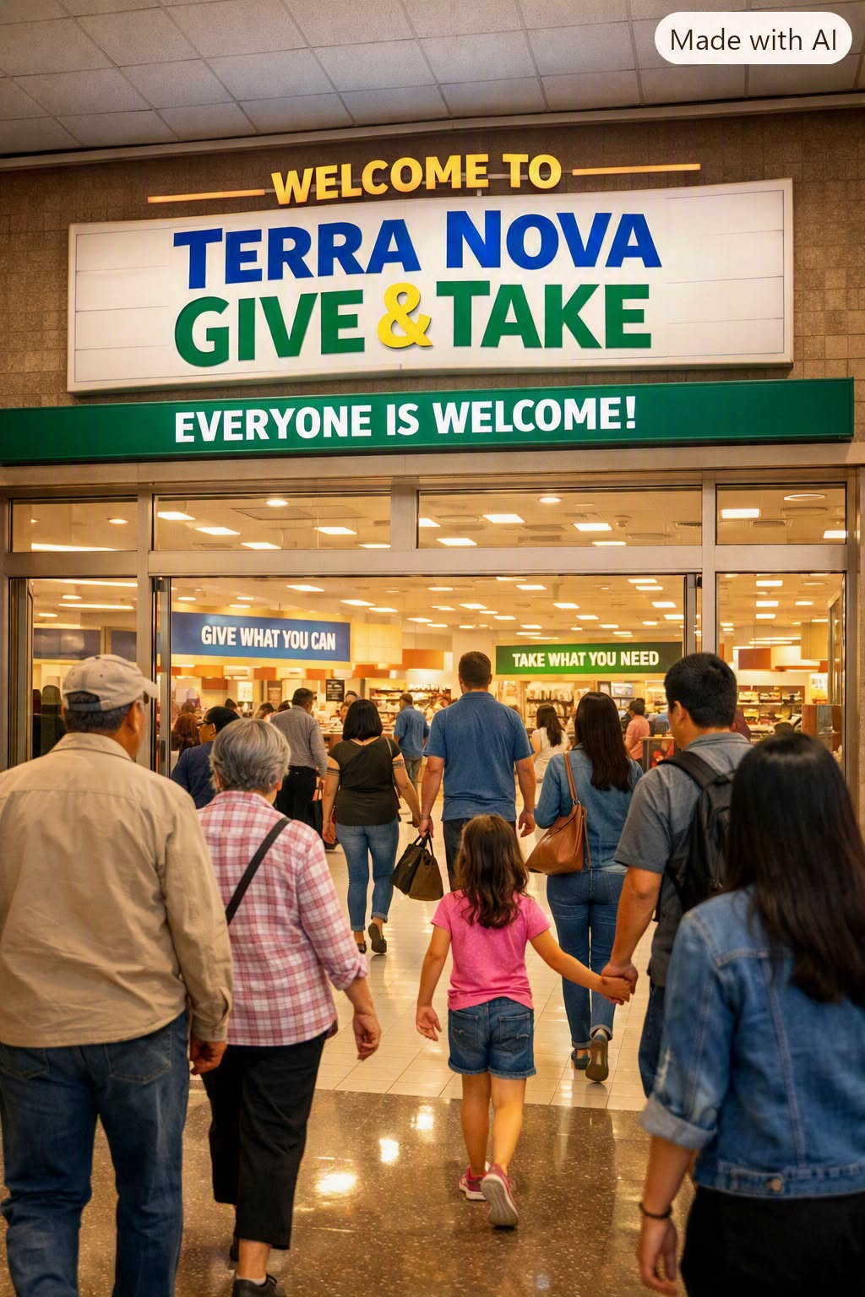
Most economic revolutions announce themselves loudly — through protests, manifestos, or political upheaval.
But the next one may begin quietly, inside a clean, dignified room where people simply give and take.
The Terra Nova Give & Take Center is a department‑store‑style space where anyone can bring items and anyone can take items, with no eligibility, no limits, and no questions asked.
What appears to be a simple exchange room is actually a prototype for a new economic system — one built on circulation instead of scarcity, dignity instead of gatekeeping, and community instead of hierarchy.
This is how Terra Nova begins its economic revolution.

I. Ending Scarcity Economics
Traditional economies are built on scarcity.
Scarcity creates competition.
Competition creates hierarchy.
Hierarchy creates exclusion.
The Terra Nova Give & Take Center flips the model.
Inside it, there is no check‑in, no checkout, no tracking, no gatekeeping.
Scarcity is not the organizing principle.
Abundance is.
When people can take what they need without shame, and give what they no longer need without ceremony, the economy stops being a battlefield and becomes a commons.
This is not charity.
This is not welfare.
This is post‑scarcity economics in miniature — a living demonstration that abundance is possible when circulation replaces hoarding.

II. The Circular Flow of Value
In the traditional economy, value is created once, sold once, and consumed once.
In the Terra Nova Give & Take Center, value circulates.
A jacket is not “used.”
It is re‑used.
A tool is not “discarded.”
It is re‑deployed.
A book is not “donated.”
It is re‑circulated.
Local businesses become active partners, contributing overstock, returns, discontinued items, slightly damaged goods, and seasonal inventory.
In this model:
- Waste becomes supply
- Surplus becomes opportunity
- Inventory becomes community wealth
This is the foundation of a circular economy, but without corporate jargon — just people and businesses participating in dignity.

III. The Hidden Economy of Accumulation
Across every neighborhood, people accumulate items they no longer use — things too valuable to throw away, yet too inconvenient to give away. Closets, garages, attics, and storage units overflow with clothes, tools, furniture, electronics, toys, kitchenware, sports gear, décor, and sentimental items that sit idle for years.
But the storage units — those endless rows of metal doors stretching across every city — are the most striking symbol of this hidden economy.

What’s actually inside them?
- Furniture that doesn’t fit in the current home
- Boxes of clothes from past phases of life
- Tools used once
- Holiday decorations
- Old televisions, monitors, printers
- Children’s items from years ago
- Collectibles never sold
- Appliances replaced but still functional
- Entire households from past moves
- Items inherited but never used
- Things people intend to sell but never do
Storage units are America’s attics away from home — filled with items too good to trash, too awkward to sell, too sentimental to decide on, and too inconvenient to give away.
People pay $80–$200 a month to store things they don’t use, don’t need, and often don’t even remember.
This is not waste.
This is trapped value — a shadow economy of unused goods worth billions.

Terra Nova Give & Take unlocks that value.
It provides a convenient, dignified, frictionless way for people to release what they no longer need into the community stream.
No listings.
No pricing.
No strangers meeting in parking lots.
No guilt.
No hassle.
And in return, people gain access to items they would have bought — clothing, tools, household goods, children’s items — allowing their money to go toward:
- groceries
- rent
- transportation
- medical needs
- reducing debt
- building savings
- simply making ends meet
This is where the economic revolution becomes real.

IV. A Deflationary Force for the Entire Economy
If Terra Nova Give & Take Centers scale across cities, they become a deflationary vector — a pressure that lowers the cost of living without lowering wages.
When millions of items circulate freely:
- families buy fewer new goods
- household budgets stretch further
- demand for essentials becomes more manageable
- people avoid debt for basic purchases
- quality of life rises without increased income
This is healthy deflation — not recessionary collapse, but community‑driven abundance.
It is the first deflationary force in history that raises quality of life instead of lowering it.

V. Upward Mobility for Low‑Income Households
The lowest‑income households benefit the most.
When they can obtain clothing, tools, cookware, children’s items, and household goods without cost:
- their disposable income increases
- their debt decreases
- their financial stress drops
- their ability to save rises
- their economic stability improves
- their upward mobility accelerates
This is not charity.
This is structural empowerment.
A family that saves $150 a month on basic goods can redirect that money toward:
- paying down credit cards
- securing transportation
- improving housing
- investing in education
- building emergency funds
Give & Take becomes a launchpad for economic progress.

VI. The Well‑to‑Do Become the Engine of Abundance
Meanwhile, the well‑to‑do — those with surplus items, surplus space, surplus purchasing power — become the natural contributors.
Not out of guilt.
Not out of ideology.
But because it is the most effective method of sharing their wealth.
They see their unused items:
- helping families
- reducing waste
- improving neighborhoods
- strengthening community
- increasing local stability
- raising the quality of life for everyone
It becomes a positive‑sum exchange:
- The well‑to‑do clear space and feel good.
- The low‑income gain stability and mobility.
- The community becomes more resilient.
- The economy becomes more humane.
This is not redistribution.
This is recirculation — a more elegant, voluntary, and dignified form of shared prosperity.

VII. Repurposing Vacant Buildings
The Terra Nova Give & Take model thrives in repurposed spaces — vacant department stores, midsize retail buildings, and unused municipal properties. Across the United States, entire chains have collapsed, leaving behind thousands of large, structurally sound buildings that sit idle, draining neighborhoods of energy and purpose.
These spaces are perfect for Terra Nova.

Sears — once 3,500+ stores

Kmart — once 2,400 stores

Toys “R” Us — 800+ stores

Bed Bath & Beyond — 360+ stores

Circuit City — 700+ stores
These buildings already have:
- parking
- lighting
- HVAC
- restrooms
- loading docks
- accessibility infrastructure
They are ready to serve — they simply need purpose.
Operating costs are low and absorbed by the community through:
- volunteer labor
- donated goods
- local business partnerships
- shared maintenance
- civic pride
These buildings once served commerce.
Now they can serve community.

VIII. The Business Model for a Community Give & Take
A Terra Nova Give & Take Center is intentionally simple.
It is designed to be low‑cost, low‑bureaucracy, and high‑impact.

1. The Building
A repurposed retail space with wide aisles, loading docks, HVAC, restrooms, and parking.

2. Utilities
Basic monthly costs:
- electricity
- water
- internet
- trash/recycling

3. Staffing: A Small, Stable Team Supported by Many Hands
A large Give & Take needs a core paid team supported by a wide volunteer base.

Core Paid Staff
- Manager
- Assistant Manager
- 2–4 paid staff members
They handle:
- intake
- sorting
- cleanliness
- visitor assistance
- business donations
- back‑of‑house storage
- lounge supervision
- refreshments
- donated food safety

Casual Volunteers
Volunteers fold, sort, tidy, greet, serve refreshments, and help in the lounge.
No pressure.
No quotas.
People help because it feels good.

Store Hours
A simple baseline schedule keeps staffing costs low and volunteer energy high:
- 4–5 days per week
- 6–8 hours per day
But the Give & Take model is intentionally flexible.
If demand is strong, hours can expand:
- additional evening hours
- weekend availability
- a sixth operating day
- extended daily operations up to 10–12 hours
The Give & Take grows with the community.
The goal is simple:
be open when people need it most.

IX. Optional Community Lounge & Activities Area
The lounge transforms the center into a third place — a public living room.

Refreshments
- coffee, tea, water
- donated snacks
- simple food prep when donated food is available

Activities
- tutoring
- craft circles
- repair workshops
- language exchanges
- job‑search help
- community meetings
- reading hours
- skill‑sharing
The lounge becomes the emotional core of the Give & Take.

X. Surplus Food: A Gamechanger Requiring Strict Safety Protocols
Adding surplus food elevates the Give & Take into a community food‑security engine — but it must be done with professional safety standards.

Strict Protocols
- temperature control
- refrigeration logs
- food‑handler certification
- daily inspection
- clear labeling
- dedicated food area
- safe transfer from businesses
- liability coverage
- professional oversight
When done correctly, surplus food:
- reduces grocery bills
- improves nutrition
- lowers debt
- stabilizes households
- strengthens community resilience
It becomes the first deflationary force in America that raises quality of life instead of lowering it.

XI. The Human Services Economy
Skills circulate just like goods.
Handymen, electricians, plumbers, carpenters, tutors, translators, cooks — all contribute.
The Give & Take becomes a human‑services exchange, where people help one another directly, without bureaucracy, without applications, and without the cold impersonality of a labor market.
This is not employment.
This is not gig work.
This is mutual aid as infrastructure.

A Living Bulletin Board of Human Help
Inside the Give & Take, one or more large bulletin boards display handwritten notes from community members:
- “Need help installing a ceiling fan.”
- “Offering free tutoring in algebra.”
- “Looking for someone to help translate a document.”
- “Retired carpenter willing to repair small furniture.”
- “Can teach basic computer skills.”
- “Need help assembling a crib.”
These boards are categorized by technical area, so people can find help quickly:
- Home Repairs
- Electrical & Lighting
- Plumbing
- Carpentry & Furniture
- Auto & Bicycle Help
- Technology & Devices
- Cooking & Meal Prep
- Tutoring & Education
- Language & Translation
- Forms & Online Navigation
- Childcare Assistance
- Senior Support
- Community Projects
Anyone can post.
Anyone can respond.
No vetting.
No screening.
No fees.
No contracts.
Just people helping people.
As participation grows, the bulletin boards become a living map of community capability — a constantly renewing network of shared skill, shared time, and shared humanity.

XII. Zero Waste, Zero Shame, Zero Barriers
Receiving is not stigmatized.
Giving is not glorified.
Everyone participates as equals.
There is no requirement to show need.
No income tests.
No eligibility screening.
No “prove you deserve this.”
There is no paperwork.
No forms.
No tracking.
No documentation of what you gave or what you took.
No tax write‑off slips.
No bureaucratic hoops.
Because Give & Take is not a charity model.
It is not a welfare model.
It is not a transactional model.
It is sharing the way sharing should be — simple, human, voluntary, dignified.
You give because you have something you no longer need.
You take because there is something you can use.
That’s it.
No shame in receiving.
No pride in giving.
No hierarchy.
No labels.
No separation between “donors” and “recipients.”
Just people circulating abundance.
This is the philosophical core of Terra Nova’s economic revolution.

XIII. The Terra Nova Vision
The Terra Nova Give & Take Center is not a room.
It is not a program.
It is not a service.
It is a prototype for the next economy — one where generosity is infrastructure, dignity is policy, and community is the marketplace.
This is how the revolution begins:
with a simple idea that grows until it becomes impossible to ignore.

Terra Nova Give & Take — A Vision in Images


