Ice Master: A New Era in Autonomous Roadway De-Icing
  - Terra Nova Development | Technology Concept & Vision
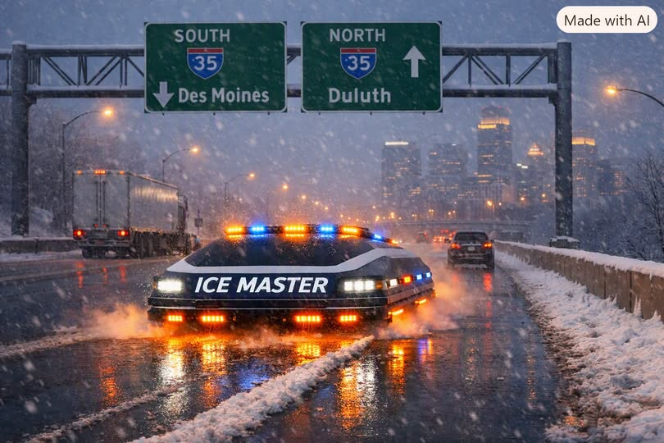
Concept illustration supplied by the author; not evidence of an operational prototype.

Introduction: The Winter Roadway Problem
Winter storms continue to challenge modern transportation systems, overwhelming traditional snowplows and chemical de-icers. These legacy methods push snow aside rather than eliminate it, leave dangerous residual ice, corrode infrastructure, and require repeated labor-intensive passes. Municipalities need safer, more efficient, and more sustainable solutions.

A New Approach: Direct Thermal Roadway Restoration
The proposed Ice Master Autonomous Roadway De-Icing System introduces a different strategy: melting snow and ice directly at the pavement interface. Envisioned as a low-profile autonomous vehicle smaller than a compact car, it would span the full width of a roadway lane. By applying distributed thermal energy across the lane, the concept aims to restore traction while reducing residual ice.

Core Technology: The Underbody Heat Transfer Apparatus
The proposed Underbody Heat Transfer Apparatus (UHTA) would use a full-width array of modular thermal plates, overlapping slightly to avoid cold gaps. Internal channels could circulate a heated working medium such as thermal oil or pressurized air. A combination of radiant and conductive heating would target the ice–road interface. A flexible thermal skirt would help contain heat, while integrated grooves would direct meltwater away from the vehicle.

Thermal Engineering: Efficient, Targeted Melting
The concept would use zoned temperature controls to respond to different ice thicknesses and exposed pavement. Engineering validation must establish whether the available energy, heat-transfer rate, travel speed, and meltwater drainage are sufficient for real roadway conditions. Refreezing and pavement thermal stress would be important design risks.

Adaptive Operation: Speed, Sensors, and Autonomy
Vehicle speed could adjust in response to snow depth, ice thickness, ambient temperature, and pavement conditions. Lidar, radar, thermal imaging, and surface-temperature sensors could inform an automated system controlling heating, routing, and movement. Multiple units might coordinate routes to reduce unnecessary overlap, subject to reliable obstacle detection and safe public-road operation.

Safety and Visibility: Designed for Public Trust
The proposal emphasizes high visibility in poor weather, including full-body LED arrays, undercarriage lighting, pulsing warning lights, and indicators showing operational width. Lighting would need to comply with applicable vehicle and emergency-light regulations; blue lights in particular may be restricted. Safe stopping, remote oversight, and emergency intervention would also be essential.

Energy Efficiency and Cost Advantages
Potential benefits include less reliance on salt, reduced infrastructure corrosion, and fewer conventional plow passes. These benefits are goals rather than demonstrated results. A rigorous comparison should account for fuel or electrical demand, snow-melting energy, vehicle capital cost, maintenance, operating speed, road wear, and the cost of managing runoff.

Deployment Strategy: A Citywide Fleet
A practical rollout would begin with controlled tests on closed pavement, followed by small pilots on selected municipal routes. Performance would be measured against conventional plowing and de-icing methods for cost, safety, energy use, speed, refreezing, and environmental effects. Only after successful validation should wider fleet operations be considered.

Geographic Suitability
Northern cities facing frequent snow and ice may have the greatest reason to evaluate the concept. However, heavy snowfall could require substantial thermal energy and very slow travel speeds. In some settings, conventional snow removal combined with targeted thermal treatment may prove more practical than melting all accumulated snow.

Conclusion: A Transformative Step Forward
Ice Master imagines a shift from reactive snow removal toward precision, sensor-guided roadway treatment. Its potential lies in autonomous coordination and targeted heating, but its technical and economic feasibility remains to be proven. With careful engineering, testing, and public oversight, the idea could contribute to future winter transportation systems.
Development note: Ice Master is presented here as a proposed concept, not a verified commercially deployed technology.

