  - TERRA NOVA DEVELOPMENT

The Future of Magnetic Levitation
China’s experimental acceleration test and the transportation systems it could inspire
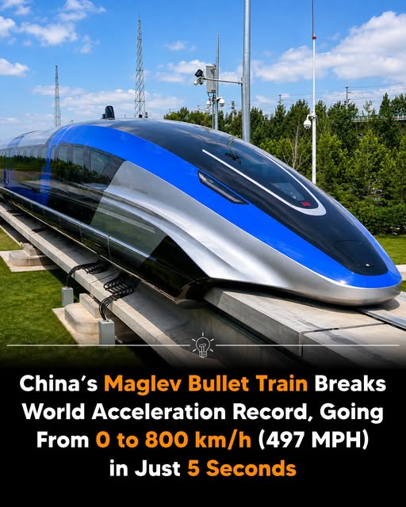
Illustration supplied with the source post. The pictured train should not be assumed to be the actual experimental vehicle.

A glimpse of what may be possible
A reported Chinese maglev experiment accelerated a test vehicle to approximately 800 kilometers per hour (497 miles per hour) in 5.3 seconds on a roughly one-kilometer test track in Hubei province. If accurately reported, this is an extraordinary demonstration of propulsion and control—not evidence that a passenger train can safely accelerate or travel this way in ordinary service.

How maglev changes transportation
Magnetic levitation lifts a vehicle away from conventional wheel-and-rail contact, while electromagnetic propulsion moves it along a specially engineered guideway. Eliminating rolling contact can support very high speeds, although aerodynamic drag, power consumption, guideway precision, and safety remain major challenges.

The acceleration problem
Reaching 800 km/h in 5.3 seconds corresponds to an average acceleration of about 42 meters per second squared, or roughly 4.3 times Earth’s gravitational acceleration. That level would be inappropriate for routine passenger comfort and safety. The experiment is best understood as a short-duration engineering test, not a model for how people would ride.

What America could learn
The United States should study high-speed magnetic propulsion as part of a broader transportation strategy. Potential uses include carefully designed intercity passenger corridors, time-sensitive freight, airport connections, and industrial logistics. Each application needs its own cost-benefit analysis; ordinary electrified rail may be more economical on many routes.

Building a national research program
A practical U.S. approach would begin with university and industry research partnerships, controlled test tracks, independent safety review, and open publication of performance data. Demonstrations should evaluate energy use, emergency braking, reliability, maintenance, weather resilience, passenger comfort, and the full cost of guideways and stations.

Infrastructure is the real challenge
A vehicle capable of extreme speed is only one part of a transportation system. New maglev corridors require land, structures, electrical capacity, switching systems, terminals, noise mitigation, and long-term maintenance. Routes must be judged against realistic ridership or freight demand, not headline speeds alone.

The Terra Nova perspective
Technology should be measured by how well it serves people. Faster travel could connect communities, reduce some short-haul air travel, and improve freight movement—but only where safety, affordability, accessibility, and environmental performance justify the investment. The objective is not simply to set records. It is to build transportation that improves everyday life.

Conclusion: turn experiments into public benefit
The reported Chinese test points toward remarkable possibilities in electromagnetic propulsion. America should respond with curiosity, rigorous engineering, and thoughtful investment—not with the assumption that an experimental acceleration record is a ready-to-deploy passenger railway. The future belongs to nations that turn scientific breakthroughs into safe, useful, and broadly accessible infrastructure.
Source note: This article is based on the user-provided social-media account of a reported test. The specific record and experimental details have not been independently verified here.

