Reimagining Prison Reform Through Healing, Rehabilitation, and Human Development
TERRA NOVA DEVELOPMENT | A VISION FOR JUSTICE REFORM
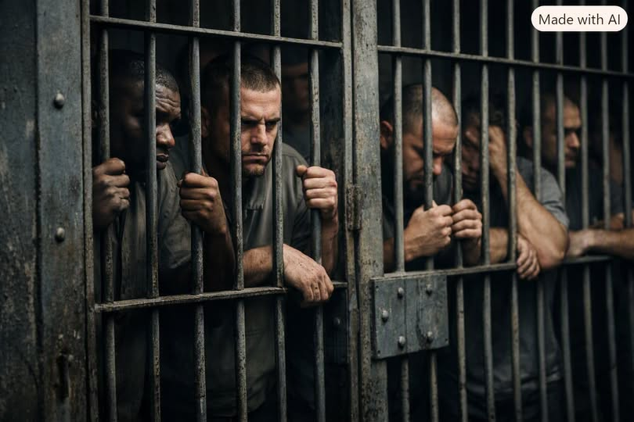
For more than a century, the American prison system has been built on a single premise: punishment. The idea was simple and deeply flawed — remove people from society, subject them to deprivation, and hope that suffering produces moral change. But suffering has never produced rehabilitation. It has produced trauma, recidivism, and generational harm. If the goal of a justice system is to create safer communities, then the current model fails at its most basic purpose.
A modern approach to prison reform must begin with a different assumption: people change when they are supported, not when they are harmed. Rehabilitation, mental and physical wellness, and structured personal development are not luxuries; they are the only proven path to reducing crime and restoring lives.

The Human Cost of Punishment-Based Systems
Punishment-based incarceration isolates individuals from family, community, and opportunity. It exposes them to violence, instability, and chronic stress. Many incarcerated people enter the system with untreated trauma, addiction, or mental illness — conditions that are worsened, not healed, by punitive environments. When they leave, they carry deeper wounds, fewer skills, and limited support. Society then expects them to reintegrate successfully, even though the system has done nothing to prepare them for life outside.
This cycle is predictable. It is also preventable.

A Rehabilitation-Centered Model
A humane prison system would operate on three pillars: mental health, physical wellness, and personal development. These pillars transform incarceration from a warehouse of suffering into a structured environment for growth.
Mental health treatment must be foundational. Many incarcerated individuals have experienced trauma, addiction, or untreated psychological conditions long before their arrest. Therapy, counseling, addiction recovery programs, and emotional literacy training help individuals understand their behavior, develop coping strategies, and rebuild their sense of identity. Healing the mind is not optional — it is the core of rehabilitation.
Physical wellness is equally important. Exercise, nutrition, sleep, and medical care directly affect mood, cognition, and resilience. A healthy body supports a healthy mind. Facilities should provide regular fitness programs, outdoor time, balanced meals, and preventive healthcare. These are not indulgences; they are basic human needs that support long-term stability.
Personal development is the bridge between incarceration and reintegration. Education, vocational training, financial literacy, conflict resolution, and communication skills give individuals the tools to succeed outside prison walls. When people leave with real skills and real confidence, they are far less likely to return.

Community, Structure, and Purpose
A rehabilitative prison is not a place of chaos or permissiveness. It is structured, disciplined, and purposeful. Daily routines revolve around learning, work, wellness, and reflection. Small-group living units encourage accountability and community. Staff are trained not as guards but as mentors, coaches, and facilitators. The environment resembles a campus or treatment center more than a fortress.
This model is not theoretical. Countries like Norway and Finland have implemented rehabilitation-first systems with dramatically lower recidivism rates. Their prisons are calm, clean, and focused on human development. People leave prepared to contribute to society, not to harm it.

The Benefits to Society
Rehabilitation-centered prison reform is not only morally right — it is economically and socially strategic. When formerly incarcerated individuals return with skills, stability, and support, they are more likely to find employment, maintain relationships, and avoid reoffending. Communities become safer. Families become stronger. Taxpayer costs decrease. The justice system becomes a system of restoration, not destruction.

A New Vision of Justice
True justice is not about inflicting pain. It is about preventing future harm. It is about recognizing that people are more than their worst decisions. A rehabilitative prison system acknowledges that accountability and compassion are not opposites — they are partners. It replaces fear with structure, punishment with purpose, and hopelessness with opportunity.
If society wants safer streets, healthier communities, and fewer victims, then it must invest in the humanity of the people it incarcerates. Rehabilitation is not softness. It is strategy. It is strength. And it is the only path toward a justice system that actually works.

