  - TERRA NOVA DEVELOPMENT • ARTICLE #091

Americans Don’t Use More Healthcare. We Just Pay More for Everything.
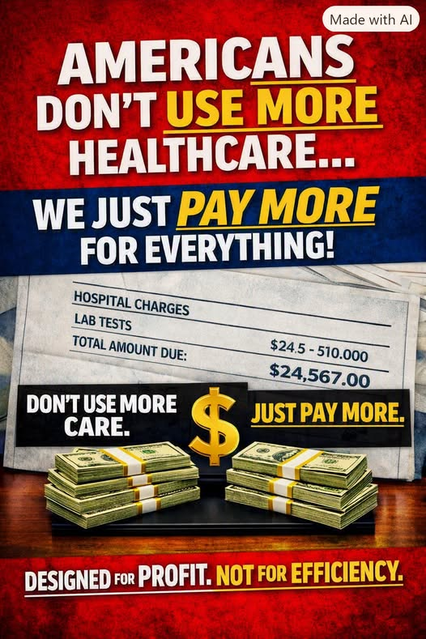
The American healthcare cost problem is primarily a price and system-design problem—not simply a question of how much care people use.

The central problem: paying more, not necessarily receiving more
The United States spends far more per person on healthcare than comparable wealthy countries. Yet Americans do not consistently receive more physician visits, longer hospital stays, or better health outcomes in return. The important distinction is between the quantity of services delivered and the prices charged for those services.
A hospital procedure, specialist appointment, imaging study, or prescription can cost substantially more in the United States than a similar service elsewhere. That difference compounds across an entire economy. Higher spending does not automatically mean more treatment—or better treatment.

Where the extra money goes
- Hospital and facility prices: Negotiated rates vary widely among insurers and providers, often with little transparency to patients.
- Prescription drugs: Brand-name medicines and certain specialty drugs can carry much higher U.S. prices than in peer countries.
- Administrative complexity: Multiple insurers, contracts, networks, coding rules, prior authorizations, and appeals require costly staff and technology.
- Market concentration: Consolidation among hospital systems, insurers, and intermediaries can weaken price competition.
- Financial incentives: Revenue targets, billing arrangements, and investor expectations can reward higher charges or more profitable services rather than efficient delivery.

The cost is paid by everyone
Employers pay insurance premiums that could otherwise support wages, hiring, or investment. Employees pay their own premiums, deductibles, and copayments. Taxpayers finance Medicare, Medicaid, public-employee coverage, and other programs. Uninsured and underinsured patients face medical bills and debt. These are different payment channels into the same costly system.
High prices also influence decisions about care. A patient may delay a diagnostic test, ration medication, or skip a follow-up visit because the bill is unpredictable. In that case, high spending and inadequate access exist side by side.

Why “profit extraction” matters—and what it does not explain alone
The illustration makes a forceful argument: too much of American healthcare financing rewards revenue capture rather than efficiency. That concern deserves attention, particularly where opaque pricing, excessive administrative costs, and concentrated market power divert resources from patient care.
But profit is not the only driver. U.S. healthcare also faces high labor and facility costs, complex regulation, expensive technology, fragmented financing, and genuine clinical needs. A serious reform must address all of these factors rather than treating every dollar of spending as waste.

What a better system would do
- Make prices transparent and comparable, with meaningful negotiation or regulation where competition fails.
- Simplify billing and reduce redundant administrative requirements.
- Negotiate more affordable prescription prices while supporting useful innovation.
- Ensure access to preventive, primary, mental-health, and necessary specialty care without financial barriers.
- Measure success by health outcomes, patient experience, equitable access, and total cost—not revenue growth.

The Medicare for All opportunity
A Medicare for All approach proposes replacing fragmented insurance financing with a unified public system. Its potential advantages include simpler administration, stronger purchasing leverage, and fewer financial barriers to necessary care. Whether it saves money overall depends on the actual legislation: payment rates, benefits, utilization, taxes, transition costs, and how providers adapt.
Expanded coverage could increase the use of needed services, especially among people who currently postpone care. That is a benefit, but it must be included honestly in budget estimates. The goal is not merely to spend less; it is to deliver more reliable, equitable care for the resources the nation commits.

Conclusion: fix the prices and the incentives
Americans should not have to pay dramatically more for ordinary medical services simply because the financing system is fragmented and prices are opaque. A country can support excellent doctors, hospitals, researchers, and new treatments without making illness a financial catastrophe.
The question is not whether Americans deserve less healthcare. It is why they pay so much for the care they receive—and how to build a system that directs more of every healthcare dollar toward health.
We do not need to accept high prices as the price of good care. We can demand both quality and efficiency.
Editorial note: This is a policy argument, not a quantified cost study. International utilization and price comparisons vary by service and year; specific numerical claims should be checked against current OECD, CMS, and peer-reviewed data before publication as factual estimates.

