  - TERRA NOVA DEVELOPMENT • ARTICLE #092

Reducing Costs — Booming Business
How Medicare for All could strengthen American enterprise through lower healthcare costs
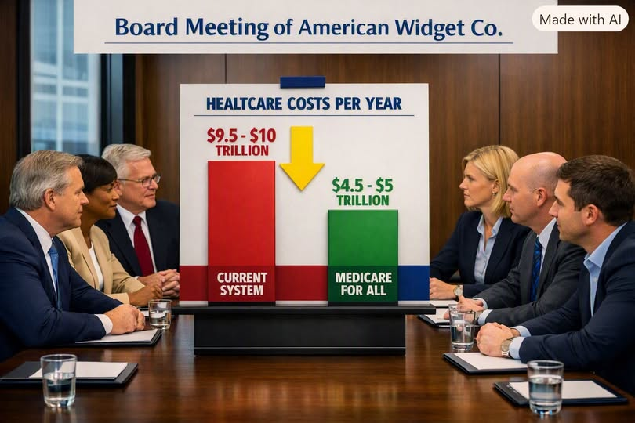
Illustration: a hypothetical boardroom comparison. The $9.5–$10 trillion and $4.5–$5 trillion figures shown are not established like-for-like national healthcare expenditure estimates.

The Business Case Beyond Politics
One of the most important—and least understood—potential benefits of Medicare for All is its effect on the cost structure of American business. Employers today devote substantial resources to health insurance premiums, benefit administration, compliance, and managing coverage changes. Those expenses influence hiring, compensation, investment, and the prices customers ultimately pay.
Medicare for All would replace employer-sponsored premiums with a publicly financed system. The crucial question for any company would be whether its new tax or payroll contribution is smaller than the health-benefit costs it no longer pays. Under a well-designed financing plan, many businesses could see meaningful net savings.

Where the Savings Could Come From
- Lower benefit administration costs: fewer insurance contracts, enrollment processes, and billing disputes.
- More predictable budgets: financing based on transparent rules rather than annual premium negotiations.
- A healthier workforce: earlier access to treatment could reduce some avoidable absences and productivity losses.
- Greater labor mobility: workers could change jobs or start businesses without losing health coverage.
- Stronger competitiveness: lower net employment costs could free resources for hiring, investment, research, and innovation.

Healthy Cost Reduction, Not Automatic Deflation
If healthcare becomes less expensive to administer and purchase, businesses may be able to lower prices, raise wages, increase investment, or improve margins. These are potential benefits of removing waste from a major cost category. They do not guarantee economy-wide price declines: the outcome depends on taxes, provider payments, utilization, market competition, and how firms allocate their savings.

Efficiency Creates Wealth. Waste Destroys It.
A dollar spent navigating overlapping insurance rules is a dollar that cannot be used to deliver care, build equipment, improve a product, or pay an employee. Medicare for All aims to redirect some of that spending toward useful services and productive activity. At the same time, expanded coverage may increase the amount of medically necessary care delivered; that added care has real costs and must be included in responsible projections.

The Numbers Must Be Compared Carefully
The illustration contrasts a claimed $9.5–$10 trillion annual burden for the current system with $4.5–$5 trillion for Medicare for All. Those figures should be treated as an advocacy scenario, not a verified apples-to-apples comparison. Direct national health expenditures, indirect productivity losses, and hypothetical gains cannot simply be added without checking for double counting, and different single-payer proposals have different financing and spending outcomes.
The strongest argument is not that every business will save a fixed amount, but that a unified financing model could reduce waste and make healthcare spending more predictable—provided that the transition and replacement taxes are designed carefully.

Conclusion: Reducing Costs, Booming Business
Medicare for All is not only a question of healthcare access. It is also a proposal for economic modernization. By replacing fragmented insurance financing with a more coordinated system, the nation could give employers and workers a better foundation for growth. The goal is straightforward: spend less on avoidable complexity, spend more effectively on care, and allow American enterprise to invest its resources where they create lasting value.
Reducing costs. Booming business. A stronger America.

