TERRA NOVA DEVELOPMENT | ARTICLE #077

The Vision of Terra Nova Development
  - An Organization Dedicated to Solving Problems—Whatever Their Nature
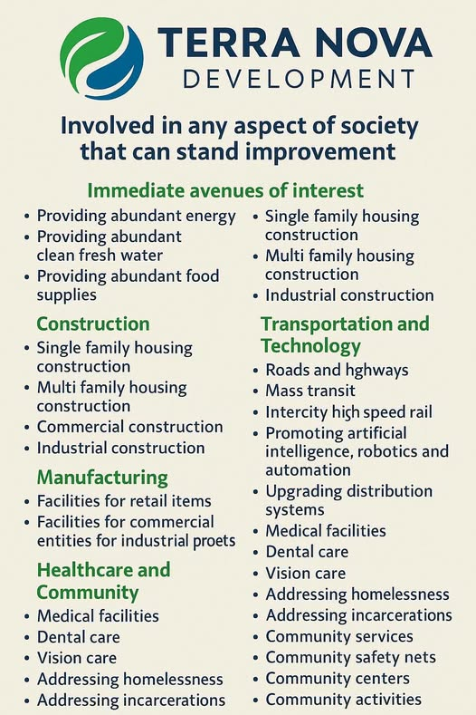
Terra Nova Development begins with a simple proposition: whenever a problem diminishes human well-being, someone should be willing to examine it, understand it, and work toward a practical solution. The nature of the problem does not determine whether it deserves attention. A shortage of affordable housing, a barrier to medical care, an inefficient transportation system, or a community struggling to provide food and clean water can all become the starting point for constructive action.
Terra Nova is envisioned as a problem-solving organization rather than a business confined to one industry. Its purpose is to identify needs, assemble knowledge and capable people, develop workable systems, and carry those systems from concept to implementation. The organization’s scope is deliberately broad because society’s problems are interconnected.

A Mission Without Artificial Boundaries
Most organizations define themselves by a product, profession, or market. Terra Nova defines itself by a responsibility: improving any aspect of society that can stand improvement.
This does not mean attempting everything at once. It means refusing to dismiss a worthy problem merely because it falls outside a conventional organizational category. Terra Nova can begin with a single project, demonstrate that it works, and then apply the same disciplined methods elsewhere.
The guiding question is not, “Is this our industry?” It is, “What is the problem, what would a better system look like, and how can we build it?”

The Foundations of Abundance
Energy, water, food, and shelter are foundations upon which nearly every other improvement depends. Terra Nova’s immediate avenues of interest include abundant energy, abundant clean fresh water, and abundant food supplies.
Reliable, affordable energy supports homes, industry, transportation, agriculture, and digital infrastructure. Clean water supports health and resilient communities. Modern food production and distribution can reduce waste and expand access. These systems should be designed together, not as unrelated projects.

Construction and Housing
Terra Nova’s construction interests span single-family homes, multifamily housing, commercial buildings, and industrial facilities. The challenge is not simply to construct more buildings; it is to improve how buildings are designed, financed, manufactured, assembled, operated, and maintained.
Standardized components, better materials, automation, and efficient project management can help make quality housing and facilities more accessible. Housing initiatives should also connect with energy, water, transportation, and community services.

Manufacturing and Productive Capacity
Solving large problems requires the ability to make useful things at scale. Terra Nova therefore includes manufacturing facilities for retail products and for commercial and industrial needs among its areas of interest.
Where appropriate, the organization can explore modular production, robotics, local supply chains, and designs that simplify repair and reuse. Manufacturing should serve a defined human need, with efficiency measured not only by output but by the lasting usefulness of what is produced.

Healthcare and Community Well-Being
Healthcare is more than hospital treatment. Terra Nova’s interests include medical facilities, dental care, vision care, homelessness, incarceration, community services, safety networks, community centers, and community activities.
These concerns are linked. A person without stable housing may struggle to maintain health; a community without accessible services may face preventable emergencies; a justice system focused only on punishment may fail to support rehabilitation. Terra Nova’s approach is to study the complete system and look for solutions that address causes as well as symptoms.

Transportation, Technology, and Distribution
Roads and highways, mass transit, intercity high-speed rail, and better distribution systems influence how people work, learn, obtain care, and participate in community life.
Artificial intelligence, robotics, and automation can assist with planning, construction, logistics, education, and service delivery. Terra Nova treats technology as a tool rather than an end in itself. The test of a technology is whether it makes essential goods and services more accessible, reliable, affordable, and humane.

A Repeatable Method for Solving Problems
Terra Nova can apply a consistent systems-engineering process across its projects:
1. Define the problem in terms of people affected, present conditions, and measurable outcomes.
2. Study the entire system, including constraints, incentives, resources, and unintended consequences.
3. Identify existing solutions and adapt what already works instead of reinventing it.
4. Design a practical pilot with clear responsibilities, costs, risks, and performance measures.
5. Test, measure, revise, and publish what is learned.
6. Scale successful models through partnerships, investment, public programs, or community ownership.
7. Continue improving the system after implementation rather than declaring the work finished.

Partnerships Rather Than Silos
No single organization possesses all the expertise or resources needed to solve society’s most complex problems. Terra Nova’s model therefore depends on collaboration with engineers, educators, healthcare professionals, builders, researchers, businesses, governments, nonprofits, and the communities directly affected.
Some initiatives may be commercially viable. Others may require philanthropy, public funding, or nonprofit structures. The funding mechanism should fit the mission and the needs of the people served, with transparent governance and accountability.

From Individual Projects to a Better Society
Terra Nova’s many areas of interest are not separate dreams competing for attention. They can reinforce one another. Affordable energy lowers the cost of water treatment and manufacturing. Better construction reduces housing costs. Accessible healthcare strengthens families and workplaces. Transportation connects people to opportunity. Education and technology improve every one of these systems.
The long-term ambition is to create an organization capable of moving from one solvable problem to the next while retaining the lessons, partnerships, and capabilities gained along the way.

Conclusion: There Is No Them, Only Us
Terra Nova Development is founded on the belief that society can be improved through practical cooperation, sound engineering, creativity, and a willingness to question systems that no longer serve people well.
Its vision is not limited to energy, housing, healthcare, manufacturing, transportation, or technology. Those are starting points. Wherever a problem exists and a better solution can be built, Terra Nova can have a role.
The purpose is simple: identify what needs improvement, bring people together, and make the improvement real.
There is no them. There is only us.

