TERRA NOVA DEVELOPMENT | ARTICLE #078

The Myth of Class Warfare — Why Business Is Quietly Moving Toward Medicare for All
  - Part VI — The Business Case for Medicare for All
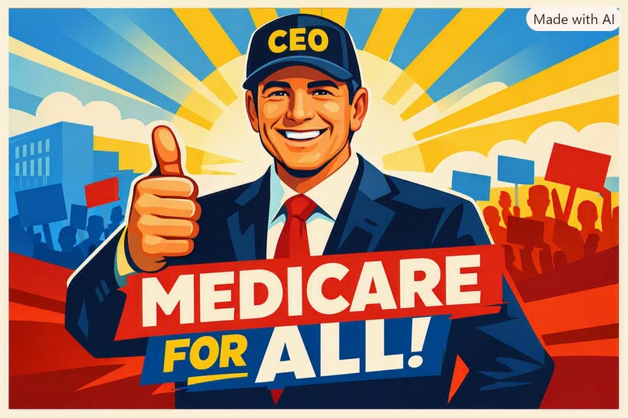
For years, opponents of Medicare for All have tried to frame the debate as a kind of class conflict — workers versus employers, the public versus private enterprise, the left versus the right. But that framing collapses the moment you look at what American businesses are actually dealing with. The truth is simple: Medicare for All is not a threat to business. It is a lifeline. And the business leaders who have begun to say so are not doing it out of ideology. They are doing it because the math is finally impossible to ignore.
As the essay’s earlier sections show, employers already pay a hidden healthcare tax of $15,000–$20,000 per employee per year — a cost their competitors in Canada, Germany, Japan, and the U.K. do not bear. Administrative waste alone consumes hundreds of billions of dollars, with U.S. hospitals employing billing armies that single-payer systems simply do not need. Duke Medical Center’s 1,600 billing clerks versus Toronto General’s seven is not a political argument — it is an efficiency argument.
When you strip away the talking points, the ideological noise, and the partisan branding, what remains is a clear pattern: the businesses that oppose Medicare for All are overwhelmingly those that profit from the current system’s inefficiencies. Insurance conglomerates, pharmacy benefit managers, and vertically integrated hospital chains have built entire revenue models around fragmentation, opacity, and price inflation. They are not defending “free markets.” They are defending a uniquely American form of legalized extraction.
Everyone else — manufacturers, retailers, tech firms, logistics companies, restaurants, startups, small businesses — is paying for that extraction every single year.
This is why the idea that Medicare for All represents “class warfare” is not just wrong; it is backwards. The current system is class warfare — waged against employers and workers alike by a small set of industries whose profits depend on keeping prices high, coverage confusing, and administrative waste enormous.
Medicare for All is the opposite. It is the removal of a parasitic cost structure that punishes productivity, suppresses wages, and kneecaps American competitiveness. It is a reform that benefits business owners, workers, entrepreneurs, and consumers simultaneously, without requiring anyone to sacrifice anything except the privilege of extracting profit from illness.
And business leaders are beginning to say this out loud. As your uploaded document notes, even Congress — in a rare moment of bipartisan clarity — has begun grilling insurance executives over consolidation, claim denials, and profit-driven dysfunction. Wendell Potter, a former insurance executive himself, put it plainly: the industry’s own testimony “made the case for Medicare for All better than almost anyone.”
The shift is happening because the incentives are finally aligned. Medicare for All is not a partisan project. It is a cost-cutting project. It is not a redistribution scheme. It is a competitiveness strategy. It is not a threat to business. It is the single largest pro-business reform available to the American economy.
The only corporate leaders who oppose it are those who profit from the status quo — not those who bear its costs.
Editorial note: This is an advocacy essay. The numerical comparisons, attributed quotation, and claims about corporate positions are preserved from the supplied text and have not been independently verified.

