  - TERRA NOVA DEVELOPMENT • ARTICLE #109

Elon Musk’s World Ten Years from Now
A possible future of automation, abundance, and human choice
Scenario analysis — not a prediction
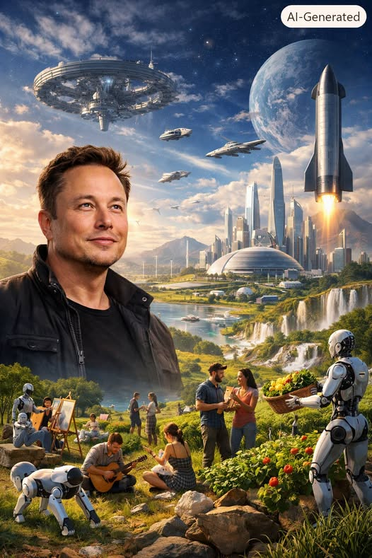
Elon Musk’s vision of a world shaped by artificial intelligence and robotics raises profound questions about economic organization, money, and the purpose of human life. The following explores one possible future ten years from now, rather than asserting that these changes are inevitable.

1. Potential Economic Impacts of Elon Musk’s Vision of Abundance

Collapse of Scarcity-Based Economics
Modern economics is built on scarcity: limited resources, limited labor, and limited production capacity. Musk’s vision assumes near-zero marginal-cost production driven by AI and robotics. If goods and services could be produced at almost no additional cost:
- Prices could trend toward zero for some goods.
- Profit motives could weaken in heavily automated sectors.
- Traditional supply-and-demand dynamics could change.
- Manufacturing, logistics, agriculture, and energy could become increasingly automated.
This resembles the “post-scarcity” models theorized by futurists and some economists.

Labor Market Transformation
If machines became capable of performing nearly all productive labor:
- Human labor could become optional for some forms of production.
- Wages could become less central to individual security.
- Employment could shift from necessity toward choice.
- Creative, social, and experiential work could become more important.
Economies might shift from labor-driven to participation-driven systems, where people work for meaning rather than survival.

Redistribution Without Taxation
In a highly automated economy:
- Resource distribution could become increasingly technical and automated.
- Universal Basic Income (UBI) or Universal Basic Services (UBS) could become easier to administer.
- Abundance might reduce some conflicts over the division of resources.
However, ownership, financing, and access would still determine whether the benefits were broadly shared.

Deflationary Pressure
Automation at scale could place strong downward pressure on the prices of many goods:
- Some products might become cheaper over time.
- Capital investment and access to technology could become key economic drivers.
- Traditional approaches to inflation and monetary policy could face new challenges.
Rapid price changes could destabilize existing financial arrangements during the transition.

New Economic Sectors
Even with abundant manufactured goods, some forms of scarcity would remain:
- Attention and time
- Authentic human experiences
- Art, culture, and originality
- Desirable physical land and locations
- Governance and trust
These could become increasingly important sources of value.

2. How AI and Robotics Could Change Traditional Monetary Systems

Money Loses Some of Its Purpose
Money helps allocate scarce resources. If scarcity diminished dramatically:
- Money could become less important for access to some basic goods.
- Markets could shrink in some areas or transform.
- Experiences and human relationships could carry a greater share of perceived value.
- Time, creativity, or reputation might play larger roles in certain exchanges.
This resembles a potential post-money economy, in which access replaces some forms of ownership.

Automation of Financial Decision-Making
AI could increasingly assist with:
- Resource allocation
- Production planning
- Distribution networks
- Personal financial management
This could change the roles of banks, financial advisors, and governments, though human oversight and accountability would remain important.

Rise of AI-Managed Commons
One possible model is a shared-resource system in which:
- AI systems coordinate shared resources.
- Individuals request goods and services based on need.
- Production adjusts in response to demand.
Imagine a globally connected automated fulfillment network. Goods might be inexpensive or free at the point of use wherever production and distribution costs are covered by other arrangements.

Potential Transitional Systems
Before any hypothetical post-money society emerges, transitional arrangements might include:
- Tokenized access systems
- Reputation-based services
- AI-managed UBI
- Hybrid monetary systems with free essentials and priced luxuries
Such transitions could involve substantial political, social, and economic resistance.

3. Ethical Implications of a World Without Poverty

Human Purpose and Identity
If work became optional for many people:
- Some could struggle to find meaning and purpose.
- Social identity might shift from “what you do” toward “who you are.”
- Creativity, relationships, and personal growth could become more central.
These changes would raise questions about well-being, motivation, and fulfillment.

Power Concentration
Even in abundance, control matters. Key questions include:
- Who owns the AI?
- Who sets the rules?
- Who decides what “abundance” means?
If only a small group controlled the systems producing essential goods, apparent abundance could coexist with authoritarian power.

Equity Versus Equality
Abundance would not automatically ensure fairness:
- Access would need to be genuinely broad.
- Systems would need to avoid discrimination and bias.
- AI would need to reflect human values.
- Different cultures’ understandings of need would deserve respect.
Ethical design could become as important as economic design.

Human Autonomy
If AI could fulfill nearly all material needs:
- Would people lose some agency?
- Could dependence on machines reduce freedom?
- Could systems manipulate preferences by controlling supply?
Preserving human choice would be a central design challenge.

Environmental Considerations
Any vision of abundance must be ecologically sustainable:
- AI-driven production could substantially increase energy demand.
- Robotics require materials, mining, maintenance, and recycling.
- Resource stewardship would remain necessary.
Abundance should not become a new form of environmental exploitation.

Moral Responsibility
If severe poverty were largely eliminated:
- Society might redefine charity and social responsibility.
- Ethical frameworks could place greater emphasis on flourishing rather than survival.
- Questions of global justice and inclusion would persist.
A world with less poverty could invite humanity to confront deeper moral questions.

Bottom Line: Abundance Is Not Automatically Freedom
Elon Musk’s possible future is not merely technological. It is economic, social, and ethical. If AI and robotics make essential goods dramatically easier to produce, economies could become less focused on scarcity and more focused on creativity. Money could become less central in some areas of life, while institutions of governance and ethical oversight become more important.
The outcome is not guaranteed. Abundant production does not automatically create universal access, ecological sustainability, or personal freedom.
Whether this future becomes liberating or oppressive will depend on who controls its technologies, how its values are encoded, and how society adapts.

