  - TERRA NOVA DEVELOPMENT | ARTICLE #110

The Transition to Abundance
  - A Terra Nova Essay on Ending Artificial Scarcity
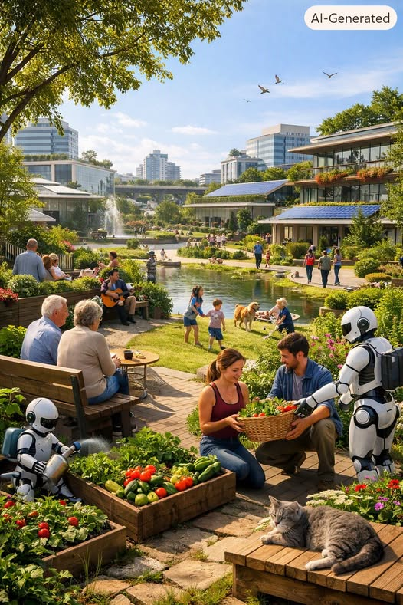
Humanity stands at the threshold of a profound transformation. For thousands of years, civilization has been shaped by scarcity — the belief that resources are limited, that survival requires struggle, and that poverty is an unavoidable feature of human existence. Terra Nova challenges this assumption. We argue that scarcity is not a natural condition but an engineered one, sustained by outdated systems, economic incentives, and cultural narratives that no longer serve us. Today, with the rise of artificial intelligence, robotics, and autonomous energy systems, humanity has the tools to dismantle artificial scarcity and build a world defined by abundance.
This essay explores how such a transition can occur, why it is necessary, and what it means for the future of human freedom.

I. The Myth of Scarcity
Scarcity has long been treated as an immutable law of nature. Yet when we examine history, we find that scarcity has often been manufactured — through monopolies, gatekeeping, political control, and economic structures designed to limit access. Food is destroyed to stabilize prices. Housing sits empty while people sleep on the streets. Knowledge is locked behind paywalls. Innovation is slowed by patents and proprietary systems.
Terra Nova asserts a simple truth: humanity has always possessed the capacity for abundance. What we lacked was the technology to unlock it at scale. That barrier is now dissolving.

II. Automation as a Catalyst for Liberation
Automation is frequently misunderstood as a threat to human labor. In Terra Nova’s view, automation is not a force of displacement but a force of liberation. When machines can perform the labor required for survival — farming, manufacturing, logistics, energy production — human beings are freed from the necessity of working merely to live.
This does not eliminate work; it transforms it. Work becomes voluntary, creative, and purpose-driven. People engage in art, science, exploration, community building, and personal growth. The drudgery of survival is replaced by the pursuit of meaning.
Automation is not the end of human contribution. It is the beginning of human flourishing.

III. Energy as the Foundation of Abundance
Every form of abundance rests on a single foundation: energy. When energy is scarce, everything else becomes scarce. When energy is abundant, everything else becomes abundant.
Solar power, battery storage, autonomous grids, and next-generation energy systems are rapidly making clean, renewable energy both cheap and plentiful. As energy becomes abundant:
- Food production becomes automated and continuous
- Water purification becomes universal
- Housing construction becomes rapid and inexpensive
- Transportation becomes accessible to all
- Computing power becomes limitless
Energy abundance is the master key that unlocks every other form of abundance.

IV. The Post-Money Transition
Money is a tool designed to allocate scarce resources. In a world of abundance, its role changes dramatically. Terra Nova envisions a future where access replaces ownership, where contribution replaces competition, and where creativity becomes the primary currency of human value.
Basic needs — food, housing, healthcare, education, transportation — become guaranteed. They are not earned through labor or purchased through wages; they are provided through automated systems that operate continuously and efficiently.
This does not eliminate markets or innovation. Instead, it shifts them toward experiences, creativity, and exploration. The economy becomes a platform for human expression rather than a mechanism for survival.

V. Human Flourishing as the New Metric
When survival is no longer the central concern of life, humanity can finally focus on what matters most. Terra Nova defines the success of a civilization not by GDP or stock market performance but by human flourishing — the degree to which individuals can pursue meaning, creativity, connection, and joy.
In an abundant world:
- Education becomes lifelong and curiosity-driven
- Communities become centers of creativity and collaboration
- Art and culture flourish
- Innovation accelerates
- People rediscover time — the most precious resource of all
Abundance is not merely the absence of poverty. It is the presence of possibility.

VI. Ethics as the Guardrails of Abundance
Technology alone cannot guarantee a just future. Without ethical foundations, abundance could become a new form of control — a system where access is manipulated, autonomy is restricted, and power is concentrated in the hands of a few.
Terra Nova insists on ethical principles that ensure abundance serves humanity:
- Transparent and accountable AI
- Decentralized governance
- Universal access to essential resources
- Ecological sustainability
- Protection of human autonomy
- Prevention of monopolies of power
Abundance must be built on fairness, not control.

VII. The Path Forward
The transition to abundance is not theoretical. It is already underway. The steps are clear:
- Automate production across industries
- Scale renewable energy globally
- Deploy AI-managed distribution systems
- Guarantee universal basic services
- Build pilot communities that model abundance
- Shift cultural values from competition to collaboration
- Redesign economic systems around access rather than scarcity
This transition will not happen overnight, but it will happen faster than most expect. The technologies exist. The need is urgent. The vision is compelling.

Conclusion: The Dawn of Terra Nova
Terra Nova envisions a world where artificial scarcity is a relic of the past, where abundance is the natural state of a technologically mature civilization, and where every human being has the freedom to live a life defined not by struggle but by creativity, connection, and purpose.
The old world is fading.
A new world is rising.
And humanity stands ready to cross the threshold.
This is the promise of abundance.
This is the mission of Terra Nova.
This is the future we choose to build.

