The Future of Fusion Energy: Promise, Challenges, and Global Impact
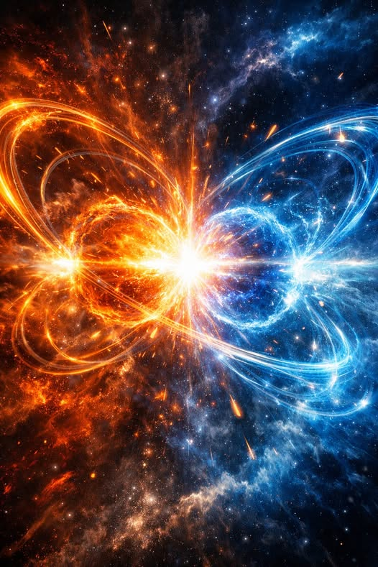

1. Introduction
Fusion energy — the process that powers the sun — has long been considered the ultimate clean-energy solution. For decades, it lived in the realm of scientific aspiration, constrained by engineering limits and the sheer difficulty of recreating stellar conditions on Earth. Today, however, fusion is entering a new phase: one defined by rapid technological progress, unprecedented private investment, and credible commercial timelines. The future of fusion energy is no longer hypothetical; it is emerging.

2. Scientific Breakthroughs
Recent advances have pushed fusion closer to viability than at any point in history.

2.1 Net Energy Gain
In 2022, researchers achieved “ignition,” producing more energy from fusion than the lasers used to trigger it. This milestone demonstrated that fusion is scientifically possible, not just theoretically sound.

2.2 High-Temperature Superconductors
New superconducting materials allow for stronger magnetic fields, enabling smaller, more efficient reactors. Compact tokamaks — once considered unrealistic — are now being built by multiple companies.

2.3 Advanced Modeling and AI
Machine learning is accelerating reactor design, optimizing plasma stability, and reducing the trial-and-error cycles that once slowed fusion research.

3. Private Sector Acceleration
Fusion is no longer driven solely by governments.

3.1 Investment Surges
Private investment has surpassed $10 billion, with companies like Commonwealth Fusion Systems, Helion, and TAE Technologies racing toward commercial reactors.

3.2 Commercial Timelines
Many firms now target 2035–2040 for the first grid-connected fusion plants. While ambitious, these timelines reflect real engineering progress rather than speculative optimism.

3.3 Diverse Approaches
The private sector is exploring multiple fusion pathways:
- Magnetic confinement
- Inertial confinement
- Field-reversed configurations
- Magnetized target fusion
This diversity increases the likelihood that at least one approach will succeed.

4. Global Collaboration
Fusion is inherently international.

4.1 ITER and Multinational Projects
ITER, involving 33 nations, remains the largest fusion experiment ever attempted. Despite delays, it continues to advance the science of large-scale plasma confinement.

4.2 National Initiatives
Countries including the U.S., U.K., Japan, South Korea, and China are building new fusion facilities, creating regulatory frameworks, and funding commercial partnerships.

4.3 Shared Knowledge
Fusion research is unusually collaborative. Breakthroughs in one country rapidly inform work elsewhere, accelerating global progress.

5. Challenges Ahead
Fusion’s future is bright, but not guaranteed.

5.1 Engineering Obstacles
Key challenges include:
- Materials that can withstand extreme neutron bombardment
- Efficient tritium breeding
- Continuous plasma stability
- Cost-effective reactor construction

5.2 Regulatory and Safety Frameworks
Fusion requires new regulatory systems distinct from fission. Governments are only beginning to build these frameworks.

5.3 Economic Viability
Fusion must compete with:
- Solar and wind
- Advanced fission
- Hydrogen
- Grid-scale storage
Cost will determine how quickly fusion scales.

6. Long-Term Impact
If fusion succeeds, the implications are profound.

6.1 Clean Baseload Power
Fusion produces no carbon emissions, no long-lived radioactive waste, and no meltdown risk. It could supply 10–50% of global electricity by 2100.

6.2 Industrial Transformation
Fusion could power:
- Desalination
- Hydrogen production
- Steel and cement manufacturing
- Space propulsion

6.3 Economic Growth
Cheap, abundant energy would reshape global economics, enabling new industries and reducing geopolitical tensions tied to fossil fuels.

7. Conclusion
Fusion energy is transitioning from scientific dream to engineering reality. While challenges remain, the momentum behind fusion — scientific, financial, and political — is stronger than ever. The coming decades may witness the birth of a new energy era, one defined not by scarcity or carbon emissions, but by the same force that lights the stars.

