BLUE SKY AIRWAYS
THE CRUISE SHIPS OF TOMORROW
A visionary concept for leisurely, panoramic airship travel
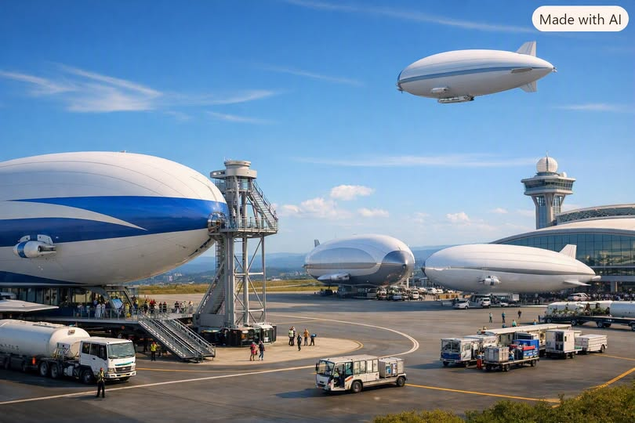
Concept illustration • Blue Sky Airways is a proposed service, not an operating airline.

Welcome Aboard
Blue Sky Airways invites travelers to rediscover the joy of the journey. Imagine grand, multi-deck airships gliding above coastlines, rivers, forests, and historic cities at a relaxed target cruising speed of approximately 100 miles per hour. Instead of rushing between airports, guests would savor the landscape below—turning transportation into the destination itself.
The vision calls for spacious airborne cruise vessels accommodating approximately 300 to 500 passengers, with lounges, observation areas, dining, and multi-stop itineraries. These are ambitious design targets that would require substantial engineering, certification, and infrastructure development.

The Blue Sky Experience

Low-Altitude SkyCruising
The concept envisions selected scenic segments at roughly 300–800 feet above ground level, where lawful and safe. Such altitudes cannot be promised across all routes: terrain, obstacles, airspace restrictions, weather, wildlife, noise, and aviation regulations would govern actual flight profiles.

Three Viewing Decks
- SkyLounge Deck — panoramic windows, comfortable seating, and quiet observation areas.
- VistaDeck — photography and viewing spaces; any outdoor terrace would require specific engineering and regulatory approval.
- Grand Promenade Deck — social gathering areas, cafés, and wide views of the world below.

A Gentle Pace
Helium buoyancy and modern propulsion could support an unusually relaxed style of travel. The goal is a quiet, comfortable ride, although turbulence, wind, noise, and operational limitations cannot be eliminated.

Environmental Ambition
Blue Sky Airways would aim to minimize emissions through efficient propulsion, low-carbon energy, and thoughtful route planning. Its actual environmental footprint would depend on vehicle mass, power source, helium supply, operating speed, infrastructure, and lifecycle impacts; “near-zero” emissions should be treated as a goal rather than an established outcome.

Flexible Landing and Local Access
A defining feature would be the opportunity to embark in one community, visit scenic and cultural destinations, disembark for excursions, and return aboard for the next leg. Unlike conventional cruise ships, an airship could potentially connect inland destinations and islands within a single itinerary.
However, large passenger airships would not simply need a compact landing pad. Safe operations would require appropriately sized mooring or docking facilities, weather-handling systems, passenger access, emergency arrangements, trained ground crews, and regulatory approvals. Protected natural areas would need special safeguards.

Signature Sky Routes
- Caribbean SkyRibbon — reefs, island chains, mangroves, and luminous lagoons.
- American Southwest SkyCanyon — red mesas, desert horizons, and dramatic canyon country.
- European SkyHeritage Tour — castles, vineyards, medieval towns, and winding rivers.
- Asian SkyRiver Passage — terraced hillsides, waterways, mountains, and cultural landmarks.
- Pacific SkyCoast Voyage — volcanic cliffs, coastal landscapes, and open ocean vistas.
These are illustrative itineraries; route feasibility, weather exposure, airspace access, international permissions, and site infrastructure would need evaluation.

Choose Your Journey
SkyCruise Luxury Class — Private suites, curated dining, concierge service, and multi-day aerial journeys.
SkyView Explorer — Half-day scenic experiences with guided interpretation and photography opportunities.
SkyFloat City Tours — Short sightseeing flights around iconic urban landscapes, subject to flight restrictions.
EcoRoutes — Educational expeditions designed with conservation organizations and researchers.

Designed for Many Kinds of Travelers
Families, photographers, retirees, nature enthusiasts, couples, and travelers seeking a memorable once-in-a-lifetime experience could all find a place aboard. Inclusive design would prioritize accessible circulation, seating, restrooms, and boarding.

Safety, Comfort, and Responsible Development
The proposed design would incorporate redundant avionics, robust weather monitoring, climate-controlled cabins, accessible walkways, emergency systems, and carefully engineered passenger spaces. The ability to carry hundreds of people safely at low altitude—particularly with multiple decks and large viewing areas—must be demonstrated through detailed structural analysis, flight testing, operational planning, and certification.

A Practical Path from Vision to Reality
- Feasibility: model lift, payload, propulsion, energy demand, flight envelope, economics, and weather limits.
- Prototype: develop and test a smaller demonstrator before attempting a large passenger vessel.
- Infrastructure: identify viable terminals, mooring systems, maintenance facilities, and routes.
- Certification: work with aviation authorities on airworthiness, operating rules, accessibility, and passenger safety.
- Pilot service: validate reliability, customer experience, costs, and environmental performance before scaling.

The Cruise Ships of Tomorrow
Blue Sky Airways is a proposal to change the meaning of travel: from getting somewhere as quickly as possible to enjoying every mile along the way. Its promise lies in the experience—an unhurried journey through the sky, with time to look, learn, and wonder.
Not fast. Not rushed. Just breathtaking.

