Tariffs vs. Medicare for All
  - Two very different defenses of American interests
TERRA NOVA DEVELOPMENT | POLICY & ECONOMIC SYSTEMS
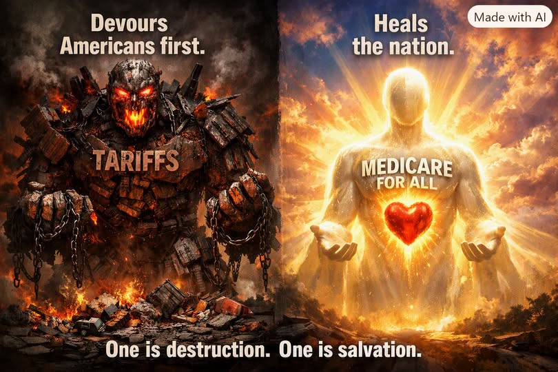
One policy raises the price of some goods crossing the border. The other proposes to redesign how Americans finance healthcare. Both are defended as ways to protect American interests—but their economic mechanisms are fundamentally different.

Two approaches to national strength
Tariffs are an external trade instrument: a tax on specified imports, intended to influence sourcing, protect certain domestic producers, or gain negotiating leverage. Medicare for All is an internal structural proposal: a publicly financed universal health insurance system intended to reduce fragmentation and expand access to care. Neither policy can be judged solely by its slogan; the details and trade-offs matter.

1. What tariffs actually do
A tariff is collected on imported goods, generally from the importing business. Some of its cost may be absorbed by importers or foreign suppliers, but much can be passed through to American manufacturers and consumers in higher prices.
- Targeted protection: Domestic producers competing with imports may benefit, especially in strategically important sectors.
- Higher input costs: U.S. companies that use imported steel, electronics, components, or equipment may face higher expenses.
- Retaliation risk: Trading partners can respond with tariffs on U.S. exports, harming farmers and other exporters.
- Supply-chain disruption: Businesses may need to change suppliers, absorb costs, or delay investment.
Tariffs can be useful when carefully targeted to a clear objective, such as countering unfair trade practices or protecting a critical supply chain. Broad tariffs, however, often impose costs beyond the industry they are intended to help.

2. What Medicare for All proposes
Medicare for All would replace much of today’s mix of private insurance and public coverage with a national financing framework. Its central economic argument is that simplified administration, stronger purchasing leverage, and continuous coverage could lower total health-system costs while reducing financial barriers to treatment.
- Less insurance complexity: Providers could spend less time navigating multiple insurers, billing rules, and networks.
- Lower household exposure: Depending on the legislation, premiums, deductibles, and copayments could be replaced by tax-based financing.
- Greater labor mobility: Workers could change jobs or start businesses without losing employer-sponsored coverage.
- Potential employer savings: Businesses could avoid private insurance premiums, though any new payroll or business taxes must be included in the comparison.
- Healthier workforce: More reliable access to care could improve treatment continuity and productivity over time.

3. An engine upgrade, not a free lunch
The distinction is important: removing employer-paid premiums does not make healthcare free to produce. Doctors, nurses, hospitals, medicines, and equipment still require funding. A national plan would shift who pays, how providers are reimbursed, and how prices are negotiated. Savings depend on benefit design, payment rates, administrative changes, drug pricing, utilization, and implementation.
Some single-payer models project substantial system-wide savings; others show smaller savings or higher spending depending on their assumptions. A claim of roughly $1 trillion in annual savings should be presented as a model-based estimate, not a guaranteed outcome. Likewise, a reduction in employer premiums is not identical to a reduction in every employer’s total taxes and healthcare-related costs.

4. Which policy strengthens competitiveness?
Tariffs attempt to improve competitiveness by making selected imported goods more expensive. Medicare for All attempts to improve competitiveness by reducing a domestic cost burden and improving access to healthcare. The first changes relative prices at the border; the second changes the financing and administration of an essential service.
For a manufacturer dependent on imported components, broad tariffs may raise production costs. For a small business struggling with health insurance renewals, a well-designed universal system could make hiring and budgeting more predictable. Yet both outcomes depend on actual policy details and economic conditions.

5. A smarter definition of “America First”
National strength is more than the ability to penalize imports. It is also the ability to keep people healthy, businesses productive, families financially secure, and industries globally competitive. Strategic trade policy has a place, but it cannot substitute for repairing expensive weaknesses at home.

Conclusion: Shield versus engine
A tariff can act as a shield for a particular industry. Medicare for All, if carefully designed and financed, could function as an engine upgrade for the broader economy. The strongest national strategy asks not only how to defend American businesses from outside competition, but also how to stop imposing unnecessary costs on them from within.
The question is not simply how to make foreign products cost more. It is how to make American lives—and American enterprise—work better.
Editorial note: The accompanying artwork is conceptual advocacy imagery. Economic effects described here are policy mechanisms and potential outcomes, not guarantees.

