The Sun Is Already Powering Our World. Why Not More of It?
  - A Terra Nova Development vision for abundant, affordable, clean electricity
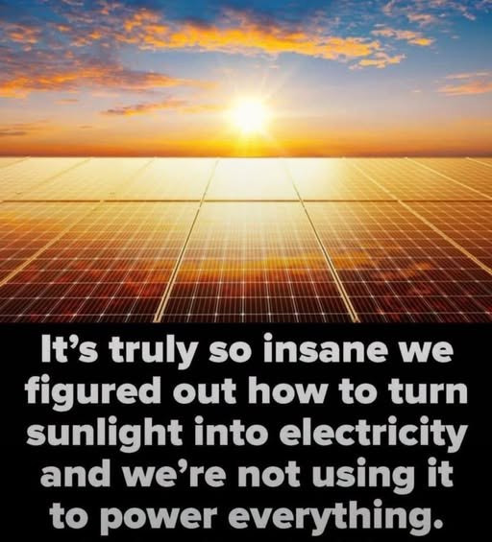
“We figured out how to turn sunlight into electricity—and we’re not using it to power everything.”

The remarkable opportunity above our heads
Every morning, sunlight reaches rooftops, parking lots, fields, and communities across the planet. Solar panels can convert part of that light directly into electricity without burning fuel at the point of generation. The image captures a powerful question: if we have learned to harvest such an abundant resource, why are we still so dependent on costly and polluting energy systems? The answer is not that solar power lacks promise. It is that transforming an entire energy system takes engineering, investment, and deliberate public choices.

The infrastructure is already around us
A solar future need not begin by covering untouched landscapes with panels. Homes, schools, hospitals, warehouses, factories, and parking canopies offer enormous opportunities to generate electricity near where it is consumed. Rooftop installations can reduce the need for new land; parking canopies can provide shade while generating power. Large solar farms also have an important role, especially where transmission connections and land-use conditions are favorable. The sensible approach is not rooftop solar versus utility-scale solar. It is to use both intelligently.

Why solar cannot power everything by itself—yet
Sunlight changes by hour, season, weather, and location. Electricity demand does not always follow the same pattern. That makes batteries, long-duration storage, stronger transmission lines, flexible demand, and complementary power sources essential. Heating, industrial processes, aviation, and some heavy transport also require technologies beyond simply placing panels on roofs. Solar can become a much larger share of the energy mix, but dependable round-the-clock power requires an integrated system rather than a single device.

The economic case for abundant energy
Once built, solar systems require no purchased sunlight. That can reduce exposure to volatile fuel prices and provide predictable generation costs over many years. Yet panels, installation, financing, maintenance, storage, and grid upgrades all have real costs. The objective should be lower total system costs—not the misleading claim that electricity becomes literally free. Well-designed public investment, competitive procurement, and fair grid rules can help more households and businesses share in the savings.

Energy independence begins locally
Schools could produce electricity for classrooms. Hospitals could combine solar with batteries and backup generation to improve resilience. Communities could develop shared solar for renters and households whose roofs are unsuitable. Rural cooperatives could expand access, while commercial buildings could turn unused roof space into productive infrastructure. Local ownership and community benefits should be part of the design, not an afterthought.

A practical national strategy
First, map suitable rooftops, parking areas, brownfields, and other developed spaces. Second, streamline permitting while maintaining safety and building standards. Third, modernize distribution networks and expand transmission where necessary. Fourth, invest in storage, workforce training, domestic manufacturing, recycling, and responsible mineral supply chains. Fifth, design financing so low-income households and small businesses can participate rather than leaving the benefits only to property owners with capital.

From scarcity thinking to abundance engineering
The central challenge is no longer whether sunlight can be turned into electricity. We have demonstrated that it can. The challenge is building a system that delivers clean power reliably, affordably, and equitably—on sunny afternoons and cold nights alike. That is an engineering problem, a policy problem, and an opportunity for cooperation. We should treat it with the urgency and imagination it deserves.

Conclusion: Put the sunlight to work
The image is provocative because its underlying intuition is right: humanity has discovered an extraordinary tool, and we have only begun to use its potential. We should not pretend solar energy alone solves every energy problem. We should recognize that combining solar with storage, modern grids, and complementary technologies can move us toward a cleaner and more abundant future. The sun is already shining. Our task is to build the systems that make its benefits available to everyone.
Terra Nova Development | Vision article | November 2026

