The Real People’s Movement
From division to shared purpose • A Terra Nova Development vision
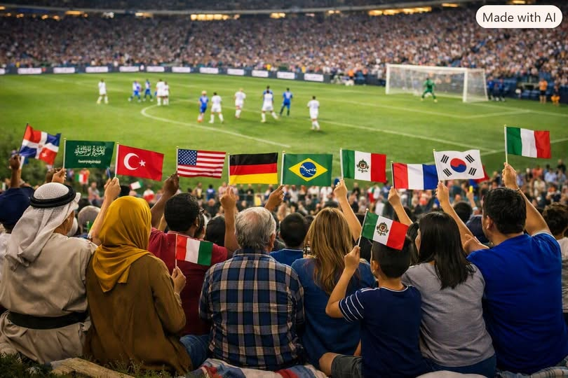

A Movement Built on Shared Purpose
A true people’s movement will not rise from anger or division. It will rise from shared purpose — from solutions that every human being can recognize as good for the country and good for the world.
Put down your weapons. The era of “us versus them” has run its course. For decades, that cry has fueled conflict, fear, and exhaustion. But the truth is simple: there is no “them.” There is only us — one species, one planet, one destiny.

Understanding the Past Without Living in It
We must recognize why the world produced the inequities and dysfunctions of the past — not to dwell in guilt or resentment, but to understand the systems that shaped them. Those systems were born of fear, scarcity, and separation. They taught humanity to compete for survival instead of cooperate for abundance. But that era can end.
Understanding injustice does not require forgetting it. It gives us a foundation for repair, accountability, and the possibility of reconciliation.

Abundance as a Shared Project
Abundance is not merely a dream; it is a possibility waiting to be unlocked through technology, human ingenuity, and fair access to the essentials of life. We already possess extraordinary productive capacity. The challenge is to organize our institutions so that its benefits reach everyone.
As we build that future, we can make room for forgiveness without demanding that anyone surrender their history or their claim to justice. We can release bitterness and blame while still repairing the damage left by exclusion and inequality.

The Meaning of Freedom
This is the path toward fuller freedom — freedom from the invisible constraints of fear, hierarchy, and false separation. Many of the chains that limit human potential are psychological, spiritual, economic, and systemic. They can be challenged and changed.
Freedom is more than the absence of restraint. It is the real ability to learn, participate, create, belong, and live with dignity.

A Revolution of Cooperation
The next revolution need not be about overthrowing; it can be about unifying. It can build a world where cooperation complements healthy competition, empathy replaces fear, and abundance is shared rather than hoarded.
That work begins locally: neighbors helping neighbors, communities creating opportunities, and institutions measuring success by the well-being they make possible.

The Future Is a Garden
The future is not a battlefield. It is a garden — and it belongs to everyone.
We will grow it not by declaring enemies, but by making room for one another and doing the patient work of building systems worthy of the human family.

