  - TERRA NOVA DEVELOPMENT • ARTICLE #060

Why Medicare for All in the United States Could Outperform Canada’s System
Shorter waits and better care are possible—but they require deliberate investment.
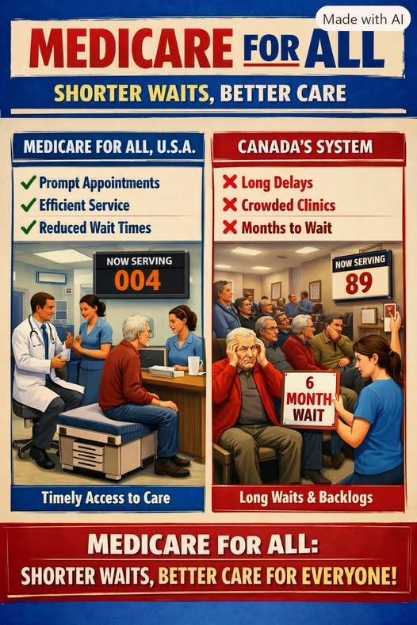
Author-provided AI-generated advocacy illustration. Its wait-time and queue comparisons are illustrative, not measured statistics.

Introduction: The Canada Comparison Is Not Destiny
Opponents of Medicare for All often invoke Canadian wait times as a warning. Canada does face significant delays for some elective specialist visits and procedures, but that does not prove that universal coverage inevitably produces long waits. Waiting times depend on workforce capacity, equipment, scheduling, financing, and how care is organized.
The United States should learn from Canada’s strengths and shortcomings—not assume that adopting universal coverage would reproduce its precise system. A U.S. Medicare for All program could be designed to preserve clinical capacity, reduce insurance-related friction, and expand timely access. It would not guarantee shorter waits automatically.

1. Capacity: Build on Existing Strengths
The United States has a large network of hospitals, specialist practices, ambulatory surgical centers, medical schools, and advanced technology. It also has important shortages, especially in primary care, nursing, rural health, and certain specialties. Comparing countries requires per-capita measures rather than raw totals; the U.S. does not lead Canada on every measure.
Medicare for All could make better use of existing facilities by removing coverage and network barriers. To shorten queues, however, reform must also fund staffing, operating capacity, and access in underserved communities.

2. Hospital Payment Is a Design Choice
Canadian provinces commonly use global hospital budgets. Those budgets can encourage cost discipline but may also constrain expansion if funding fails to keep pace with demand. U.S. Medicare for All proposals are not necessarily fee-for-service systems: prominent bills have also proposed global operating budgets for hospitals.
The policy choice is not simply ‘Canada’s caps’ versus ‘unlimited American payments.’ It is how to set budgets, fund capital investment, measure access, and respond quickly when demand rises.

3. Train and Retain More Care Professionals
The United States has a substantial medical training infrastructure, but residency funding, clinician burnout, geographic maldistribution, and workforce shortages remain real limits. A universal payer would not, by itself, create additional specialists.
A successful reform should expand training opportunities where needed, support nurses and home-care workers, reduce unnecessary administrative tasks, and offer incentives to serve rural and underserved areas.

4. Remove Insurance Barriers Without Ignoring Clinical Queues
Americans experience delays from prior authorization, restricted networks, denials, affordability, and the difficulty of finding a participating clinician. A single national coverage framework could reduce several of those barriers and allow people to seek needed care sooner.
But scheduling delays also reflect clinician availability and demand. Eliminating insurance paperwork would be valuable; claiming it would make all waiting disappear goes beyond the evidence.

5. Use America’s Health Spending More Effectively
The United States spends far more on health care per person than Canada while still leaving people uninsured or underinsured. That gives reformers an opportunity to redirect resources from fragmented administration and high prices toward care delivery.
Savings estimates depend on assumptions about provider payment rates, drug prices, utilization, and implementation. Greater national spending capacity alone does not guarantee shorter waits or better outcomes.

6. Lower Prices, Not Necessarily Every Price in the Economy
A unified purchaser could negotiate drug prices, simplify billing, and restrain excessive charges. Those changes could reduce national health spending relative to current projections and ease household financial pressure.
That is different from promising economy-wide deflation or an automatic annual savings figure. Credible estimates vary; any claimed trillion-dollar savings projection should be traced to its specific study, year, and assumptions.

7. Preserve Innovation While Broadening Access
The United States has a powerful medical research and biotechnology ecosystem. Medicare for All need not eliminate private drug development, medical-device companies, or clinical innovation. Public funding and private research already coexist in American medicine.
Payment and pricing reforms should be designed to reward useful advances while making proven treatments affordable and widely available.

8. Learn from Canada—and Improve on Both Systems
Canada demonstrates that universal coverage can protect people from many physician and hospital bills. It also shows the importance of monitoring specialist waits, diagnostic capacity, staffing, and timely access. The United States has its own weaknesses: medical debt, uneven coverage, administrative complexity, and barriers tied to employment and income.
The strongest American approach would combine universal financial protection with explicit access standards, transparent wait-time reporting, investments in capacity, and accountability for outcomes.

Conclusion: Better Is Possible, Not Automatic
Medicare for All would not have to turn the United States into Canada. It could preserve American clinical and research strengths while correcting the coverage gaps and insurance bureaucracy that burden patients and providers today.
The case for reform is strongest when it promises what policy can plausibly deliver: universal coverage, simpler administration, greater bargaining power, and a fairer foundation for care—paired with concrete investments to make appointments, treatments, and long-term support available when people need them.

A Note on Evidence
This article is a policy argument, not a forecast of guaranteed wait times. International physician, equipment, and surgery comparisons vary by year and definition. The illustration is conceptual and should not be cited as evidence. For current comparisons, consult OECD Health at a Glance, the Canadian Institute for Health Information, and the Commonwealth Fund; for U.S. legislative designs, consult the actual Medicare for All bill texts on Congress.gov.

