The Abundance Model of Child Care
  - A 24/7, No-Enrollment, No-Residency Public System for Every Family
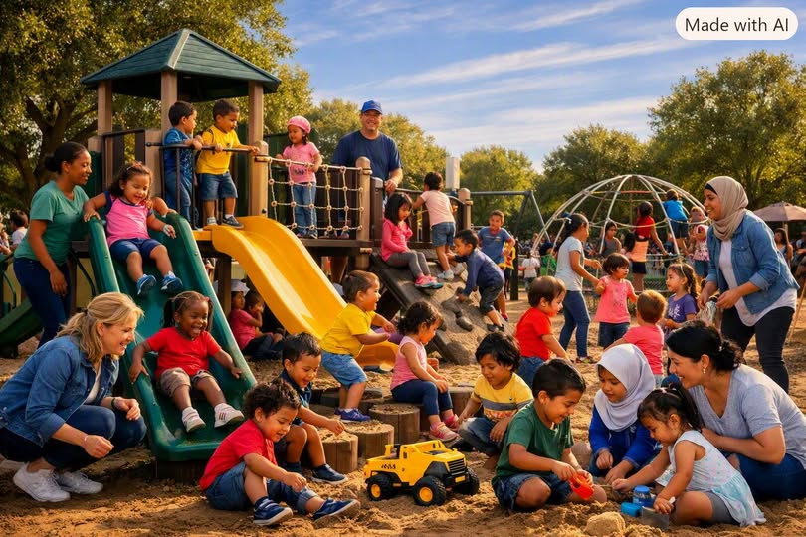
Concept illustration of an inclusive community child-care environment.
In a society still shaped by artificial scarcity, child care remains one of the most rationed, expensive, and stressful necessities of modern life. Families navigate waiting lists, income tests, residency rules, and bureaucratic hurdles simply to secure a safe place for their children. Yet the truth is simple: the infrastructure already exists, the need is universal, and the barriers are entirely human-made.
The abundance model of child care begins with a single premise: every child deserves safety, and every parent deserves support — without conditions. This is not charity. It is not welfare. It is not a selective benefit. It is public infrastructure, as essential as fire stations, libraries, and schools.
This essay outlines a system built on that premise: 24/7 child care integrated into existing public school districts, available to anyone at any time, with no enrollment, no residency requirement, and no eligibility screening — safeguarded only by proper identification to prevent abuse.

I. The End of Artificial Scarcity in Child Care
For decades, child care has been treated as a private burden rather than a public responsibility. Families are forced to navigate:
- prohibitive costs
- limited hours
- rigid eligibility rules
- long waiting lists
- inconsistent quality
- unpredictable availability
These barriers are not natural. They are artifacts of a scarcity-based system that assumes care must be rationed.
But abundance tells a different story.
Public school districts already possess:
- buildings
- kitchens
- playgrounds
- transportation networks
- security systems
- administrative staff
- maintenance crews
These assets sit idle for most of the day and nearly all of the night. The abundance model simply activates what already exists.

II. A 24/7 System Built on Existing Public Infrastructure
Under this approach, school districts opt in to offer round-the-clock child care using their existing facilities. Classrooms become early-learning spaces after hours. Gyms become play areas. Libraries become quiet rooms. Cafeterias become nutrition hubs.
The system operates:
- 24 hours a day
- 7 days a week
- 365 days a year
Because life does not operate on a 9-to-5 schedule.
Parents working night shifts, emergency responders, gig workers, single parents, and families facing unexpected crises all gain access to reliable, safe, wholesome care whenever they need it.
This is not a luxury. It is a recognition of reality.

III. No Enrollment. No Residency. No Eligibility.
The most radical — and most humane — feature of the system is its openness.
There is:
- no enrollment process
- no residency requirement
- no income test
- no employment verification
- no citizenship screening
- no paperwork
If a parent or guardian needs child care, they simply walk in.
If a family is visiting from out of town, they can use it.
If a parent needs a few hours to rest, recover, or breathe, they can use it.
If someone wants a safe place for their child while they enjoy a night out, they can use it.
Child care becomes a public right, not a conditional privilege.

IV. The Only Caveat: Proper Identification to Prevent Abuse
In a system with no barriers, one safeguard remains essential: identity verification of the adult dropping off and picking up the child.
This is not enrollment.
This is not screening.
This is not gatekeeping.
It is simply a safety measure — the same principle used in hospitals, schools, and emergency shelters.
Proper identification:
- prevents unauthorized pickups
- protects children in custody disputes
- deters trafficking and exploitation
- ensures accountability
- allows staff to respond in emergencies
The ID is checked at the moment of drop-off and pick-up.
No files. No dossiers. No bureaucratic tracking.
Just safety.
This single caveat preserves the integrity of the system without undermining its universality.

V. Wholesome, Safe, and Emotionally Supportive
The abundance model is not a warehouse for children. It is a community extension of childhood — designed to be:
- warm
- playful
- social
- enriching
- predictable
- emotionally supportive
Children enjoy being there.
Parents trust it.
Families rely on it.
It becomes a place where children learn, rest, play, and grow — not merely a holding area.

VI. Staffing and Workforce Development
Districts partner with:
- community colleges
- universities
- early-childhood programs
- nursing and social-work programs
Workers are:
- well-paid
- unionized
- professionally trained
- supported with benefits
- given career ladders
This creates a stable, respected workforce — not the high-turnover, low-wage model that dominates private child care today.

VII. The Slow Freight Train of Abundance
This system embodies the transition you’ve described so often: the slow, unstoppable freight train of abundance trampling artificial scarcity.
It begins with a few districts opting in.
Families use it.
Demand grows.
Success becomes visible.
More districts join.
The culture shifts.
The system expands.
Not through mandate.
Not through force.
But through proof of concept.
It is long overdue.
It is inevitable.
It is humane.
It is pragmatic.
It is abundance made real.

VIII. A New Social Contract for Families
In this model, society finally acknowledges what has always been true:
Children are not private burdens.
Parents are not isolated units.
Care is not a commodity.
Safety is not conditional.
Support is not earned.
Child care becomes what it should have always been:
a public good, freely available, universally accessible, and grounded in the simple belief that every child deserves safety and every parent deserves rest.

