THE WORLD BEYOND MONEY
A Terra Nova Development Reflection on Abundance, Cooperation, and Human Freedom
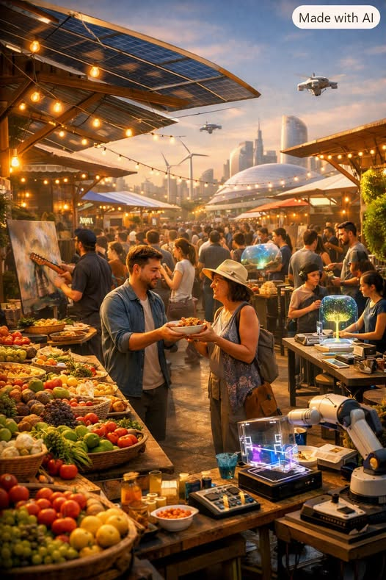
Imagine a world where money no longer defines the rhythm of life — where the exchange of paper and digits gives way to the exchange of purpose and creativity. This world is not fantasy; it is forming quietly beneath the surface of our current one, like a freight train rolling through the night — slow, unstoppable, and long overdue.
For centuries, humanity has lived under the illusion of scarcity. We were taught that there isn’t enough for everyone, that survival demands competition, and that value must be measured in currency. Yet abundance has always been here, waiting to be recognized. The Earth produces more food than we can eat, technology can automate nearly every necessity, and knowledge spreads faster than any gatekeeper can contain it. Artificial scarcity — the deliberate throttling of access, the monetization of essentials — is the last defense of a system built on limitation.
As abundance rises, the logic of money begins to crumble. When energy is renewable, when production is automated, when distribution is intelligent, the cost of creation falls toward zero. What remains is not price, but participation. People contribute because they can, not because they must. Work becomes expression, not survival. Art, science, and care flourish because they are no longer bound by profit.
The transition will not be sudden. It will move like that freight train — grinding through resistance, shaking the foundations of old institutions, and forcing humanity to rethink what “value” means. Those who cling to scarcity will see chaos; those who embrace abundance will see liberation. The shift will be messy, but inevitable.
In this new world, wealth is measured in connection, creativity, and compassion. The marketplace becomes a meeting place, not a battleground. Ownership transforms into stewardship. The idea of “earning the right to live” fades into history, replaced by the understanding that life itself is the right.
Few can see this world clearly yet, but it is coming — carried by technology, cooperation, and the simple truth that there is enough for everyone. The age of scarcity is ending. The age of abundance is arriving, and with it, humanity’s long-delayed freedom.

