The Effect of Medicare for All on Social Security Disability (SSDI)
A Terra Nova Development Policy Reflection
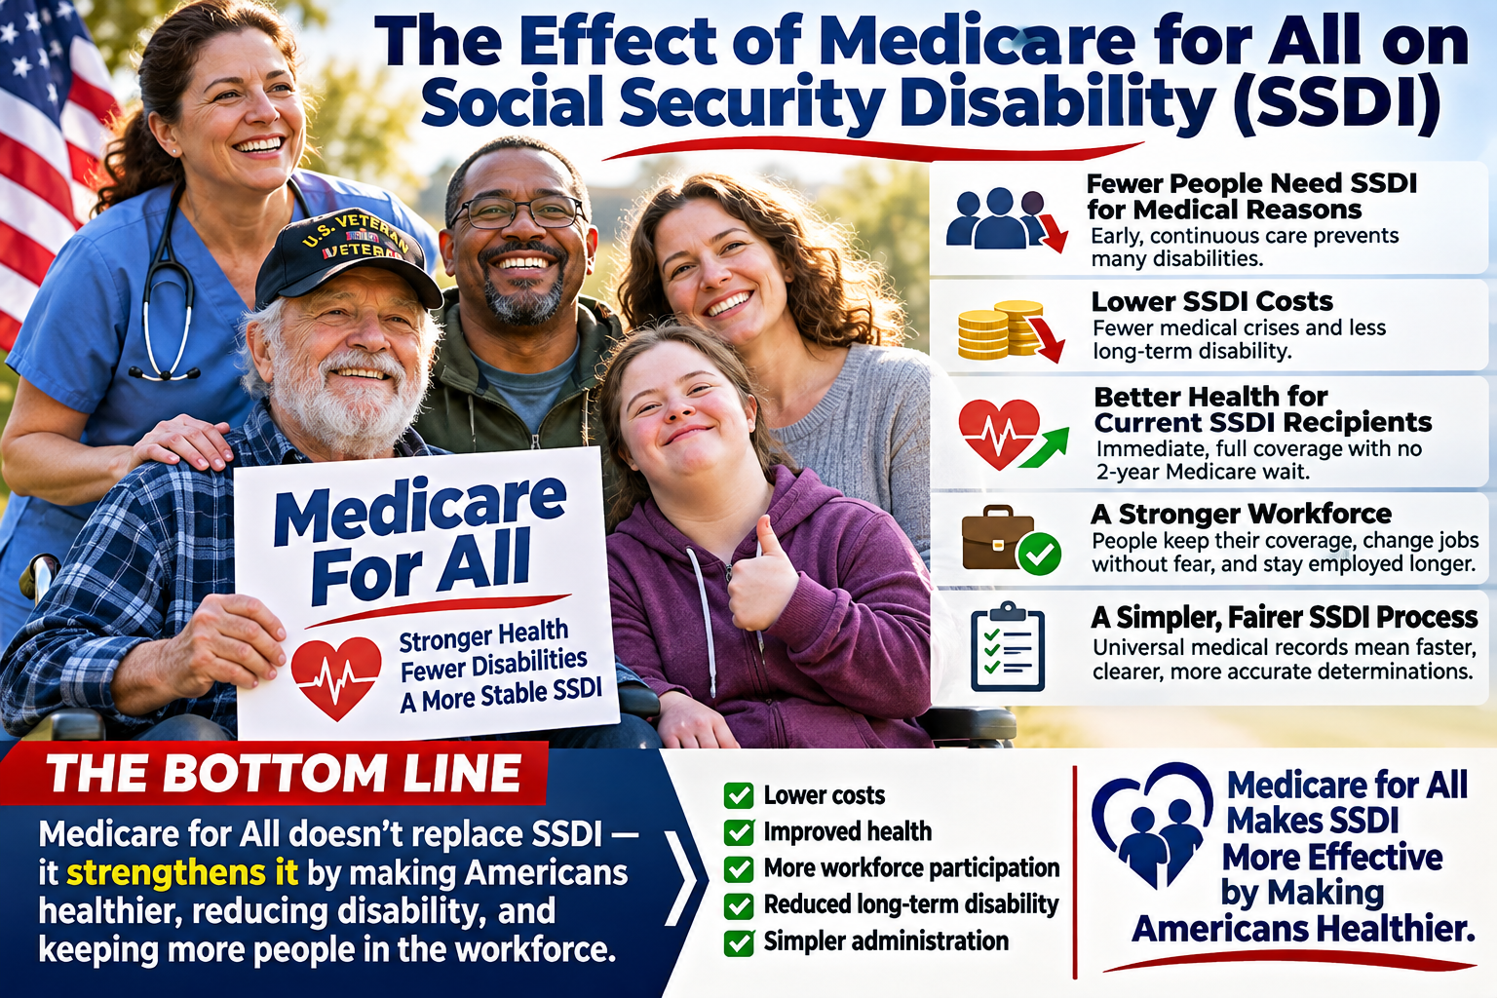
Concept illustration: potential effects of universal health coverage on SSDI; outcomes depend on policy design and evidence.

Introduction
Medicare for All could have important effects on Social Security Disability Insurance (SSDI), not by abolishing the program, but by changing access to healthcare before and after a person becomes disabled. SSDI is an income-replacement benefit for eligible workers whose medically determinable impairments prevent substantial gainful activity under Social Security rules. Health insurance and disability income serve different purposes.

1. Preventing avoidable disability
Continuous access to primary care, medications, specialists, mental healthcare, and rehabilitation could prevent some illnesses and injuries from progressing to disabling conditions. Earlier treatment of diabetes, cardiovascular disease, chronic pain, and mental health conditions may help some people remain employed. However, not every disability is preventable, and SSDI eligibility is not simply a consequence of lacking medical insurance.

2. Potential effects on SSDI enrollment and costs
If better access to treatment reduces the incidence or severity of work-limiting conditions, SSDI applications and long-term benefit spending could fall relative to what they otherwise would have been. The size and timing of any savings are uncertain. Universal coverage would also require public financing, so changes in SSDI spending alone would not establish the overall fiscal impact of Medicare for All.

3. Better continuity of care for people receiving SSDI
Many SSDI beneficiaries generally become eligible for Medicare after a 24-month waiting period tied to disability benefit entitlement, although important exceptions exist, including for ALS and certain kidney-failure cases. A Medicare for All system with immediate universal eligibility could remove this coverage delay and reduce interruptions in treatment. Whether premiums, deductibles, provider restrictions, or particular denials disappear would depend on the enacted legislation.

4. Benefits for workers and employers
Separating health coverage from employment could allow workers to change jobs, reduce hours, pursue rehabilitation, or return to work without fearing the loss of insurance. Employers could face less complexity in managing health benefits. These changes might improve workforce participation and reduce some pathways into long-term disability, though employment outcomes would also depend on accommodations, job conditions, and the severity of impairments.

5. Clearer disability determinations
Reliable access to clinicians and diagnostic testing could improve the completeness of medical evidence available to Social Security disability adjudicators. Better documentation might make some decisions more timely and accurate. It would not eliminate the need for independent disability determinations, privacy safeguards, appeals, or careful evaluation of functional limitations.

The Bottom Line
Medicare for All would not replace SSDI. It could complement the program by improving access to care, helping some people avoid preventable disability, and supporting those who already receive benefits. Reduced SSDI enrollment, lower costs, and faster determinations are plausible goals—not guaranteed results. The central proposition is straightforward: a healthcare system that treats illness earlier may help more Americans stay healthy and remain connected to work, while SSDI continues to protect those who cannot.
Policy note: This article presents a proposed reform and potential outcomes, not a projection of enacted law or a quantified cost estimate.

