  - TERRA NOVA DEVELOPMENT | ARTICLE #105

Automation and the End of Artificial Scarcity
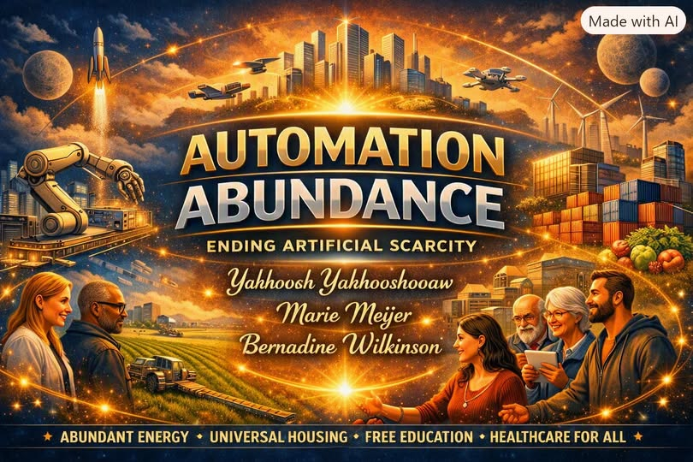
Human civilization stands at the threshold of a transformation so profound that it redefines the meaning of wealth, labor, and survival. Automation — the fusion of robotics, artificial intelligence, and digital networks — has created a bounty of goods and services unprecedented in history. Machines now perform tasks once reserved for human hands and minds, producing abundance at scales that defy the old logic of scarcity. Yet poverty persists. Hunger persists. Inequality persists. The contradiction is not technological; it is systemic. Scarcity today is not a reflection of what humanity lacks, but of what our institutions refuse to recognize.

I. The Myth of Scarcity
For centuries, economics has been built on the assumption that resources are limited and human desires infinite. This assumption justified competition, hierarchy, and control. But automation has shattered that foundation.
- Food production can feed billions with precision agriculture.
- Manufacturing can produce goods with near-zero marginal cost.
- Digital systems replicate knowledge infinitely.
Material scarcity has ended in principle — yet our systems continue to behave as if it were eternal. The result is artificial scarcity: a deliberate throttling of abundance through outdated laws, monopolies, and financial structures that reward limitation over liberation.

II. The Broken Systems
Our institutions — economic, political, and bureaucratic — were designed for a world of manual labor and limited production. They have not caught up to the reality of automated abundance.
- Markets still price goods based on human labor, even when machines do the work.
- Ownership models concentrate wealth rather than distribute access.
- Governments measure success by growth, not by sufficiency.
Automation has outpaced ideology. The systems that once managed scarcity now manufacture it.

III. The Economics of Abundance
When systems evolve to match technological reality, scarcity dissolves.
- Energy becomes infrastructure, not commodity.
- Housing becomes universal, not speculative.
- Healthcare becomes a right, not a privilege.
- Education becomes open, not gated.
In such a world, poverty is not solved — it is rendered impossible. The end of scarcity is not the end of economics; it is the birth of a new economics based on distribution, creativity, and stewardship rather than extraction and competition.

IV. The Human Transition
The challenge is not producing abundance — it is learning to live within it. Automation frees humanity from necessity, but it also demands a new definition of purpose. Work will shift from survival to creation, from repetition to imagination. The measure of value will no longer be hours worked, but ideas shared and lives improved.
This transition will be resisted by those who profit from scarcity. But history shows that systems built on false premises eventually collapse under their own contradictions. The feudal order fell when land ceased to define power; the industrial order will fall when labor ceases to define value.

V. The Future Beyond Lack
Automation is not the enemy of humanity; it is the liberation of humanity from the tyranny of need. Once our systems catch up to reality, all lack and poverty will end — not through charity, but through structural coherence.
The future will not be defined by what we own, but by what we share.
Not by competition, but by collaboration.
Not by scarcity, but by sufficiency.
Automation has already given us the tools. What remains is the courage to redesign the systems that govern them.

