  - TERRA NOVA DEVELOPMENT | ARTICLE #102

Give & Take Community Centers: A Pathway to Economic Freedom for Every American
  - How sharing the abundance we already possess could transform poverty, reduce the cost of living, and create a new foundation of economic freedom throughout the United States.
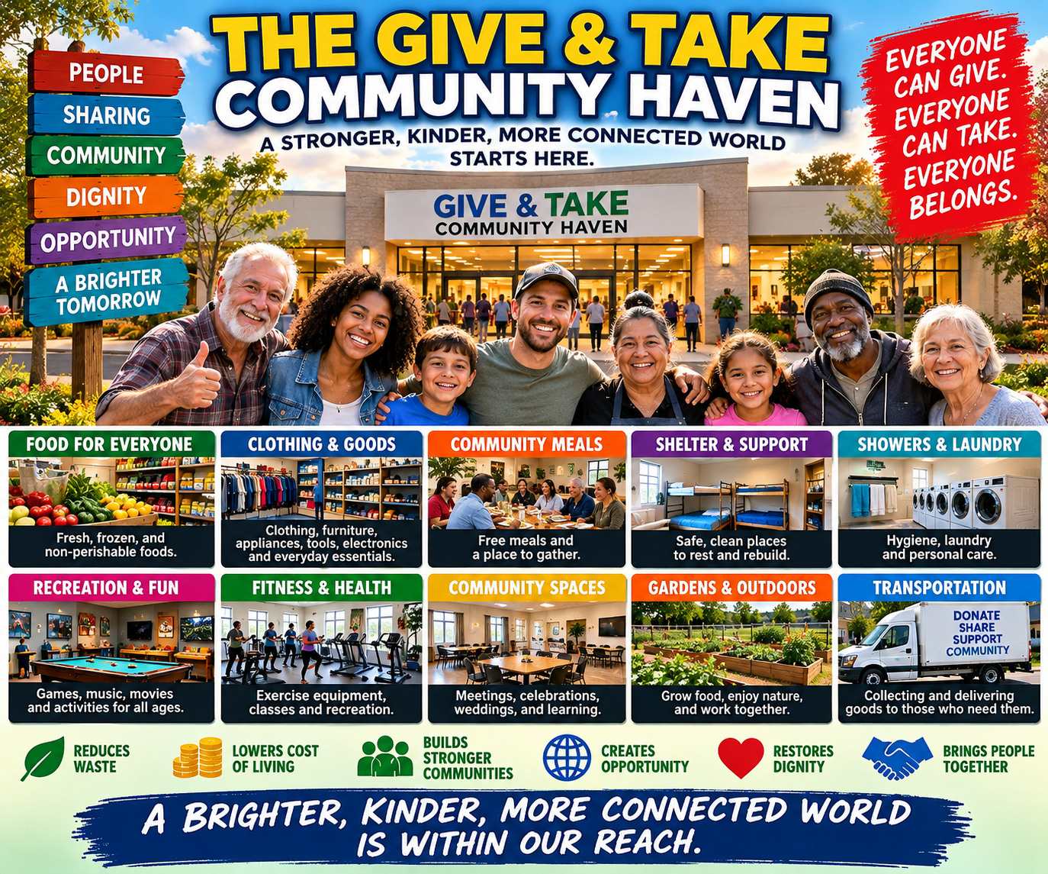

Introduction: Economic Freedom Begins With Freedom From Necessity
Imagine an America where no family worries about having enough food, where clothing and household necessities are freely available, where useful goods are shared instead of discarded, and where every community has a welcoming place that anyone can enter without reaching for a wallet.
Imagine a country where losing your job does not immediately threaten your family’s ability to survive. Where a retired person on Social Security can obtain everyday necessities without sacrificing other needs. Where young families can save money for a home instead of spending every available dollar simply maintaining their lives. And where people experiencing homelessness have a safe place to eat, shower, rest, recover, and begin rebuilding their independence.
This is the vision behind Give & Take Community Centers, an essential component of Terra Nova Development’s broader Community Haven initiative. But these centers could accomplish something much larger than providing assistance to people in need. They could help establish a new foundation for economic freedom in the United States.
The central principle is remarkably simple: The less money people must spend to meet their basic needs, the more economically free they become. Much of the abundance necessary to begin this transformation already exists.

1. America Has an Abundance Problem — But Not the One We Think
America is one of the most productive societies in human history. Our farms produce immense quantities of food. Our factories manufacture furniture, appliances, clothing, tools, and countless household products. Our businesses maintain sophisticated networks capable of delivering goods virtually anywhere in the country.
Yet millions of Americans struggle to obtain the necessities of everyday life. Food is discarded while families are hungry. Usable furniture is thrown away while people live in nearly empty apartments. Clothing accumulates in closets while families struggle to outfit their children. Commercial buildings sit vacant while communities lack welcoming gathering places and facilities for people who need assistance.
The problem is not simply that we produce too little. It is that our systems for connecting available resources with human needs are incomplete. Give & Take Community Centers offer a practical way to improve those connections.
Instead of allowing usable resources to remain idle or become waste, we can organize their voluntary recovery and redistribution. This does not require confiscating anyone’s property or eliminating private enterprise. It requires creating a convenient, dependable system through which people and businesses can share what they willingly contribute.

2. A Store Where Everything Is Free
Imagine walking into a large, clean, well-organized community center. It resembles a modern department store. There are sections for groceries, clothing, shoes, furniture, kitchen supplies, children’s toys, school supplies, books, tools, and household appliances.
The shelves are organized. The merchandise is inspected. Friendly volunteers and employees help visitors locate what they need. But there is one extraordinary difference: Nothing has a price tag.
There is no cash register, no checkout payment, no credit-card requirement, no income qualification, and no requirement to donate something before receiving something. People simply select what they need from the goods available, subject to reasonable sharing limits when supplies are scarce.
Someone might bring boxes of clothing that their children have outgrown. Another person might donate a working microwave oven. A local supermarket might contribute safe, unsold groceries. A furniture company might donate discontinued inventory. A family moving into its first apartment might obtain dishes, bedding, furniture, and other essentials.
The people donating and receiving need not be separated into different categories. Everyone belongs to the same community. This is the Give & Take philosophy: Take what you need. Give what you can. Everyone belongs.

3. The Economic Revolution: Reducing the Cost of Living Without Reducing the Quality of Life
Consider what happens when a family can obtain a meaningful portion of its everyday necessities without spending money. Suppose a household ordinarily spends $800 per month on groceries, clothing, household supplies, and other purchases that might be partially supported by a Give & Take Center.
If available donated goods allow that family to avoid $200 in monthly purchases, the result is $2,400 more financial flexibility each year. Less dependence on credit cards, more money available for rent or mortgage payments, greater ability to handle emergencies, and more opportunity to save, invest, or pursue education.
The family has not necessarily received a raise. Its income has not changed. But its effective purchasing power has increased.
Economic freedom can expand not only by increasing income, but also by reducing the amount of income required to live. A nationwide network of Give & Take Centers could multiply this benefit across millions of households.
The savings would vary according to the supply of donated goods, local participation, and individual circumstances. But every dollar of necessary spending avoided can create additional financial breathing room. Rather than measuring prosperity exclusively by how much money people earn, we could begin measuring it by how securely people can meet their needs.

4. Economic Freedom Is More Than Having a Job
Americans often define economic freedom in terms of employment, entrepreneurship, private ownership, and the opportunity to earn money. Those freedoms are important.
But consider the person who must remain in an abusive workplace because missing a paycheck would mean losing housing. Consider the parent working two jobs who has no time to raise their children. Consider the retiree who cannot afford both adequate nutrition and necessary medication. Consider the person who wants to start a small business but cannot risk losing a dependable income.
These people may possess formal economic rights while having very little practical freedom. Their choices are constrained by the immediate necessity of survival.
Give & Take Community Centers could help reduce those constraints. If food, clothing, household necessities, and some community services become more accessible, people gain additional room to make decisions about their lives. They may be better able to pursue education, change jobs, care for family members, volunteer, or begin new enterprises.
Economic freedom becomes more meaningful when basic survival requires less financial struggle.

5. A New Role for American Businesses
Give & Take Centers should not be understood as opponents of business. They could become valuable partners with American businesses.
Every day, retailers, manufacturers, wholesalers, restaurants, supermarkets, and distributors encounter products that can no longer be sold profitably. Some have damaged packaging, are discontinued or seasonal, or are surplus inventory. Others are returned items that remain perfectly usable after appropriate inspection.
Businesses must decide whether to store, discount, liquidate, recycle, or discard these goods. A Give & Take network creates another possibility: Donate suitable products to the community.
A national system of participating centers could organize scheduled collections, sorting facilities, inventory management, and redistribution. Businesses could potentially benefit from reduced disposal costs, responsible surplus management, stronger community relationships, and documented charitable contributions where legally applicable.
At the same time, households would gain access to goods they might otherwise be unable to afford. Not every product can be donated safely or economically. Food handling, recalls, product safety, transportation, and storage would require proper procedures.
But a well-managed system could recover substantial value from goods that are currently underused. This is not an attack on private enterprise. It is an opportunity for private enterprise and community organizations to cooperate.

6. From Give & Take Centers to Complete Community Havens
The Give & Take concept can begin almost anywhere: a few shelves inside a church, a small room donated by a business, a sheltered sharing area in a suitable, well-lit location, a vacant storefront, or eventually an unused supermarket or department store.
As participation and reliable funding grow, a Give & Take Center could expand into a complete Community Haven.
A larger center might provide free groceries, clothing, furniture, and household goods; a community kitchen serving nutritious meals; showers, restrooms, and laundry facilities; computers, internet access, and educational resources; recreation, fitness, and community gathering spaces; job training and employment assistance; connections to medical care and social services; assistance obtaining identification, benefits, and housing; and safe temporary accommodation at properly equipped 24-hour facilities.
The long-term goal is not simply to distribute donated products. It is to create a dependable community infrastructure that helps people remain stable, connected, and capable of participating in society.
A full Haven would require professional staffing, safety procedures, adequate funding, and compliance with applicable laws. Smaller Give & Take operations could begin with far fewer resources. Each community could develop the level of service its circumstances permit.

7. The Hidden Economic Value of Preventing Crisis
Much of America’s public and private spending occurs after people’s circumstances have already become emergencies. A family that cannot afford groceries may fall behind on rent. A person who loses stable housing may struggle to maintain employment. Someone without a safe place to rest may experience worsening health and additional barriers to recovery. A household without basic appliances, clothing, or transportation may find ordinary daily tasks increasingly difficult.
These problems can reinforce one another. Give & Take Community Centers could intervene earlier.
Providing food and essential household goods may help a family remain financially stable. A community kitchen can reduce immediate hunger. Laundry and shower facilities can help people maintain hygiene and employment readiness. Internet access can help people apply for jobs, obtain information, and communicate with service providers. Stable temporary shelter can make it easier to seek permanent housing.
These services would not eliminate every cause of poverty or homelessness. But they could prevent some manageable problems from becoming more costly emergencies. A well-designed pilot program should measure such effects rather than assume them.
The potential savings could include reduced waste, fewer crisis interventions, and improved household stability. Preventing hardship can be both more humane and more economical than responding after hardship becomes a disaster.

8. From Charity to Mutual Participation
Traditional charity often divides society into two categories: Those who give and those who receive. Give & Take Centers challenge that distinction.
The person receiving groceries today may donate furniture tomorrow. A retired electrician might volunteer to repair appliances. A teacher could offer tutoring. A restaurant owner might donate surplus food. A teenager might help organize donated books. A person experiencing homelessness might volunteer in the community kitchen. A wealthy family might donate supplies while also attending a neighborhood celebration at the center.
Nobody must contribute equally. Nobody should be required to work in exchange for basic necessities. Participation is voluntary, and people contribute according to their abilities and circumstances.
The center becomes a place where everyone can give something of value and where everyone is equally welcome. This creates something that money alone cannot purchase: A sense of belonging.
The most important transformation may ultimately be cultural rather than financial. Instead of asking whether a person is deserving of assistance, we begin asking what our community can accomplish together.

9. A Network in Every American Community
Imagine Give & Take Centers spreading across the United States. A small rural town might operate a shared room in a church. A suburban neighborhood might have a free household-goods center. A larger town might support a former grocery store converted into a community marketplace. A major city might maintain several Community Havens offering meals, hygiene facilities, recreation, shelter, and connections to housing.
Centers could share operating practices and coordinate donations. If one facility receives an excess of winter clothing while another needs it, the goods could be transferred. If a manufacturer wishes to donate thousands of useful items, a regional network could help distribute them.
If a community develops an effective volunteer scheduling system, its experience could benefit other locations. Modern inventory software, online coordination, and transportation systems could help connect centers without requiring every location to develop its own administrative infrastructure.
Over time, these centers could form a national network of voluntary sharing. Each location would remain responsive to local needs while benefiting from the strength of cooperation.

10. Beginning Without Waiting for Washington
Perhaps the most attractive feature of Give & Take Centers is that they do not require Congress to establish an entirely new national program before the first one can open.
A neighborhood could begin tomorrow. A business owner might offer a little unused space. Several residents might organize donated shelves and tables. A church might provide volunteers. A supermarket might establish a modest food donation partnership. Local residents could contribute clothing, books, household supplies, and other safe, usable goods.
The first operation might serve only a few dozen households. But it could demonstrate that a community can establish an organized system of voluntary sharing at relatively low cost.
As participation grows, the organizers could document quantities of goods redistributed, household savings estimates, operating expenses, volunteer hours, and unmet community needs.
A successful pilot could attract additional businesses, charitable organizations, foundations, and public-sector partners. Eventually, suitable sites might expand into permanent Give & Take Centers.
The objective is not to start with an enormous institution. It is to start with a working system and let demonstrated success justify expansion.

11. Who Pays for a System Where Everything Is Free?
A Give & Take Center distributes goods without charging recipients, but it does not operate without costs. Buildings require utilities and maintenance. Food requires safe handling. Transportation requires vehicles and fuel. Larger centers need trained staff and dependable management. A national network would need accounting, coordination, and operational oversight.
Potential funding sources include charitable contributions, donated facilities, corporate partnerships, private foundations, local government grants, service contracts, and community fundraising.
A modest operation may rely heavily on volunteers and donated space. A comprehensive 24-hour Haven would require a more substantial and reliable budget.
Financial transparency is essential. Communities should know what resources are received, what expenses are incurred, how donated goods are distributed, and what measurable benefits result.
The goal is not to pretend that maintaining a center costs nothing. The goal is to deliver the greatest possible public benefit with the least necessary expenditure.

12. A Pathway Toward Economic Freedom — Not the Elimination of Money
Give & Take Centers are not a proposal to abolish money, confiscate wealth, or eliminate private ownership. People would remain free to own property, operate businesses, earn income, invest, and participate in the traditional economy.
The centers would operate alongside that economy. Their purpose would be to make more of life’s necessities accessible through voluntary sharing.
Over time, the amount of income people must spend on essential goods could decrease. That would leave more income available for other purposes.
People could save more. Families could build emergency reserves. Workers could gain greater flexibility. Retirees could enjoy more financial security. Young people could pursue opportunities that might otherwise be unaffordable. And communities could become less vulnerable to temporary economic disruptions.
This approach would not eliminate the need for adequate wages, affordable housing, healthcare reform, or effective public services. It could complement those efforts by reducing some everyday costs directly.
The objective is not universal dependence on charity. It is greater independence through organized abundance.

13. Measuring Economic Freedom in a New Way
Suppose we measured the success of a community not only by average household income, but also by the cost of obtaining life’s necessities.
How much must a family earn to eat adequately? How much does it cost to furnish a modest home? Can someone obtain appropriate clothing without going into debt? Are basic hygiene facilities available to people without stable housing? Can residents access recreation, education, and community activities regardless of their financial circumstances? How much financial hardship can a community prevent by making useful resources available before a crisis develops?
These questions reflect another way to understand prosperity.
A person who earns $50,000 annually but must spend nearly all of it to survive may have less practical economic freedom than someone with similar income whose community provides dependable access to some basic necessities.
Money remains important. But the relationship between income and essential living costs matters just as much. Give & Take Centers could help improve that relationship.
Their success should be assessed through measurable outcomes: household spending avoided, usable goods recovered, participation, operating costs, community satisfaction, and connections to housing and employment.
Evidence from successful centers would help determine where the model should expand and how it could improve.

14. The Larger Vision: From Scarcity to Organized Abundance
For generations, Americans have largely approached poverty as a problem of insufficient income. People need jobs. They need better wages. They need financial assistance. All of these may be necessary.
But there is another part of the equation that receives far less attention: What if we also reduce the amount of money required to obtain the necessities of life?
What if a significant portion of the goods our economy already produces can be made accessible through organized voluntary sharing? What if every community has a place where neighbors routinely help one another without demanding payment? What if unwanted goods become useful resources instead of waste? What if community participation becomes as ordinary as shopping?
That is the deeper potential of Give & Take Community Centers.
They offer an opportunity to move from a society in which nearly every necessity depends on an individual’s immediate purchasing power toward one in which some necessities can also be obtained through dependable community cooperation.
The transition could begin gradually. It could grow through demonstration and experience. And it could strengthen the economic freedom of people across the income spectrum.

Conclusion: The Freedom to Live Rather Than Merely Survive
Economic freedom should mean more than the opportunity to earn money. It should also mean having enough security to make meaningful choices about one’s life.
The freedom to raise a family. The freedom to change jobs. The freedom to learn. The freedom to create. The freedom to help others. The freedom to grow old without constant fear of destitution.
Give & Take Community Centers cannot accomplish all of these things by themselves. But they could help create the foundation upon which greater freedom becomes possible.
We already possess extraordinary resources. We already have people willing to help. We already have businesses capable of contributing surplus goods. We already have buildings, transportation networks, technology, and organizational knowledge. What we need is a system that connects them.
We do not have to wait until every problem is solved. We can begin with a shelf. Then a room. Then a storefront. Then a Community Haven. Then a network of communities demonstrating that prosperity can mean more than individual purchasing power.
The pathway to economic freedom may begin not with producing more, but with sharing more intelligently what we already have.
Take what you need. Give what you can. Everyone belongs.
There is no them. There is only us.
Terra Nova Development — Building a Better World, Together.

