Article #064 — Solar Panel Efficiency
The Science Behind Solar Power—and Its Potential for Floating Infrastructure
Terra Nova Development | November 11, 2026
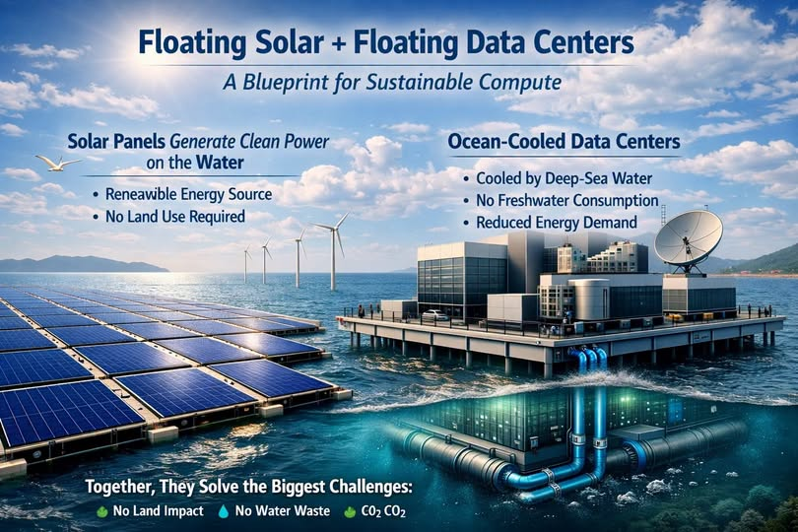
Floating solar arrays and water-cooled data centers offer an intriguing vision of sustainable computing. To evaluate that vision realistically, we first need to understand how efficiently modern solar panels turn sunlight into electricity—and what their ratings do and do not tell us.

How Solar Panel Efficiency Is Calculated
Solar module efficiency is the percentage of incoming solar energy converted into electrical power under defined test conditions. Under Standard Test Conditions (STC), irradiance is 1,000 watts per square meter, cell temperature is 25°C, and the reference solar spectrum is AM1.5.
Efficiency (%) = Rated power (W) ÷ [Panel area (m²) × 1,000 W/m²] × 100
- 400 W ÷ (1.99 m² × 1,000 W/m²) × 100 = 20.1%
- 450 W ÷ (2.205 m² × 1,000 W/m²) × 100 = 20.4%
- 410 W ÷ (1.95 m² × 1,000 W/m²) × 100 = 21.0%
These are illustrative calculations; an actual module’s official rating should be checked against its manufacturer datasheet.

What 20–22% Efficiency Means
Many contemporary commercial silicon modules have efficiencies around 20–22%, while some premium products exceed 23%. The exact range varies by manufacturer, module format, and year. A 22% rating means the module converts approximately 22% of the solar power striking its measured area into electrical output under STC—not that it produces 22% of its rated power all day.

Why Real-World Output Differs
Solar output varies with sunlight intensity, angle of incidence, shading, dirt, temperature, inverter efficiency, wiring, and system design. The 25°C STC temperature refers to the solar cells, not the surrounding air. Panels can become much hotter in ordinary operation.
A typical crystalline-silicon module loses roughly 0.3–0.4% of power per degree Celsius of cell temperature above 25°C, although the exact temperature coefficient depends on the product. For example, a 20°C temperature rise with a −0.35%/°C coefficient reduces power by about 7%, all else equal.

Understanding NOCT and NMOT Ratings
Nominal Operating Cell Temperature (NOCT) and Nominal Module Operating Temperature (NMOT) are reference approaches for estimating operation under more representative conditions than STC. Typical reference irradiance is 800 W/m², with specified ambient temperature, wind, and mounting conditions. These conditions are not a universal prediction of field output.
A 400 W STC module might deliver roughly 300–320 W under certain NOCT/NMOT test assumptions, but actual output depends on the module and conditions. Always use the manufacturer’s published NMOT/NOCT data when available.

Technologies Pushing Efficiency Higher
- TOPCon (tunnel oxide passivated contact) reduces carrier recombination losses.
- HJT (heterojunction) combines crystalline silicon with thin-film layers to improve performance.
- IBC (interdigitated back contact) moves electrical contacts to the rear of the cell, reducing front-side shading.
- Perovskite–silicon tandems are emerging technologies with promising research results, but commercial maturity and durability vary.
The often-cited approximately 33% Shockley–Queisser limit applies to an ideal single-junction cell under particular assumptions; tandem designs can exceed that single-junction limit.

Why Floating Solar Deserves Attention
Floating photovoltaic systems can reduce competition for land and, in some settings, benefit from cooler operating temperatures. They also face engineering and environmental challenges: anchoring, corrosion, wave loads, storms, maintenance access, aquatic ecosystems, and electrical safety. Offshore installations are particularly demanding.
Pairing floating solar with data centers could potentially reduce land requirements and use seawater-based heat rejection, but the energy balance must be demonstrated. Solar output is intermittent, data centers need continuous electricity, and cooling systems still consume energy. Seawater cooling does not eliminate marine thermal-discharge concerns or all freshwater needs.

The Bigger Picture
Solar efficiency is only one part of a sustainable computing blueprint. A practical system must also account for total annual energy yield, storage or grid backup, transmission, cooling efficiency, capital costs, reliability, marine impacts, and lifecycle emissions. The opportunity is real, but engineering—not slogans—will determine whether the concept works at scale.

Key Takeaway
Modern commercial solar panels commonly convert roughly one-fifth of incident sunlight into electricity under standardized laboratory conditions. The correct efficiency formula is rated watts divided by panel area times 1,000 W/m². Real-world generation requires a more complete performance model, especially when designing floating solar systems to power critical infrastructure.

