Solar Power Has Barely Scratched the Surface
  - The energy is already here. The challenge is building the systems to use it.
TERRA NOVA DEVELOPMENT | ARTICLE #065 | NOVEMBER 2026
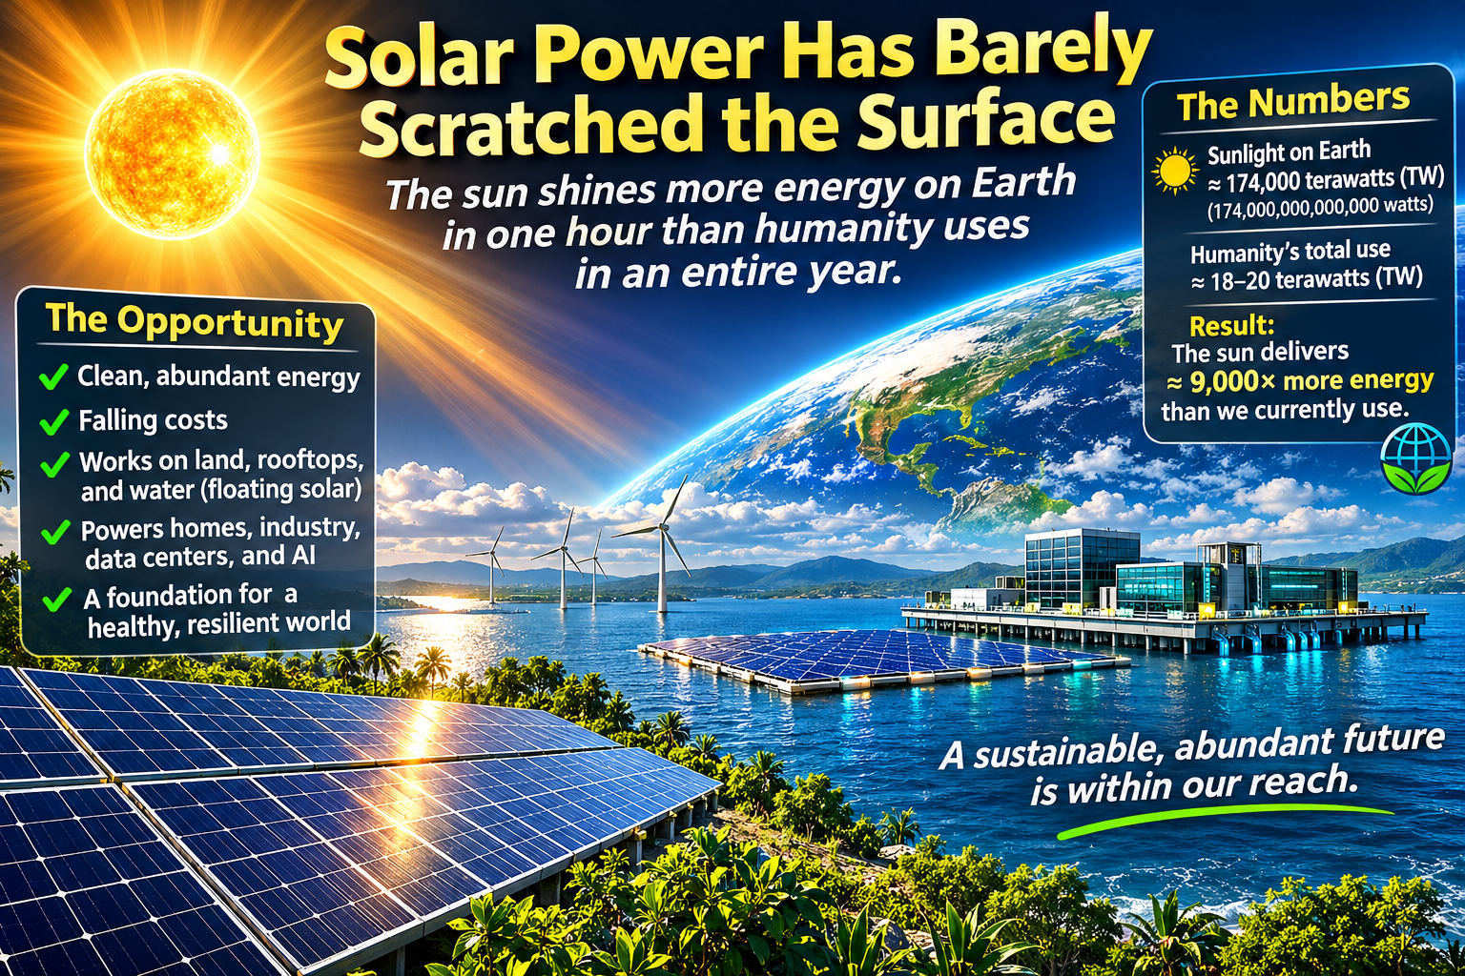
Solar power has barely scratched the surface. The sun delivers more energy to Earth in roughly one hour than humanity consumes in an entire year. This extraordinary comparison is a measure of potential—not a claim that we can capture all that sunlight. Yet it reveals a fundamental truth: the long-term limits of solar energy are not primarily the amount of sunlight available. They are the engineering, economics, infrastructure, land-use choices, and public decisions that determine how much of it we can harness.

An Abundance Beyond Our Current Imagination
At the top of Earth’s atmosphere, incoming sunlight amounts to roughly 174,000 terawatts at any given moment, averaged across the planet’s sunlit and dark sides. One hour of that incoming energy is about 626 exajoules—comparable to the energy humanity uses in a year. Some sunlight is reflected into space; much is absorbed by oceans, land, and atmosphere. Only a portion reaches suitable collection sites, and no technology converts all of it into usable electricity. The comparison is nevertheless a powerful illustration of scale.
Energy abundance is not the same as dependable electricity. Electricity must be generated where and when it is needed, moved through transmission lines, stored or balanced across periods without sunlight, and delivered affordably to homes, businesses, and public services.

The Technology Is Improving
Commercial silicon solar modules commonly convert around one-fifth or more of incident sunlight into electricity under standardized test conditions. Better cell architectures, manufacturing improvements, and emerging tandem designs offer room for further progress. Efficiency matters, but it is only one measure of a successful energy system. Lifetime, reliability, installed cost, recyclability, and maintenance matter just as much.
Solar installations are modular. A household can install a few kilowatts; a utility can deploy hundreds of megawatts. Rooftops, parking canopies, reservoirs, brownfields, agricultural settings, and appropriately chosen open land all offer different opportunities. Floating solar can reduce competition for land at some sites, but must be designed for wind, waves, corrosion, ecological effects, access, and safe electrical operation.

The Real Challenge: Building a Complete System
A society powered substantially by solar energy needs more than panels. It needs batteries and other forms of storage, flexible demand, regional transmission, resilient distribution networks, and complementary low-carbon sources. It also needs skilled workers, dependable supply chains, modern permitting, and recycling systems that recover valuable materials at the end of equipment life.
Solar generation changes with weather, season, latitude, and time of day. Batteries can shift daytime production into the evening; longer periods of low output may require additional solutions. Engineers must plan for extreme weather, peak demand, equipment failure, and communities that cannot easily afford up-front investment.

A Systems-Engineering Opportunity
The goal should not be to maximize solar panels in isolation. It should be to minimize the total cost and environmental impact of delivering reliable energy while expanding access. That requires examining generation, storage, transmission, buildings, transportation, industry, and water as connected systems.
Imagine solar-covered parking lots that shade vehicles while generating electricity; public buildings that serve as neighborhood resilience hubs; batteries that support the grid; and carefully designed floating arrays on suitable reservoirs. Electric vehicles and efficient heat pumps can increase the value of clean electricity while reducing fossil-fuel consumption. Each project should be evaluated with transparent cost, safety, and environmental metrics.

From Scarcity Thinking to Practical Abundance
The sun does not send a fuel bill. But solar power is not free: panels, inverters, land or structures, labor, storage, grid upgrades, maintenance, and financing all have costs. Nor is every site environmentally appropriate. Recognizing these realities makes the case for solar stronger, not weaker, because it turns aspiration into a plan that can be built and measured.
Public policy can accelerate progress through research, competitive procurement, grid modernization, workforce development, equitable financing, and fair access for renters and low-income households. Private companies, universities, utilities, and communities all have roles to play. The measure of success should be reliable energy delivered at a sustainable total cost, not merely the number of panels installed.

The Future Is a Design Decision
Humanity does not face a shortage of sunlight. We face the immense but solvable task of transforming a small, useful fraction of that sunlight into dependable prosperity. With careful engineering and cooperation, solar power can become a cornerstone of cleaner industry, more resilient communities, and broader economic opportunity.
Solar power has barely scratched the surface. The next chapter will be written by the systems we choose to build.

