Who Pays for Medicare for All?
  - A Clear Explanation of How Costs Would Be Restructured in a Single-Payer System
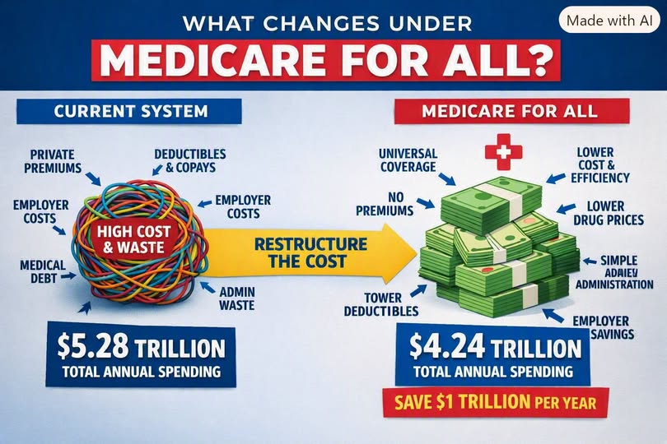
Illustration supplied by the author. Dollar amounts represent a modeled scenario, not an enacted program.
The question “Who pays for Medicare for All?” is often framed as though universal coverage creates an entirely new healthcare bill. But Americans already finance healthcare through taxes, employer contributions, insurance premiums, deductibles, copays, and out-of-pocket payments. Single-payer reform would change who collects those funds, how providers are paid, and how much the system costs overall.
The central question is not simply who pays. It is how to replace today’s fragmented financing with a fairer, more predictable arrangement—and whether the resulting savings outweigh the transition costs.

I. The Current System: A Patchwork of Visible and Hidden Costs
U.S. healthcare spending is measured in trillions of dollars annually. One modeled comparison estimates $5.28 trillion under the existing system versus $4.24 trillion under a comprehensive single-payer alternative, suggesting a possible $1.04 trillion annual reduction. These are scenario estimates, not a guaranteed forecast for every Medicare for All proposal.
- Employer and employee insurance premiums
- Deductibles, copays, and other out-of-pocket spending
- Public programs, including Medicare, Medicaid, VA care, and CHIP
- Insurance administration, complex billing, and collection expenses
- Prescription-drug spending and prices negotiated across fragmented purchasers
The system also imposes indirect costs: medical debt, time spent navigating insurance rules, delayed treatment, and employment decisions influenced by the need to keep coverage.

II. Who Pays Today?

Employers
Many employers pay substantial amounts toward health benefits, while employees contribute through payroll deductions and sometimes forgone wage growth. The cost varies dramatically by plan, firm, and coverage tier. Employer-sponsored insurance is also an administrative burden, especially for smaller businesses.

Workers and families
Households pay premiums, deductibles, copays, coinsurance, and bills for services their insurance does not cover. Unpredictable costs can discourage timely treatment and create debt.

Government and taxpayers
Federal, state, and local governments already finance a large share of healthcare through public coverage, tax preferences, subsidies, and public-employee benefits.

The uninsured and the broader economy
People without adequate coverage may face unaffordable bills or defer care. Employers and communities can also bear productivity and financial consequences when medical needs go unmet.

III. Who Would Pay Under Medicare for All?
Under a single-payer model, the federal government would become the primary insurer for covered services. The funding would come from public revenue—potentially a combination of payroll contributions, income-based taxes, and existing healthcare spending redirected into the new system. The precise distribution depends on legislation.

Employers
A proposal could replace private health premiums with a predictable payroll-based contribution. Some employers would save; others could pay more, depending on their current benefit costs and the tax structure.

Workers and households
A comprehensive plan could eliminate covered-service premiums, deductibles, and copays, replacing them with tax contributions. Whether a given household saves depends on its income, present insurance costs, and the enacted financing design.

Government
Federal healthcare outlays would rise sharply as private spending shifted into public budgets. That does not necessarily mean total national healthcare spending rises: the public budget and the entire country’s healthcare bill are different measures.

IV. Where the Savings Could Come From
- Simplified insurance administration and provider billing
- Negotiated prescription-drug prices and purchasing arrangements
- More standardized payment rules and less duplication
- Earlier access to preventive and chronic-disease care
- Reduced household exposure to medical bills and debt
These savings are plausible mechanisms, but their size is debated. A transition would also require investment in administration, provider capacity, workforce planning, and payment reform. Universal coverage may increase use of needed care, which should be included in cost estimates.

V. Healthcare Costs and the Wider Economy
Lower administrative costs and more predictable healthcare financing could improve business competitiveness, labor mobility, and household financial security. Such changes could slow healthcare cost growth and lower some prices, but broad economy-wide deflation is not automatic. Outcomes depend on provider payment rates, drug policy, capacity, demand, and implementation.

VI. A Side-by-Side Financing Comparison
Current financing | Possible single-payer financing
Private premiums and employer plans | Public contributions replace most private premiums
Deductibles and copays for many services | Potentially no point-of-care charges for covered services
Many insurers and billing arrangements | One principal public payer and simpler billing
Public spending plus private spending | Larger public budget, potentially lower total spending
Medical debt from uncovered costs | Substantially reduced new debt for covered care

VII. Conclusion: The Real Answer to “Who Pays?”
We already pay for American healthcare. Medicare for All proposes to reorganize those payments—away from fragmented premiums and bills, toward transparent public financing. The promise is that broad coverage, simpler administration, and stronger purchasing power could deliver better financial protection at a lower overall cost.
The crucial next step is to specify the financing law, test the estimates openly, and ensure that the benefits and obligations are distributed fairly. The question is not whether healthcare costs money. It is whether we can design a system that spends our shared resources more wisely.
Editorial note: Figures and proposed tax arrangements in this article are illustrative and depend on the model and legislative design. The supplied infographic contains typographical errors and should not be treated as a primary data source.

