  - TERRA NOVA DEVELOPMENT | HEALTHCARE & ECONOMIC REFORM

Medicare for All: The Efficient System America Has Been Avoiding
  - A systems-oriented case for reducing healthcare friction, improving access, and strengthening American business
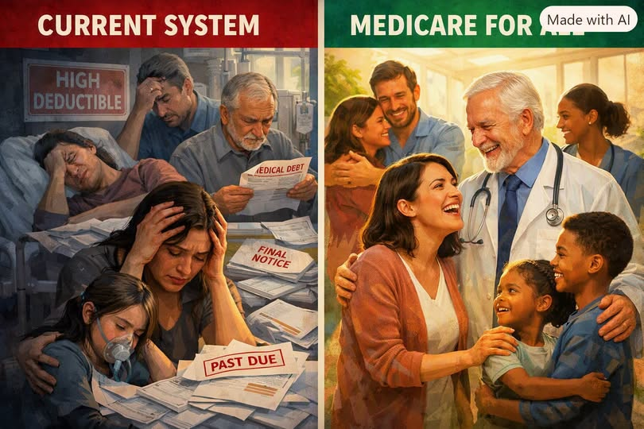
Concept illustration supplied by the author (AI-generated).
“Poverty for all” is a criticism sometimes aimed at universal healthcare. Yet the existing system already imposes substantial costs on families and employers: premiums, deductibles, medical debt, lost productivity, and untreated conditions. Medicare for All proposes replacing much of this complexity with universal coverage and unified financing. Whether it delivers its promised savings depends on the policy design and implementation.

Introduction | The Wrong Debate
For decades, Medicare for All has been framed as socialism versus capitalism, or government versus freedom. A more useful question is operational: How can the United States deliver timely, high-quality healthcare with less waste, fewer financial barriers, and predictable costs?
The current multipayer system requires extensive billing, coding, claims adjudication, prior authorization, and insurance administration. These activities can be necessary under today’s rules, but they do not themselves deliver treatment. A single-payer proposal aims to simplify this architecture.

I. Direct Costs | The Healthcare Tax No One Voted For
Employer-sponsored coverage represents a major compensation expense. The author’s draft cites roughly $23,000 for family coverage in 2023, with a substantial share paid by employers. Premiums are compensation costs even when employees do not see them on paychecks.
Small businesses often have less bargaining power and fewer options. Moving basic health coverage away from individual employers could make staffing and budgeting more predictable, though the overall effect depends on the taxes or contributions used to finance the new system.

II. Hidden Costs | The Balance Sheet Never Shows Them
Healthcare costs extend beyond premiums. Presenteeism, absenteeism, delayed treatment, chronic disease complications, medical debt, and job lock can reduce productivity and economic opportunity.
When people avoid appointments, prescriptions, or diagnostic tests because of out-of-pocket costs, preventable conditions can become more serious. Universal coverage could reduce these barriers. It would not eliminate all illness, missed work, or productivity losses, and the scale of improvement must be measured rather than assumed.
Insurance-linked employment can discourage job changes and entrepreneurship. Portable coverage would let workers make decisions without the same fear of losing health insurance.

III. The Inflation and Pricing Question
Fragmented negotiation, differing provider prices, administrative complexity, and market concentration contribute to high U.S. healthcare spending. A national payer could negotiate standardized rates and simplify payments, potentially reducing spending growth.
Lower medical prices are not automatic: payment levels must also support adequate staffing, provider participation, quality, and access. Changes to healthcare prices do not necessarily translate into broad economy-wide deflation or immediate wage increases.

IV. American Business and Global Competitiveness
Businesses in other wealthy countries generally operate within universal-coverage arrangements, although employers often still contribute through payroll taxes or other financing. The relevant comparison is total labor cost and total national healthcare spending, not just the line item called “insurance premium.”
A U.S. single-payer plan could reduce employer administrative responsibilities and remove unpredictable insurance renewals. The net effect on each company would depend on its current benefit spending and the replacement financing structure.

V. The Trillion-Dollar Efficiency Argument
The draft proposes annual national savings of approximately $1.04 trillion, attributed to administrative consolidation, provider payment changes, and prescription-drug negotiation. This is a scenario estimate, not a guaranteed budget outcome. Published single-payer analyses vary widely because they make different assumptions about utilization, provider rates, drug pricing, and financing.
An effective reform would need to account for increased use of care by previously uninsured or underinsured people, transition costs, provider capacity, and the redeployment of workers now employed in insurance administration.
The famous comparison between billing staffing at Duke and Toronto General, and the cited 2026 Yale study and its specific numbers, should be independently sourced before publication.

VI. Entrepreneurship, Mobility, and Family Security
When coverage is not tied to employment, workers may be more willing to change careers, start firms, retire, or take time to care for family members. Universal coverage could also reduce medical debt and the financial uncertainty associated with illness.
These are important potential gains, but their magnitude depends on implementation, access to clinicians, and the broader economy.

VII. What a Serious Medicare for All Plan Must Answer
A practical proposal must specify covered benefits; financing and tax incidence; provider payment levels; prescription-drug negotiation; treatment capacity and wait times; the transition for employers, patients, and healthcare workers; and protections for quality and innovation.
Critics raise legitimate questions about taxes, public budgeting, provider reimbursement, and transition risk. Supporters emphasize universal access, simpler administration, bargaining leverage, and reduced medical debt. These competing concerns should be assessed with transparent assumptions and credible evidence.

Conclusion | The Math Does Not Have a Party
The case for Medicare for All can be made in practical terms: Can we provide better access to care while spending less on paperwork, avoidable complications, and fragmented negotiations? Can we give employers more predictable costs and workers more freedom?
The present system is costly and complicated. Medicare for All offers one structural alternative, with meaningful opportunities and consequential trade-offs. The public deserves a full accounting of both—measured by healthcare outcomes, household security, business competitiveness, and total economic cost.

Publication note | Figures requiring verification
The supplied draft includes specific estimates for premiums, deductibles, absenteeism, presenteeism, inflation, administrative savings, lives saved, and international employer contributions. These have not been independently verified for this edition. Before publication, attach dated primary sources (for example, KFF employer-benefits surveys, CMS national health expenditures, OECD health statistics, and the original peer-reviewed single-payer model). Do not present modeled savings as guaranteed results.

