TERRA NOVA DEVELOPMENT, INC.

Leadership Begins by Listening: What a Mayor’s Shelter Visits Teach Us About Homelessness
Article #018 | Version 001 | November 2026
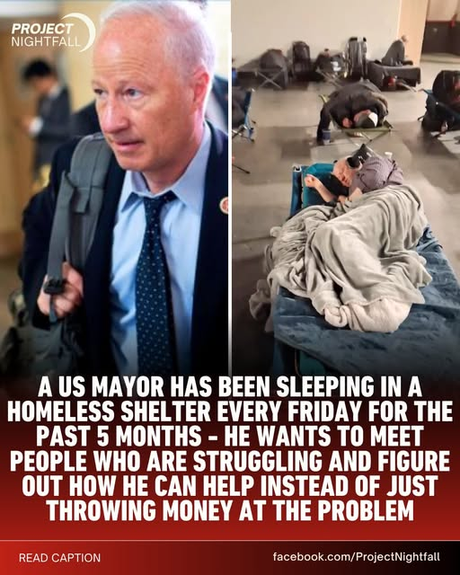
Image supplied from a Project Nightfall Facebook post; claims in the post are attributed, not independently verified.

Leadership Begins by Listening
The story of Aurora, Colorado Mayor Mike Coffman spending Friday nights at a homeless shelter offers an important lesson: public policy must begin with the people living its consequences. According to a Project Nightfall Facebook post, Coffman has been staying at the Aurora Regional Navigation Center, speaking with residents and learning directly about barriers to stable housing. The post describes his practice as an effort to understand what works, what fails, and what needs to change.

A Shelter Is More Than a Bed
A safe place to sleep matters enormously, but homelessness is not solved by providing a cot alone. People may also need identification documents, reliable transportation, medical care, employment support, personal safety, and assistance navigating housing applications. When any one of these steps fails, the path back to housing can stall.

What Leaders Can Learn
The reported visits illustrate a practical form of accountability: listen to residents, observe operations, follow up on complaints, and connect problems to specific corrective actions. The source post describes concerns about facility conditions and access to case management. Those claims should be independently verified before being treated as established findings, but they underscore why direct feedback matters.

The Terra Nova Community Haven Approach
Terra Nova proposes neighborhood Community Havens that coordinate immediate necessities with pathways to long-term stability. A Haven could connect food, hygiene, rest, donated goods, social support, and referrals to appropriate housing and health services. Such programs must be designed with resident participation, transparent governance, trained staff, and meaningful safeguards—not simply good intentions.

From Charity to Systems Engineering
A systems approach asks what happens after someone enters a shelter. Can they obtain an ID? Is there a housing placement process? Are case managers accessible? Are repairs completed promptly? Is progress measured by stable housing outcomes rather than only beds occupied? Public leaders should map these dependencies and remove obstacles one by one.

The Principle
No one should have to experience homelessness to understand its urgency. But leaders who listen carefully to people living through it can design better solutions. The goal is not merely to spend more money or to spend less. It is to build systems that restore dignity, security, and a real route home. There is no them. There is only us.

Source and context
Adapted from a Project Nightfall Facebook post provided by the author about Aurora Mayor Mike Coffman and the Aurora Regional Navigation Center. The post’s detailed dates, statistics, quotations, and operational claims have not been independently verified for this article.
Source: https://www.facebook.com/ProjectNightfall/posts/pfbid04rmSJg9yjtDz3fJTRs7Vju1kKzkfTng8gTL8TnFCDETraCDuQvWzuF3sckAsVso9l
Terra Nova Development, Inc. • There is no them. There is only us.

