TERRA NOVA DEVELOPMENT • ARTICLE #073

Solar Power Has Barely Scratched the Surface
The Energy Abundance Above Our Heads
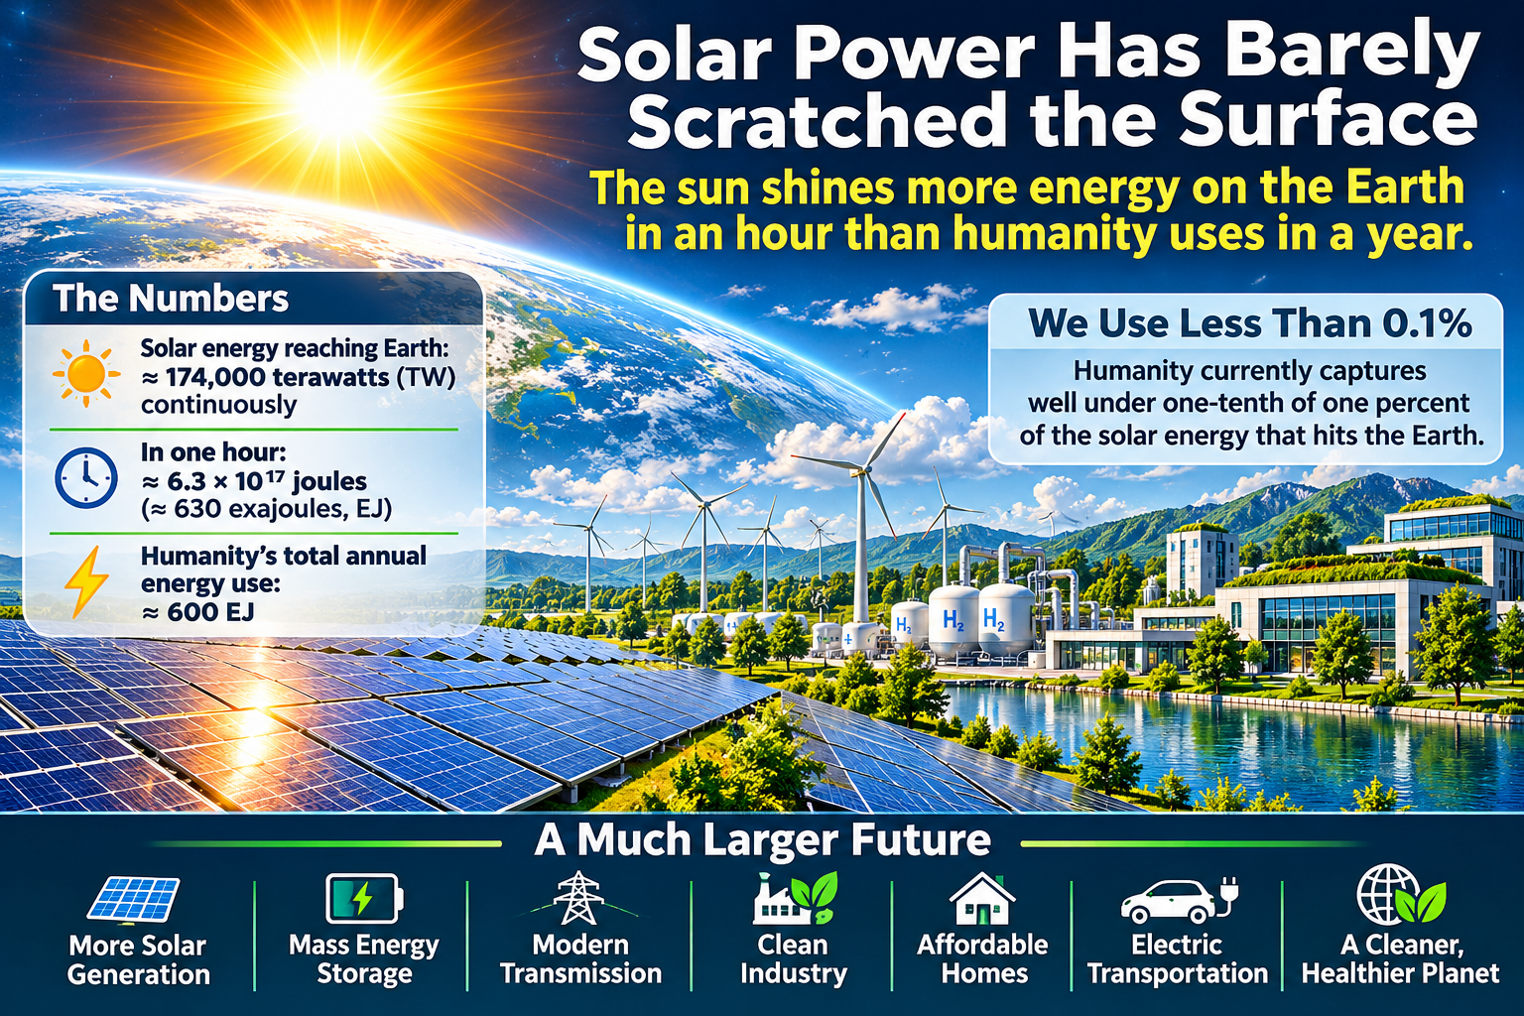
“The sun shines more energy on the Earth in an hour than humanity uses in a year.”

A Planet Bathed in Energy
Every morning, an immense stream of solar energy reaches Earth. It warms our atmosphere, drives weather, powers plant growth, and sustains nearly every living system. It is also an energy resource so large that the amount of sunlight arriving at Earth over roughly an hour is comparable to humanity’s total annual energy use. The comparison is an illustration of scale, not a claim that all that sunlight can be collected.
For generations, energy policy has been organized around extracting, transporting, and burning finite fuels. Solar power offers a different starting point: energy arrives continuously from a source beyond any national border or corporate supply chain. The challenge is not to create the sunlight. It is to build systems capable of capturing, storing, moving, and using it reliably.

What the One-Hour Comparison Really Means
The Sun delivers on the order of 170,000 terawatts of power to the top of Earth’s atmosphere. Multiplying that global incoming power by one hour produces a quantity of energy comparable to annual worldwide human energy consumption. This widely used comparison refers to incoming sunlight over the whole planet, including oceans, clouds, deserts, and regions where practical collection would be difficult.
Actual solar electricity depends on geography, daylight hours, weather, module efficiency, available land or water, grid capacity, storage, and environmental constraints. The vast physical resource does not remove the need for engineering or investment. It does, however, show why solar energy deserves to be considered foundational infrastructure rather than a niche supplement.

We Are Still at the Beginning
Solar modules already convert a meaningful share of incident sunlight into electricity, and manufacturing advances continue to improve output and cost. Yet today’s solar installations occupy only a small fraction of the surfaces and locations that could potentially host them. Rooftops, parking canopies, industrial sites, degraded land, reservoirs, and carefully selected utility-scale sites can all contribute.
The next leap will not come from efficiency alone. It will come from integrating generation with buildings, transportation, industry, batteries, long-duration storage, and flexible electricity demand. The objective is a complete energy system, not merely a larger collection of panels.

The Technologies That Can Unlock Abundance
Better solar cells: Advanced silicon architectures and emerging tandem designs may increase the electricity generated from each square meter.
Energy storage: Batteries, thermal storage, pumped hydro, and other technologies can help bridge the gap between sunshine and electricity demand.
Modern grids: High-voltage transmission, grid-enhancing technologies, and intelligent controls can move solar electricity from high-production regions to places that need it.
Flexible demand: Electric vehicles, water treatment, industrial heat, and data centers can increasingly adjust some of their operations to periods of plentiful clean electricity.
Distributed generation: Rooftops, community solar, microgrids, and resilient local systems can broaden participation and reduce some transmission requirements.

Solar Power and the Cost of Living
Energy costs flow through almost everything people buy: food production, transportation, housing, manufacturing, communications, and public services. Where solar power is economical and well integrated, it can reduce exposure to fuel-price volatility and help lower the long-term cost of electricity. Those benefits are not automatic; they depend on financing, grid investment, maintenance, and how savings reach consumers.
Affordable electricity could also support cleaner water systems, electrified transportation, efficient buildings, and new manufacturing opportunities. Solar power should be evaluated not only as a way to replace fossil-fuel generation but also as a platform for broader economic productivity.

The Obstacles Are Real—and Solvable
Solar power is variable: it does not produce at night, and output changes with weather and season. Building a reliable system requires a mix of storage, transmission, complementary generation, demand flexibility, and careful planning.
Large projects must address habitat, land use, materials, recycling, labor, supply chains, and community consent. Solar facilities on water introduce additional ecological, corrosion, maintenance, and permitting questions. A future of abundance must be designed responsibly rather than assuming every available surface should be covered.

A National Strategy Worth Pursuing
The United States could accelerate solar deployment by modernizing the electric grid, simplifying appropriate permitting, investing in storage research, expanding workforce training, encouraging domestic manufacturing, and ensuring that households and communities can share in the benefits.
Public research institutions, utilities, private firms, local governments, and universities all have roles to play. A durable strategy would set measurable goals for affordability, reliability, environmental performance, and access—not simply installed panel capacity.

Conclusion: From Scarcity Thinking to Systems Thinking
The sunlight falling on Earth is an extraordinary resource. Humanity has only begun to convert it into the electricity that powers daily life. Our limitations today are primarily technological, economic, geographic, and institutional—not a shortage of sunshine.
The opportunity is to create a future in which clean energy is plentiful enough to support thriving communities, industry, education, healthcare, and human creativity. The sun has been delivering its energy all along. Our task is to build the systems that make far more of it useful to everyone.
Editorial note: The “one hour versus one year” statement is an order-of-magnitude comparison of total incoming sunlight and global energy consumption; it is not an estimate of recoverable solar electricity.

