TERRA NOVA DEVELOPMENT | ARTICLE #074

Who Pays for Medicare for All?
  - A Clear Explanation of How Costs Would Be Restructured in a Real Single-Payer System
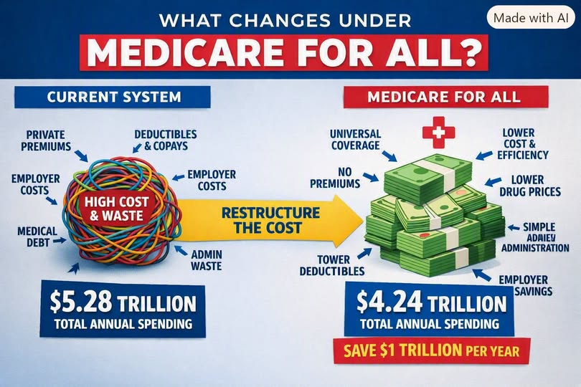

Introduction
The question “Who pays for Medicare for All?” is usually asked as if the answer is mysterious or frightening. We already pay for healthcare through a fragmented combination of premiums, taxes, and out-of-pocket costs. A proposed single-payer system would restructure those payments rather than eliminate the need to finance care.

I. The Current System: A $5.28 Trillion Patchwork of Visible and Hidden Costs
The article estimates annual healthcare spending at $5.28 trillion, including employer and employee premiums, deductibles, copays, out-of-pocket payments, public programs, private insurance overhead, drug markups, and administrative waste. It cites a model projecting that a single-payer system could reduce spending to $4.24 trillion, a $1.04 trillion reduction. This is a scenario estimate, not a guaranteed outcome.

II. Who Pays Today?
Employers finance health insurance as a labor cost. Workers pay premiums, deductibles, copays, and may experience lower wages or job lock. Federal and state governments pay through Medicare, Medicaid, and other programs. Uninsured people face medical debt and delayed treatment. The economy also absorbs indirect costs from absenteeism and reduced productivity.

III. Who Pays Under Medicare for All?
The proposed system replaces employer-sponsored premiums with predictable public contributions, potentially including payroll contributions. Workers would contribute through progressive taxes rather than premiums and cost sharing for covered care. The federal government would pay providers, with potential system-wide savings from negotiated prices and simpler administration. The distribution of costs depends on the actual legislation.

IV. The Hidden Savings
Improved access to preventive care may reduce absenteeism and presenteeism. Comprehensive coverage could prevent new medical debt for covered care. Portable coverage could reduce job lock and support entrepreneurship. Consolidated billing could reduce administrative expenses. The magnitude of each benefit requires empirical evaluation.

V. The Deflationary Effect
The article argues that unified purchasing, negotiated drug prices, standardized provider payments, and reduced insurance overhead could put downward pressure on healthcare costs. Whether overall prices fall, and by how much, depends on payment rates, capacity, transition costs, and policy design.

VI. So Who Pays?
Today, Americans finance healthcare through a complex mixture of premiums, deductibles, copays, employer contributions, government spending, and medical debt. Under the proposed model, progressive public financing replaces much of that fragmented structure, and covered care would not generate point-of-service charges. The article argues that total national spending could decline and costs could be distributed more fairly.

VII. Conclusion
Medicare for All would not make healthcare free to produce. It would change how healthcare is financed: from fragmented premiums and unpredictable bills to unified public financing and transparent budgeting. The article argues that this restructuring could make care more affordable and accessible, if enacted and implemented effectively.
Editorial note: Numerical claims are from the supplied article and have not been independently verified.

