TERRA NOVA DEVELOPMENT | ARTICLE #086

The True Cost of American Healthcare: Counting What the Bills Leave Out
  - Why a broader accounting strengthens the case for Medicare for All — and why expanded access must be included in the calculation.
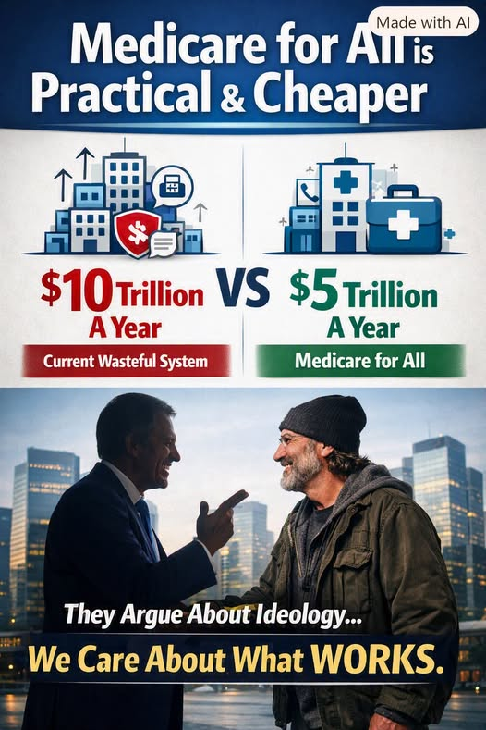

Introduction: The Price Tag Is Bigger Than the Medical Bill
The familiar comparison is striking: a graphic portrays the current American healthcare system as costing roughly $10 trillion per year, versus roughly $5 trillion for Medicare for All. Its central idea deserves serious attention. Premiums, hospital charges, and taxes are only part of what the nation pays. Illness, delayed treatment, paperwork, medical debt, lost work, and financial insecurity also impose real costs. A sound national comparison should account for both direct medical spending and indirect economic damage.
But the two headline figures in the illustration are advocacy scenarios, not verified, apples-to-apples national totals. Some indirect costs overlap with one another or with spending already counted. Medicare for All would also require additional care for people who currently go without treatment. A credible case must acknowledge both realities.

1. Direct Costs: What the Nation Pays Explicitly
- Employer and employee health insurance premiums, including the portion of compensation devoted to coverage.
- Federal, state, and local healthcare spending through Medicare, Medicaid, veterans’ programs, public employees’ coverage, and other programs.
- Deductibles, copayments, coinsurance, prescription purchases, and other household out-of-pocket expenses.
- Hospital, physician, pharmaceutical, medical-device, insurer, and administrative expenses already reflected in national health expenditures.
These categories must not simply be added together: premiums and government payments finance much of the same underlying healthcare spending. National health expenditure accounts provide the baseline against which reform should be measured.

2. Indirect Costs: What the System Takes Without Sending a Bill

Lost productivity
Absenteeism, presenteeism, disability, and preventable complications can reduce output. Some losses arise from illness itself, while some may be reduced by earlier, more affordable care.

Medical debt and financial instability
Collections, borrowing costs, damaged credit, bankruptcy proceedings, and the stress of unaffordable care can impose costs beyond the medical services received. The outstanding debt principal is not automatically an additional annual cost.

Administrative friction
Employers, clinicians, hospitals, and patients spend time navigating eligibility, claims, networks, authorizations, and appeals. Some of these costs are already included in healthcare expenditures, while others fall outside them.

Delayed treatment and avoidable illness
People may postpone preventive care, medication, or treatment because of price. More severe illness later can raise spending and reduce well-being.

Job lock and lost opportunity
Insurance tied to employment can discourage changing jobs, starting businesses, or retiring when desired. The resulting economic cost is difficult to measure precisely.

Family caregiving and emotional strain
Unpaid caregiving, transportation, missed work, and psychological distress impose burdens that traditional healthcare budgets often overlook.

3. What Does “Nearly Twice as Much” Really Mean?
If an illustrative comprehensive estimate assigned $10 trillion to the current system and $5 trillion to a Medicare for All scenario, the comparison would suggest a two-to-one burden. That is the message of the accompanying illustration. It is not, by itself, proof that the United States currently loses $10 trillion annually or that a single-payer program would cost exactly $5 trillion.
To establish such a ratio, analysts would need a consistent year, a defined set of costs, transparent sources, and a model that avoids double counting. They would also need to distinguish actual cash spending from foregone production, debt balances, and harder-to-monetize human suffering.

4. Medicare for All Changes Who Pays — and May Change Total Costs
Under a proposed single-payer system, premiums and most point-of-care charges could be replaced by public financing. That would change how costs are collected, but it would not make the cost of doctors, nurses, hospitals, medicines, equipment, and infrastructure disappear.
Potential savings could come from simpler billing, reduced insurer-related overhead, negotiated drug prices, and different provider payment arrangements. Actual savings depend on the legislation, provider rates, taxes, utilization, administrative design, and transition costs. Some studies project substantial savings; others find higher total spending under different assumptions.

5. The Essential Caveat: Better Access Means More Services
Medicare for All would likely increase the use of healthcare services by people who are uninsured, underinsured, or currently delaying treatment. That is not a flaw in the proposal; it is one of its purposes. A comprehensive analysis must budget for additional primary care, specialist visits, behavioral health services, prescriptions, diagnostics, surgeries, dental or vision benefits where covered, and the staff and facilities needed to deliver them.
Some earlier treatment may prevent costly emergencies and advanced disease. Other added services would raise expenditures without producing an immediate financial offset. Both effects must be modeled rather than assumed away. Capacity constraints and the time required to expand the healthcare workforce also matter.

6. A Fair National Accounting
- Start with measured annual national healthcare spending, not the sum of premiums and payments that finance the same care.
- Identify indirect costs separately and include only nonoverlapping, attributable estimates.
- Estimate savings from administration, prices, and care coordination under specific policy rules.
- Add the cost of newly accessible services and transitional investments.
- Report who pays under each system, including taxes, employers, households, and government.
- Present ranges and uncertainty instead of a single guaranteed savings number.

Conclusion: The Right Question Is Total National Value
The strongest case for Medicare for All is not that healthcare becomes free to produce. It is that America may be able to purchase more comprehensive, reliable care with less waste and less financial harm. When we count direct spending alongside lost productivity, debt-related damage, and the costs of delayed care, the burden of the current system becomes clearer.
The illustration’s “$10 trillion versus $5 trillion” comparison is a provocative way to begin the discussion. The responsible next step is to test that proposition with transparent accounting — including the extra care millions of Americans would finally receive. The goal is not merely a smaller bill. It is a healthier, more productive nation getting better value for everything it spends.
Editorial note: Article #086 is a policy essay. The $10 trillion and $5 trillion figures are illustrative claims from the supplied image, not independently validated national estimates. Direct and indirect cost categories may overlap; a formal economic model is required to quantify net savings.

