TERRA NOVA DEVELOPMENT • ARTICLE #087

The Reality of Employer-Provided Health Care
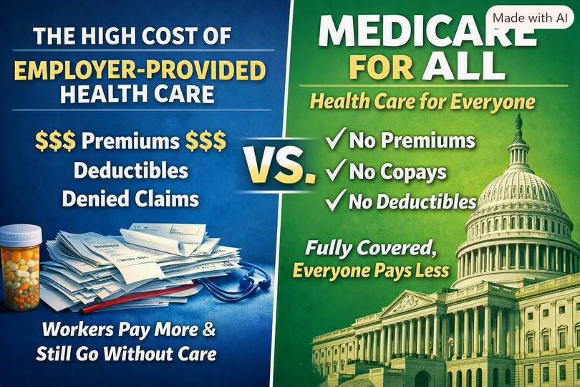
Employer-provided health insurance looks generous on the surface, but the real costs are split between businesses and workers in ways most people never see.

What Employers Spend
Companies pay most of the premium — usually 70–80%.
- $6,300–$7,600 per employee for single coverage
- Approximately $20,000 per employee for family coverage
- Estimated national total: $1.1–$1.3 trillion every year
This is money businesses could otherwise use for wages, hiring, expansion, or lowering prices.

What Employees Chip In
Workers cover the rest of the premium plus out-of-pocket costs.
- About $1,400 a year in premiums for single coverage
- About $6,800 a year for family coverage
- Deductibles often cited at $3,000–$6,000 (single) and $6,000–$12,000 (family)
- Out-of-pocket maximums commonly cited at $5,000–$12,000
Even with insurance, many families struggle to afford basic care.

Copays, Deductibles & Declined Coverage
Employer insurance still leaves people exposed:
- Copays for visits, prescriptions, and tests
- Deductibles that may apply before certain benefits are paid
- Coinsurance — a percentage of covered costs after the deductible
- Denied claims based on medical necessity, authorization, or network rules
These mechanisms shift costs onto workers and can delay or prevent needed care.

Total Cost of the System
The proposed estimate for combined employer spending, employee premiums, out-of-pocket expenses, and insurer overhead is approximately $1.8–$2.0 trillion per year. This figure needs a defined year and accounting method to ensure that premiums, claims, and overhead are not counted twice.
Businesses and workers both pay heavily, yet millions still encounter deductibles, copays, and coverage disputes.

Where Medicare for All Changes Everything
Under a comprehensive single-payer proposal, employer and employee insurance premiums, deductibles, and copays could be eliminated and replaced with public, tax-based financing. Coverage rules would change, though decisions about medical necessity and covered services would still be necessary.
The central promise is simpler financing and universal access. Whether total spending and each household’s costs decline depends on the legislation, taxes, provider payments, drug prices, and expanded use of care.

Conclusion
Employer-provided insurance is not free: its cost is shared through compensation, premiums, and medical bills. Medicare for All offers a different way to finance care, potentially reducing administrative complexity and financial barriers. The question is not simply what taxes would rise, but how total costs, coverage, and financial risk would change for businesses and families.
Editorial note: Dollar amounts and ranges above are supplied advocacy estimates, not independently verified figures. Employer-based coverage spending cannot be compared directly with the entire national cost of Medicare for All; such a comparison must include all populations, services, and funding sources.

