The World We Could Have Tomorrow If We Stopped Arguing Today
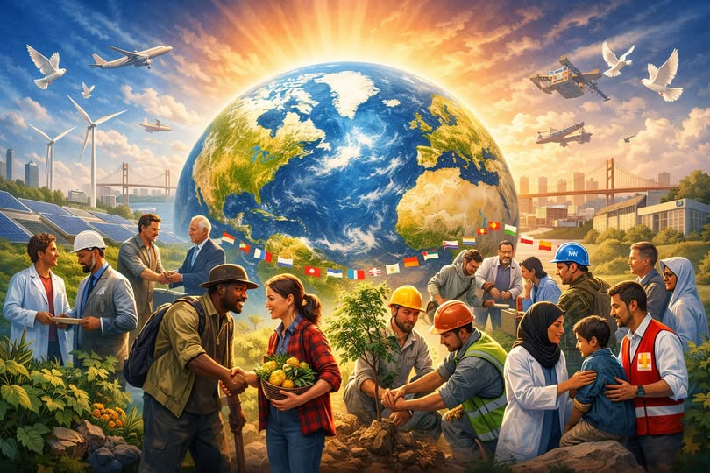
There is a version of this world — not centuries away, not dependent on miracles — where the biggest problems humanity faces are no longer “debates,” but memories. A world where homelessness, hunger, failing schools, and endless conflict are not accepted as the background noise of civilization. A world where we finally act like the intelligent species we claim to be.
And the only thing standing between this world and that world is the energy we waste fighting each other instead of fixing things.
Humanity doesn’t lack solutions.
Humanity lacks cooperation.

The Cost of Arguing Instead of Solving
Every major global problem today has a known solution. Not a perfect solution, not a utopian fantasy — a real, practical, implementable solution.
But instead of implementing them, we:
- argue about who gets credit
- argue about who’s to blame
- argue about ideology
- argue about identity
- argue about everything except the problem itself
Meanwhile, the problems sit there, unchanged, waiting for adults to show up.
Imagine if engineers behaved this way.
Imagine if doctors behaved this way.
Imagine if pilots behaved this way.
Civilization would collapse in a week.
Yet somehow, when it comes to the biggest issues — poverty, housing, education, peace — we tolerate endless argument as if it’s a substitute for progress.

What Cooperation Actually Makes Possible
Let’s strip away the noise and look at what could be fixed right now if humanity simply decided to cooperate.

1. Homelessness
We know how to build housing.
We know how to fund it.
We know how to support people transitioning into stability.
The only missing ingredient is the will to do it together.

2. Hunger
The world produces more than enough food for every human being.
Distribution, waste, and logistics are solvable engineering problems — not mysteries.
Hunger persists because cooperation doesn’t.

3. Education
Every child on Earth could have access to:
- world-class digital curriculum
- AI-powered tutoring
- safe learning environments
- teachers supported instead of burned out
This isn’t science fiction.
It’s infrastructure and coordination.

4. Peace and Security
Most conflicts today are not about survival — they’re about pride, power, and old grudges.
Cooperation doesn’t erase differences, but it makes differences irrelevant to survival.
Peace is not a dream.
It’s a decision.

5. Climate and Environment
We already have:
- renewable energy
- carbon capture
- sustainable agriculture
- clean transportation
- circular manufacturing
The planet isn’t waiting on new inventions.
It’s waiting on cooperation.

The Hidden Truth: Problems Are Easier Than People Think
People imagine global problems as towering, impossible mountains.
But when you break them down — the way engineers, planners, and problem-solvers do — they become manageable:
- homelessness is a housing + services equation
- hunger is a logistics equation
- education is a resource + access equation
- peace is a negotiation + incentives equation
- climate is an energy + policy equation
These are solvable.
They’ve always been solvable.
The hard part isn’t the math.
The hard part is the mindset.

The World We Could Build If We Chose Cooperation
Picture a world where humanity finally grows up:
- Nations share knowledge instead of hoarding it
- Communities solve problems instead of scoring points
- Leaders focus on outcomes instead of arguments
- People see each other as teammates instead of opponents
In that world:
- no child sleeps on concrete
- no family goes hungry
- no student is denied opportunity
- no nation lives in fear
- no problem is ignored because it’s “too hard”
This isn’t idealism.
This is what happens when cooperation becomes the default instead of the exception.

The Real Question
The world doesn’t need a thousand heroes.
It doesn’t need a billion geniuses.
It doesn’t need a miracle.
It needs one shift:
Stop arguing. Start cooperating.
Once humanity makes that choice — even once — the dominoes fall fast.
Solutions accelerate.
Progress compounds.
And the world transforms.
Not in centuries.
Not in decades.
But in our lifetime.

