TERRA NOVA DEVELOPMENT | ARTICLE #119

Artificial Scarcity in a Bountiful World
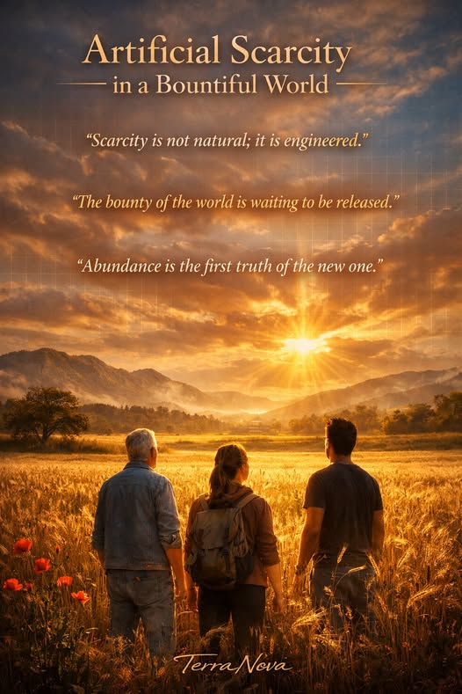
Humanity stands at a paradoxical crossroads. We live in a world overflowing with abundance — a planet capable of feeding, housing, and empowering every person alive — yet we continue to behave as if we are poor. The contradiction is not natural; it is engineered. Artificial scarcity is the invisible architecture of modern civilization, a system that constrains plenty to preserve power.

The Age of Bounty
Look around: the evidence of abundance is everywhere.
Automation, robotics, and artificial intelligence have multiplied human productivity beyond imagination. Agriculture can feed billions with a fraction of the land once required. Renewable energy can power entire cities from sunlight and wind. Knowledge flows freely across networks that span the globe.
We have the means to provide food, shelter, medicine, and education for all. The bounty is not theoretical — it is measurable, tangible, and already here.

The Machinery of Scarcity
Yet scarcity persists. Not because the Earth lacks resources, but because our systems demand it.
Money, markets, and ownership are built on the assumption that not everyone can have everything. If abundance were universal, profit would vanish, and control would dissolve. So scarcity is maintained — not by nature, but by design.
It appears in subtle ways:
- Patents that lock away life-saving technologies.
- Empty homes beside homeless families.
- Food destroyed to stabilize prices.
- Artificial limits on production to protect margins.
Scarcity is the oxygen of the monetary system. Without it, the system cannot breathe.

The Psychology of Lack
Artificial scarcity also shapes the human mind. It teaches competition over cooperation, fear over trust, and accumulation over generosity. It convinces us that survival depends on winning rather than sharing.
This psychology of lack keeps humanity fragmented — each person guarding their piece of the pie while the bakery overflows.

The Economics of Control
Scarcity is not just an economic condition; it is a mechanism of governance. When access to essentials is limited, obedience becomes currency. People trade freedom for security, creativity for employment, and conscience for survival.
The few who control scarcity control society itself.

The Path Beyond
But the illusion is cracking. Technology has outgrown the economy that birthed it. Automation can produce without labor; AI can manage without hierarchy; renewable energy can flow without depletion. The tools of liberation already exist — they simply operate inside a framework that forbids liberation.
To transcend artificial scarcity, we must redesign the system around abundance:
- Shift from ownership to stewardship.
- Replace competition with collaboration.
- Treat knowledge as a commons, not a commodity.
- Measure wealth by well-being, not accumulation.

A Civilization Ready to Awaken
The bounty of the world is not waiting to be discovered; it is waiting to be released.
When humanity finally recognizes that scarcity is a choice, not a law of nature, we will step into a new era — one where economics serves life rather than constrains it, and where prosperity is measured by how freely we can give.
Artificial scarcity is the last illusion of an old world.
Abundance is the first truth of the new one.

