THE SALUDOS MANIFESTO
  - A Universal Welcome for a Shared Humanity
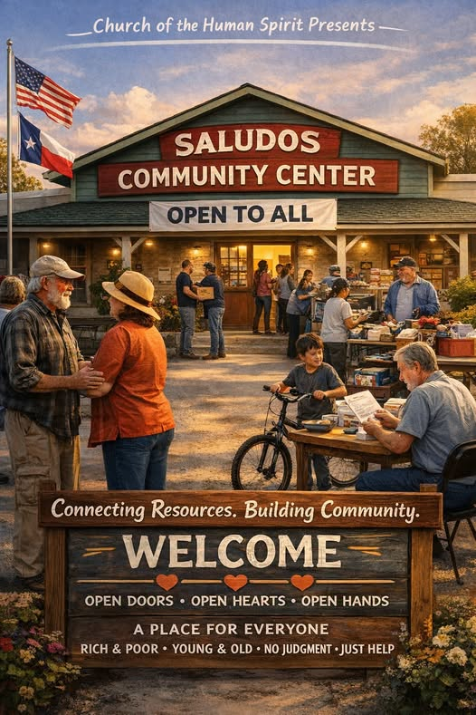

I. The Human Principle
Every person on this planet is born with the same truth: Human needs are not privileges. They are rights. Rest is a right. Nourishment is a right. Safety is a right. Dignity is a right. Community is a right.
SALUDOS exists to make these rights real — not through paperwork, programs, or prerequisites, but through presence, welcome, and unconditional belonging.
Wherever a SALUDOS Center stands, the message is the same: If you are human, you belong here.

II. The End of Eligibility
The world has built endless gates — income checks, residency rules, identification demands, categories, labels, and judgments. These gates do not protect society; they fracture it.
SALUDOS abolishes the gate. No screening. No sorting. No separation. A SALUDOS Center is a place where the unhoused and the housed, the wealthy and the struggling, the local and the traveler, the young and the old, all share the same tables and the same dignity.
This is not charity. This is civilization.

III. The Give and Take — The Heart of the Movement
At the center of every SALUDOS facility is the Give and Take, where the bounty of this world is shared freely by the people and businesses of the area served.
Food, clothing, tools, books, supplies — all flow in and out without price or permission. It is the living proof that abundance is not the problem; distribution is.
The Give and Take transforms communities from consumers into contributors, from isolated individuals into a shared ecosystem of care. It is the antidote to waste, the enemy of scarcity, and the foundation of a new social economy rooted in generosity.

IV. The SALUDOS Model
A SALUDOS Center provides the essentials of human dignity:
- Resting spaces
- Showers and hygiene
- Laundry
- Food and drink
- A shared kitchen
- Social space
- Digital access
- Job support
- A mailing address
- Safety, calm, and community
But more than services, SALUDOS provides stability, the soil from which self-determination grows.
SALUDOS does not “fix” people. It gives them the space to breathe, recover, and begin again — on their own terms.

V. A Global Network of Welcome
Imagine SALUDOS Centers in every city on Earth — a worldwide constellation of human sanctuaries. A traveler in Nairobi, a student in São Paulo, a refugee in Athens, a retiree in Toronto, a family in Manila — all knowing that wherever they go, there is a place where they are welcome.
This is not a dream. It is a blueprint for a new global commons.
SALUDOS Centers would:
- Reduce homelessness by providing stability
- Reduce waste by circulating surplus goods
- Reduce loneliness by creating shared spaces
- Reduce crisis response costs by offering early support
- Reduce division by bringing all classes together
A SALUDOS world is a world where no one falls through the cracks because the cracks no longer exist.

VI. Community as a Verb
SALUDOS is built not by governments alone, but by people — volunteers, neighbors, businesses, students, retirees, churches, civic groups, and anyone who believes that compassion is a civic duty.
Renovation becomes community. Meals become community. Teaching becomes community. Repairing becomes community. Presence becomes community.
SALUDOS is not a building. It is a behavior.

VII. The New Social Contract
The old world was built on the belief that people must earn their dignity. The new world begins with the truth that dignity is inherent.
SALUDOS is the first institution of that new world — a universal welcome center for a shared humanity.
Its promise is simple: Wherever you are, whoever you are, whatever you are facing — you are not alone.

VIII. The Call
Let every city open its doors. Let every community build its commons. Let every nation recognize that compassion is not weakness — it is infrastructure.
Let SALUDOS become a global movement, a worldwide network of human welcome, a living testament to the truth that we rise together or not at all.
The world we want is possible. The world we need is overdue. The world SALUDOS envisions begins now.

