  - TERRA NOVA DEVELOPMENT • ARTICLE #121

Designing a New Civilization from Scratch
What Could Humanity Accomplish with Today’s Technology If We Were No Longer Constrained by Yesterday’s Systems?
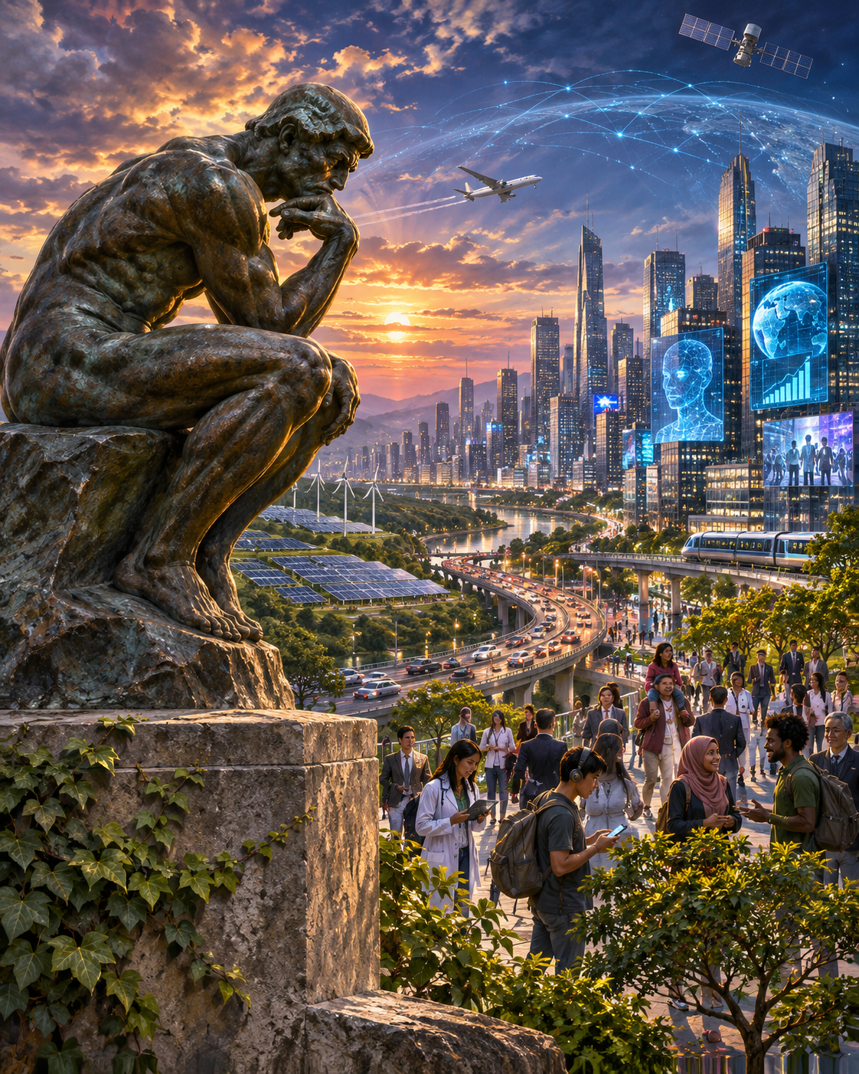

Introduction: The Greatest Opportunity in Human History
Stop for a moment and imagine something extraordinary.
Suppose humanity could sit down together tomorrow morning with a completely blank sheet of paper.
We would have all the scientific knowledge accumulated throughout history. We would have artificial intelligence, robotics, computers, global communications, renewable energy, advanced medicine, modern agriculture, automated manufacturing, and the extraordinary productive capacity of the twenty-first century.
We would have everything humanity has learned.
But we would not be required to preserve the institutions through which that knowledge developed.
No obligation to maintain outdated bureaucracies.
No requirement to preserve obsolete economic arrangements.
No need to protect inefficient industries merely because they already exist.
No inherited assumption that the way something has always been done is the way it must continue to be done.
We would not be starting over technologically.
We would be starting over institutionally, with the full benefit of everything humanity already knows.
That distinction changes everything.
It is the foundational opportunity behind Terra Nova Development.
Terra Nova Development has the advantage of imagining a new civilization from scratch, with no legacy systems treated as prerequisites.
The objective is not to destroy existing civilization. It is to design better systems, demonstrate that they work, and allow them to replace outdated arrangements through their own success.
The question is simple:
If we were designing civilization today, knowing everything we know now, would we design anything the way it currently works?
And if the answer is no, why are we still doing it that way?

I. The Extraordinary Burden of Inherited Systems
Most of the institutions governing modern life were not created through a comprehensive process of rational design.
They evolved.
A problem arose, and someone invented a solution.
Another problem appeared, and someone added another solution.
Then another rule.
Another department.
Another institution.
Another exception.
Another funding mechanism.
Another administrative process.
Over generations, these additions accumulated into the systems we now regard as normal.
Our healthcare system is a patchwork of programs, insurance companies, providers, employers, billing systems, and regulations.
Our education system is organized around buildings, classrooms, calendars, districts, degrees, and age-based progression inherited from earlier centuries.
Our economic system ties access to necessities largely to income and purchasing power, even as automation dramatically expands productive capacity.
Our governments maintain layers of administration developed long before instantaneous communication, digital records, or artificial intelligence existed.
Our cities were designed around transportation technologies and land-use assumptions that are now changing.
None of this means every inherited institution is worthless.
Many exist for important reasons, and some embody hard-won protections, rights, and lessons from history.
But the existence of a system is not evidence that it represents the best possible design.
A systems engineer would never begin designing a new machine by assuming that every component of the previous machine must be preserved.
The engineer would begin by defining what the machine must accomplish.
Civilization deserves the same discipline.

II. Start with Requirements, Not Institutions
Imagine being asked to design a national healthcare system from scratch.
Would the first question be:
How do we preserve the insurance companies?
Of course not.
The first question would be:
How do we ensure that every person receives appropriate healthcare, reliably, efficiently, and affordably?
Now imagine designing an educational system.
Would we begin by asking how to preserve every existing school district, textbook business, tuition arrangement, and academic calendar?
No.
We would ask:
How do we make the accumulated knowledge of humanity accessible to every person who wants to learn?
Consider housing.
Would we begin by preserving every financing arrangement, zoning practice, construction convention, and real-estate incentive?
Or would we ask:
How do we provide safe, comfortable, durable housing for everyone at the lowest sustainable cost?
Consider food.
Would we begin by protecting every existing layer of the food distribution industry?
Or would we ask:
How do we ensure that everyone has dependable access to nutritious food while minimizing waste?
This is the essential shift.
Stop asking how to maintain existing structures.
Start asking what outcomes humanity actually needs.
Only then should we design the institutions necessary to deliver those outcomes.
Requirements first. Systems second. Institutions third.
That is how Terra Nova Development approaches the future.

III. What Would Healthcare Look Like If We Designed It Today?
Suppose we had the medical capabilities of the twenty-first century but no inherited health insurance arrangements.
We would begin with universal access.
Every person would have a dependable pathway to medically necessary care.
Medical records could follow patients securely across participating providers.
Artificial intelligence could assist medical professionals with scheduling, documentation, research, diagnostics, and care coordination, subject to appropriate safeguards.
Preventive services could become a central feature rather than something patients postpone because of cost.
Healthcare facilities could coordinate staffing, equipment, supplies, and appointments through interoperable information systems.
Payment arrangements could be designed to minimize unnecessary administrative work and encourage effective care.
We would still need trained professionals, medical facilities, research, regulation, funding, privacy protections, and accountability.
But we would not have to preserve avoidable complexity simply because it has accumulated over decades.
Whether the final financing model were Medicare for All or another universal arrangement, the design objective would remain the same:
Deliver the best achievable healthcare to everyone while using society's resources responsibly.
Healthcare should be designed around healing.
Not around protecting the machinery of billing.

IV. What Would Education Look Like If All Human Knowledge Were Available to Everyone?
Now consider education.
For most of history, knowledge was scarce because books, teachers, institutions, and communication were scarce.
Today, much of the world's accumulated knowledge can be accessed digitally.
Artificial intelligence can explain concepts, answer questions, generate exercises, provide feedback, and adapt instruction to different learning needs.
Why, then, must education remain tied so tightly to physical buildings, fixed schedules, rigid age categories, and expensive tuition?
Imagine Terra Nova University.
A free, globally accessible learning environment built around the knowledge humanity has accumulated.
A child could begin exploring mathematics at an early age.
A factory worker could learn engineering.
A retiree could study astronomy.
A farmer could learn robotics.
A student in a remote village could access advanced scientific instruction.
A person with disabilities could use adaptive technology to learn at an appropriate pace.
AI tutors could assist students at any hour, while qualified human educators provide guidance, mentorship, evaluation, and support.
Formal credentials could be earned through demonstrated mastery under trustworthy assessment standards.
Accreditation, academic integrity, practical training, and access to necessary equipment would still matter.
But a person would not need to purchase access to knowledge merely because previous generations organized education around expensive institutions.
The purpose of education is learning, not preserving the cost structure of educational institutions.
If we were designing education today, universal access would be one of our starting requirements.

V. What Would Housing Look Like If We Designed It as an Engineering Problem?
Housing is another example of inherited assumptions governing a modern problem.
We already possess sophisticated architectural software, advanced materials, modular manufacturing, automated fabrication, and increasingly capable construction technologies.
Yet housing remains unaffordable for millions.
Suppose we began with a different question:
How can we produce safe, attractive, energy-efficient housing at the greatest practical scale and lowest sustainable lifetime cost?
We could standardize appropriate components without forcing every house to look alike.
We could use modular construction where it offers genuine advantages.
We could simplify permitting while maintaining safety and environmental standards.
We could integrate renewable energy, efficient insulation, water conservation, and durable building materials from the beginning.
We could design neighborhoods around walking, accessibility, transportation, green space, and community participation.
We could expand nonprofit, cooperative, public, and private housing models according to local circumstances.
We could use modern logistics to coordinate materials and construction schedules.
The objective would not be to abolish private homeownership or dictate how everyone must live.
It would be to ensure that the systems producing housing are designed to deliver housing efficiently.
Land availability, environmental limits, infrastructure, construction labor, maintenance, and local preferences would remain real constraints.
But inherited inefficiency would no longer be accepted as unavoidable.
Housing would become a deliberate exercise in meeting human needs rather than merely navigating an accumulation of historical barriers.

VI. What Would an Economy Look Like If Automation Performed Most Necessary Labor?
This may be the most transformative question of all.
For most of history, productive output depended heavily on human labor.
People needed to work to produce goods and services.
Income from that work provided the means to purchase necessities.
But artificial intelligence and robotics are changing the relationship between labor and production.
Machines can increasingly manufacture, transport, analyze, sort, inspect, and coordinate.
Software can perform tasks that previously required extensive human administrative effort.
Renewable energy and automated infrastructure may reduce some of the operating costs of production.
Now imagine an economy designed with those capabilities as its starting point.
Would we automatically assume that everyone must sell a fixed number of hours of labor to obtain the necessities of life?
Or would we ask:
How should the benefits of automated production be shared so that technological progress increases everyone's practical freedom?
We might develop a combination of universal basic services, public infrastructure, employee ownership, cooperative enterprises, competitive markets, and new income arrangements.
We might reduce the cost of essential goods through productive efficiency.
We might establish systems that allow communities to share surplus resources instead of discarding them.
We might create opportunities for people to devote more time to creativity, scientific inquiry, caregiving, education, entrepreneurship, and community service.
Automation will not automatically eliminate scarcity. Land, materials, energy, maintenance, and human attention still have limits.
Nor will automation automatically distribute its benefits fairly.
Those are design challenges.
But the fundamental opportunity remains:
We can begin designing an economy in which people benefit from machines doing more necessary work, rather than being threatened by that achievement.
The purpose of technology should be to improve human life.

VII. What Would Community Support Look Like Without the Traditional Charity Model?
Imagine designing a system for ensuring that people have access to food, clothing, basic household supplies, hygiene facilities, and community support.
Would we begin by creating dozens of separate eligibility programs and requiring people to prove that they deserve assistance?
Or would we begin with a welcoming place where useful resources are organized and shared?
This is the principle behind Give & Take Community Centers and SALUDOS.
A community could establish a location where residents and businesses voluntarily contribute usable goods.
People could take what they need from available supplies, with reasonable safeguards to prevent waste and maintain fairness.
The same facility could provide meals, showers, laundry, internet access, employment support, recreation, and connections to healthcare and housing services as resources permit.
It could operate as a place of mutual participation rather than a facility divided into donors and recipients.
Some people might contribute money.
Some might donate food or household goods.
Some might volunteer their skills.
Some might need assistance without being able to contribute anything in return.
Everyone would be welcome.
The operational requirements would still include safe facilities, food handling, staffing, funding, accountability, and protection of participants.
But the guiding question would be different:
How do we connect the abundance already present in our communities with the people who can use it?
That is a systems-design problem.
And it is one we can begin solving locally.

VIII. What Would Government Look Like If We Invented It in the Age of Artificial Intelligence?
Government is one of humanity's most consequential systems.
It establishes laws, protects rights, provides public services, maintains infrastructure, supports security, and coordinates collective responsibilities.
But many governmental procedures were created in eras when information traveled slowly and recordkeeping required enormous quantities of paper.
Imagine designing government today.
Public information could be organized into accessible digital systems.
Residents could track the progress of applications and service requests.
Administrative processes could be simplified.
Public expenditures could be documented transparently.
AI systems could assist officials with research, translation, document processing, fraud detection, and resource planning.
Communities could participate more directly in identifying priorities and evaluating results.
Public programs could be designed around measurable outcomes rather than the number of employees or departments they maintain.
But digital efficiency must not replace democratic rights.
A well-designed government would still need due process, independent courts, transparent decision-making, privacy protections, cybersecurity, human accountability, and mechanisms for correcting mistakes.
AI should support public administration, not become an unaccountable authority over citizens.
The question would no longer be how to automate every inherited bureaucratic procedure.
It would be:
Which procedures are necessary, which should be simplified, and which would not exist at all if we designed the system today?
That is a much more productive question.

IX. What Would Energy Look Like If We Designed the Entire System Around Modern Technology?
Our energy infrastructure developed over generations through successive technologies.
Coal.
Oil.
Natural gas.
Hydroelectric power.
Nuclear generation.
Solar energy.
Wind power.
Energy storage.
Today, we have the opportunity to reconsider the entire system.
Suppose we designed an energy network using the technologies available now, while anticipating those under development.
We could combine renewable generation, nuclear power where appropriate, long-duration storage, upgraded transmission, intelligent demand management, and local microgrids.
We could design buildings to minimize energy consumption.
We could recover industrial waste heat.
We could coordinate electric transportation and charging infrastructure with grid capacity.
We could improve resilience against storms, equipment failures, and cyberattacks.
We could make investment decisions based on total lifetime costs, reliability, environmental consequences, and public benefits.
And as advanced technologies such as fusion mature, we could incorporate them where they prove practical.
Energy would remain a physical and economic resource requiring materials, infrastructure, and maintenance.
But energy policy would no longer need to be organized around preserving every legacy arrangement.
The objective would be abundant, dependable, affordable, and environmentally responsible power.
Energy should serve civilization.
Civilization should not be organized around protecting particular energy industries.

X. What Would Transportation Look Like If We Started with the Desired Journey?
Consider how transportation systems developed.
Roads followed older travel routes.
Cities expanded around automobiles.
Parking requirements reshaped urban land use.
Airports and rail terminals emerged according to separate historical decisions.
Today, we can begin with another question:
How can people and goods move safely, comfortably, efficiently, and affordably between the places they need to reach?
The answer might involve different combinations of walking, cycling, buses, trains, private vehicles, shared transportation, autonomous systems, aircraft, and improved freight logistics.
A rural community might require very different solutions from a dense metropolitan area.
Technology could assist with route planning, traffic coordination, maintenance, accessibility, and energy management.
But the central goal would not be to maximize the number of vehicles on roads.
It would be to maximize people's ability to reach destinations and participate in society.
That is the difference between designing for infrastructure and designing for human needs.

XI. The Greatest Opportunity Is Not Technology. It Is Systems Integration.
We often discuss technologies as separate inventions.
Artificial intelligence.
Robotics.
Solar power.
Advanced materials.
Biotechnology.
Communications networks.
Automated transportation.
But the most important opportunity may lie in integrating these capabilities.
Imagine a coordinated community where:
- Clean energy powers efficient homes, local manufacturing, and transportation.
- Automated agricultural systems produce food.
- Modern logistics connect farms, businesses, and Give & Take Centers.
- AI-supported education is accessible to everyone.
- Healthcare systems emphasize prevention, continuity, and universal access.
- Digital public services reduce unnecessary administrative work.
- Community facilities provide places for learning, recreation, sharing, and mutual support.
- Residents participate in evaluating and improving local services.
Each component supports the others.
Lower energy costs can reduce manufacturing costs.
Efficient housing can reduce household expenses.
Better healthcare can improve quality of life and economic stability.
Accessible education can expand innovation and opportunity.
Reduced administrative waste can free resources for direct services.
Cooperation can reduce duplication and improve resilience.
This is what systems engineering makes possible.
Instead of optimizing isolated institutions, we optimize the performance of the civilization they collectively create.
And rather than measuring success only by financial transactions, we measure whether people are healthier, safer, better educated, more secure, and more capable of pursuing meaningful lives.

XII. We Do Not Have to Tear Down the Old World to Build the New One
There is an important distinction between designing without legacy constraints and acting without regard for consequences.
We cannot simply abandon hospitals, power grids, transportation networks, financial systems, or governments.
Millions of people depend on them.
A responsible transition must preserve essential services, protect rights, honor legitimate obligations, and avoid preventable disruption.
But we do not have to make yesterday's institutions permanent design requirements for tomorrow's solutions.
We can build new systems alongside the old ones.
We can test them.
Measure their performance.
Correct their weaknesses.
Expand them when they succeed.
Allow people to adopt them voluntarily where appropriate.
Eventually, better systems can replace older ones because they demonstrably work better.
This is how technological progress often occurs.
New architectures emerge.
They prove their value.
They become the foundation upon which further progress is built.
Civilization can evolve in the same manner.
We can preserve what humanity has learned without preserving every inefficient arrangement through which we learned it.

XIII. Terra Nova Development: A Civilization Designed from Requirements
Terra Nova Development begins with an extraordinary advantage.
It does not have to defend an existing insurance company.
It does not have to preserve an inherited university bureaucracy.
It does not have to maintain a century-old business model.
It does not have to justify a particular transportation technology.
It does not have to protect yesterday's organizational chart.
Terra Nova can begin with a blank sheet of paper.
And on that paper, it can write the requirements for a civilization worthy of the capabilities humanity now possesses.
Every person should have access to essential healthcare.
Every person should have the opportunity to learn.
Every person should have access to adequate food and safe shelter.
Every community should be able to participate in the benefits of technological progress.
Every person should enjoy meaningful freedom, dignity, and opportunity.
Our institutions should be transparent, accountable, adaptable, and efficient.
Our technologies should serve human flourishing.
Our productive abundance should not coexist with avoidable deprivation simply because we have failed to design effective systems of access.
These become the requirements.
Then we ask:
What technologies can satisfy them?
What organizations must exist?
What funding mechanisms are sustainable?
What legal protections are required?
What risks must be managed?
What outcomes can be measured?
What can we build first?
And what can we learn from the results?
That is the difference between dreaming of a better civilization and engineering one.

XIV. Start Small, Think Globally, Design Without Artificial Boundaries
A new civilization does not require the entire world to change at once.
It can begin with a single working demonstration.
A Give & Take Center that reduces waste and helps families.
A free educational platform that gives people access to knowledge.
An affordable housing project that demonstrates better construction methods.
A community energy system that reduces costs and improves reliability.
A healthcare pilot that simplifies administration and improves access.
Each project can be evaluated according to measurable results.
How much did it cost?
How many people benefited?
What resources were saved?
What failed?
What can be improved?
Can the model be replicated elsewhere?
A successful system can expand from one neighborhood to one city, from one city to a region, and eventually across national borders.
The goal is not to impose a universal blueprint regardless of local circumstances.
It is to develop adaptable systems that people and communities can use to improve their lives.
This approach combines an unlimited imagination with a disciplined engineering process.
Think globally. Begin locally. Measure everything. Improve continuously.

Conclusion: The Question That Changes Everything
Humanity has spent generations trying to make inherited systems work better.
We have revised them, expanded them, subsidized them, regulated them, automated them, and argued about them.
Sometimes those efforts have produced genuine progress.
But perhaps we have not asked the most important question often enough.
What would we build if we were starting today?
Not starting without knowledge.
Not starting without technology.
Not starting without experience.
Starting without the assumption that the institutions inherited from yesterday must define the possibilities of tomorrow.
We already possess extraordinary scientific knowledge.
We have the beginnings of astonishing technological capabilities.
We have global communication, automation, advanced engineering, and the accumulated experience of thousands of years of civilization.
What we need now is the freedom to think beyond the structures we inherited.
We need to stop asking what existing systems will permit us to accomplish.
We need to start asking what humanity actually needs — and then design systems capable of delivering it.
That is the opportunity before Terra Nova Development.
Not simply to improve the old world.
But to demonstrate how a better one can be built.
We inherit humanity's knowledge, not an obligation to preserve humanity's mistakes.
We begin with the people. We define what they need. We design systems that deliver it.
And we never forget the principle that unites the entire effort:
There is no them. There is only us.
Terra Nova Development — Building a Better World, Together.

