TERRA NOVA DEVELOPMENT | ARTICLE #122

Embracing the World God Created
Why Our Purpose Is to Experience, Cherish, and Improve Creation—Not Reject It
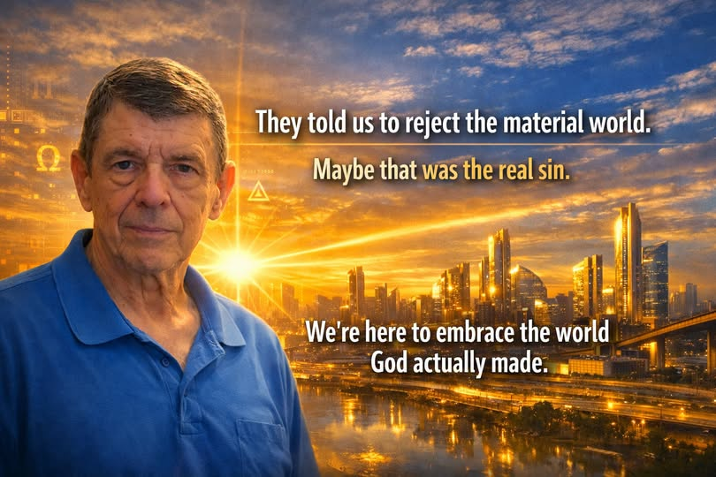
“We’re here to embrace the world God actually made.”

Introduction: What If We Have Misunderstood the Gift?
For centuries, people have been told, in various religious and philosophical traditions, that the material world is something to rise above, escape, or reject. Earthly life is sometimes portrayed as a waiting room, physical experience as a distraction, and the beauty of creation as less important than a world beyond it.
But what if we have misunderstood the purpose of being here? What if the astonishing world around us is not a mistake to endure but a gift to receive? What if our Creator placed us in a material universe not to despise it, but to know it, enjoy it, learn from it, care for it, and help it flourish?
The question is not whether there is a spiritual dimension to human life. It is whether spirituality requires us to turn away from the world that God made. Perhaps the opposite is true: our spiritual responsibility begins with how we treat creation, one another, and the life entrusted to us.

I. Creation Is Not an Accident to Be Escaped
The opening chapter of Genesis repeatedly describes creation as good. Light, water, land, living things, and humanity are not introduced as failures. They are presented as purposeful parts of an unfolding whole. In Genesis 1:31, God sees what has been made and declares it “very good.”
Whatever differences exist in how believers interpret that account, its moral direction is clear: the physical world matters. The earth is not worthless simply because it is temporary, and the body is not meaningless simply because human life is finite.
Consider what it means to awaken in a universe of galaxies, forests, oceans, animals, music, human relationships, and the astonishing capacity for thought. If creation is a gift, then curiosity is one way of unwrapping it. Gratitude is one way of receiving it. Stewardship is one way of honoring its Giver.

II. The Difference Between Materialism and Loving the Material World
Embracing creation is not the same as worshiping possessions. There is a profound difference between appreciating the physical world and making wealth, status, or consumption the purpose of existence.
We can value a home because it shelters a family without measuring human worth by property. We can appreciate technology because it relieves suffering without treating machines as gods. We can celebrate food because it nourishes life without making excess the object of our devotion.
The danger is not matter itself. It is the misuse of matter: greed, exploitation, waste, neglect, and the willingness to sacrifice people or nature for private gain. The spiritual task is not to reject material things, but to put them in their proper relationship to love, justice, and human dignity.

III. Our Senses Are Invitations to Experience Creation
We see color and light. We hear music and laughter. We taste food. We feel rain, sunlight, and the embrace of someone we love. We learn through touch, movement, exploration, and discovery.
Why would we be given these extraordinary capacities only to regard the world they reveal as an obstacle? These senses can be understood as invitations: to witness what exists, to recognize beauty, and to participate gratefully in life.
A child discovering a butterfly, a scientist studying distant stars, a farmer harvesting crops, a musician composing a song, and a grandparent holding a newborn are not necessarily turning away from God by engaging the physical world. They may be encountering its wonder in different forms.

IV. Jesus Did Not Teach Indifference to Human Needs
The Christian tradition contains warnings against greed, pride, and treating possessions as ultimate. But it also describes a faith expressed through concrete acts in this world: feeding the hungry, welcoming strangers, caring for the sick, and protecting the vulnerable.
In Matthew 25, care for those in need becomes a test of how people respond to Christ himself. The hungry require actual food. The thirsty require actual water. The sick require actual care. These are physical needs, answered through physical acts of love.
Jesus also speaks of the lilies of the field and the birds of the air, inviting attention to the beauty and provision found in creation. In the Gospels, compassion is not merely an idea about another life. It is practiced among actual people living here and now.
We may therefore understand faith not as permission to abandon this world, but as a reason to make life within it more humane.

V. To Love the Creator Is to Respect Creation
If the world is the work of a Creator, then what does it say about our gratitude when we poison rivers, exhaust soil, discard useful resources, or allow preventable suffering to continue beside extraordinary productive capacity?
We cannot claim to honor a magnificent gift while remaining indifferent to its destruction. Environmental responsibility is not separate from spiritual responsibility. Clean air, healthy land, safe water, and the protection of living systems are ways of respecting what has been entrusted to us.
Stewardship does not mean that every landscape must remain untouched or that technological progress should cease. It means that innovation must be guided by wisdom: use what we have, repair what we damage, and leave future generations a world worth inhabiting.

VI. Abundance Is an Opportunity to Practice Love
Humanity now possesses capabilities that previous generations could scarcely imagine. We can communicate across continents in seconds, produce immense quantities of food, develop powerful medical treatments, harvest renewable energy, and use automation to perform increasingly difficult work.
Yet millions still struggle for food, shelter, healthcare, education, and security. Much of that suffering reflects real limitations; much also reflects failures of organization, access, and collective priorities.
If God has given humanity intelligence and the ability to learn, then those gifts carry responsibility. Knowledge should not be celebrated merely because it increases profits or power. It should be used to reduce needless hardship and expand the opportunity for people to live fully.
Terra Nova Development asks what becomes possible when we approach technology with that moral purpose: not simply to produce more, but to share benefits wisely; not merely to build systems, but to build systems that serve people.

VII. We Are Participants, Not Spectators
It is tempting to imagine that the world will be repaired someday, by someone else, in another place. But our lives are taking place now. The suffering we can ease is here. The kindness we can offer is available today. The beauty we can protect is before us.
Human beings were given capacities for reason, creativity, cooperation, and compassion. Those gifts suggest an active role. We can build, heal, teach, cultivate, invent, restore, and welcome. We can make our communities more generous and our institutions more just.
That does not mean we can perfect the world or eliminate every tragedy. It means we do not have to confuse humility with passivity. We can acknowledge human limits while still accepting our responsibility to act.

VIII. Spiritual Hope and Earthly Responsibility Belong Together
Belief in an eternal future need not diminish the importance of earthly life. Indeed, the hope of something beyond this world can deepen our obligation to live lovingly within it.
A person can believe in heaven and still cherish a sunrise. A person can pray and still study engineering. A person can trust God and still build a hospital, protect a forest, or help a neighbor find housing.
Faith becomes impoverished when it makes us indifferent to the people and places in front of us. A spirituality that honors creation seeks a richer balance: worship without contempt for the earth, hope without neglect of the present, and gratitude expressed through useful action.

IX. A Civilization That Honors the Gift
Imagine designing our institutions around a simple premise: this world and the lives within it have intrinsic worth.
Healthcare would exist to preserve life and relieve suffering. Education would help everyone explore the knowledge available to humanity. Housing would provide security and belonging. Energy systems would support prosperity while respecting the planet. Community centers would offer hospitality without humiliation. Economic arrangements would be judged by whether they help people flourish.
None of those goals requires rejecting science, economics, enterprise, or spiritual faith. They require placing those things within a coherent moral framework.
Terra Nova Development envisions precisely such a framework: use the best knowledge and technology available, preserve what works, redesign what fails, and make human dignity the central requirement of every system.

Conclusion: We Are Here to Embrace the World God Made
The material world is not an embarrassment to be overcome. It is the home in which our lives unfold, the field in which we practice love, and the astonishing creation we have been invited to experience.
We should not mistake detachment from greed for rejection of creation. We should not confuse spiritual aspiration with indifference to earthly suffering. We should not spend our lives longing for a better world while refusing to improve the one entrusted to us.
Let us look again at the world: the seas and mountains, the cities and fields, the science and music, the friendships and families, the countless possibilities that remain unrealized.
Let us receive it with wonder, care for it with humility, and improve it with courage.
We are not here to reject the world God created. We are here to experience it, cherish it, and help make it a place where every person can flourish.
There is no them. There is only us.

