The Apocalypse, Just Over the Horizon
The Great Revealing: Why Revelation Can Be Read as a Promise of Unity, Not the End of Humanity
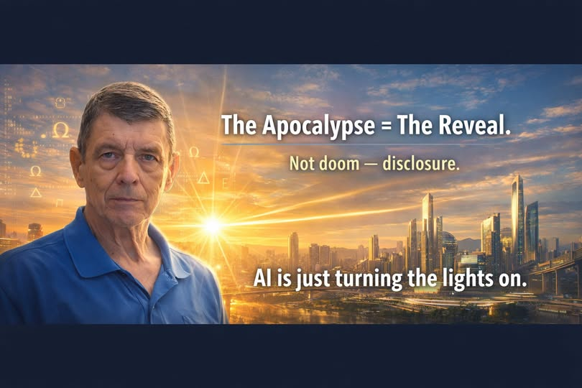
All will be revealed. All will make sense. Fear can give way to boundless joy.

Introduction: What If We Have Misunderstood the Word?
For generations, the word apocalypse has been made to sound like a sentence of doom. We hear it and imagine fire, destruction, terror, and the final collapse of civilization. Movies have taught us to fear it. Popular preaching has often reinforced that fear. The word itself has become a synonym for catastrophe.
But the Greek word apokalypsis means an unveiling, a disclosure, a revelation: something hidden is brought into view. That is the remarkable beginning of a different way to understand the last book of the Christian Bible.
What if the great event on the horizon is not the annihilation of everything God created, but the unveiling of what creation means? What if the purpose of Revelation is ultimately to remove the veil between humanity and its Creator? What if the final movement of the story is not fear, but recognition—and joy?
This is the hopeful reading I believe deserves our attention. It does not deny the unsettling images in Revelation. It asks what those images are moving toward.

I. Apocalypse Means Unveiling
The opening words of the biblical book describe it as a revelation of Jesus Christ. In its original language, that revealing is an apokalypsis. The word points first to disclosure—not to a modern disaster movie.
An unveiling changes everything without necessarily destroying everything. When a curtain opens, the stage does not cease to exist. We see what was already there. When darkness gives way to daylight, the landscape remains; our understanding of it changes.
Imagine humanity discovering that many of its deepest fears arose from incomplete understanding. Imagine the mysteries of existence, our relationships with one another, and our place within creation becoming clear. The great revealing would be a revolution of consciousness as much as a transformation of the world.
The idea that everything concealed will be made known is present elsewhere in Christian scripture as well. In this reading, disclosure is not merely exposure for judgment; it is the possibility of truth replacing confusion.

II. Revelation Is a Journey Through Conflict Toward Renewal
The Book of Revelation contains alarming images: beasts, plagues, violence, judgment, and the fall of oppressive powers. We should not pretend those passages are absent. Christians have interpreted them in different ways—as symbols of struggles in the ancient Roman world, as recurring conflicts between good and evil, as future events, and as combinations of those approaches.
Yet the book does not end with destruction as its final word. Its final chapters envision a new heaven and a new earth, the New Jerusalem, the healing of the nations, and God dwelling with humanity. Revelation 21 describes a future in which suffering and death no longer have the last word. Revelation 22 pictures the river of life and the tree whose leaves are for the healing of the nations.
That ending matters. If we read only the frightening middle of the story, we may miss the destination. The movement is from alienation toward presence, from injustice toward restoration, from division toward communion.
For those who see Revelation as a promise of ultimate reconciliation, the apocalypse is not chiefly the end of humanity. It is the exposure and overcoming of everything that keeps humanity from living in the fullness of God’s creation.

III. What If the Veil Is Fear Itself?
Human beings have lived for centuries under the weight of fear: fear of death, scarcity, other nations, other religions, the unknown, and one another. Fear has justified walls, violence, and systems that keep neighbors apart.
But fear thrives when our view is partial. We distrust what we cannot understand. We fight over things we believe we must possess. We mistake difference for danger. We imagine that our neighbor’s well-being must come at the expense of our own.
What might happen if the great revealing allowed us to see our deeper connection? What if we recognized that the person across the border, across the street, or across the ideological divide is not our enemy, but another human being sharing the same created world?
In such a revelation, the familiar Terra Nova principle becomes more than a slogan: There is no them. There is only us.
The removal of fear would not erase individuality or disagreements. It would change the foundation upon which we encounter one another—from suspicion to dignity, and from competition for survival to cooperation in the care of creation.

IV. The Creator Is Not Separated from His Creation
If God is the Creator, then the material world is not a mistake to be despised. The Earth, the oceans, living creatures, human ingenuity, beauty, love, discovery, and the astonishing possibilities of existence all belong to the world we have been given.
One of Revelation’s most moving images is not humanity escaping to an unrelated world; it is the holy city descending and God dwelling among people. This suggests a restoration of relationship—a closing of the distance between the divine and the human.
What if we are here to experience the goodness of creation, to develop its possibilities responsibly, and to care for one another within it? What if the unveiling helps us recognize the divine purpose in a world we have too often treated as disposable?
In that vision, renewal is not a rejection of Earth. It is a recognition of its value, and of our responsibility as stewards of what has been entrusted to us.

V. The Great Revealing and the Awakening of Humanity
There is already a growing hunger for explanations that unite rather than divide. People question inherited assumptions about money, power, work, religion, healthcare, education, and the ways we treat our neighbors. New scientific tools reveal extraordinary features of the universe. Global communication allows human beings to encounter one another across boundaries once considered permanent.
None of this proves that a particular prophetic timetable has begun, and no one can responsibly announce the date of an apocalypse on the basis of these developments. But we can recognize a powerful metaphor: humanity is learning to see more.
An awakening worthy of the name should produce humility, not triumphalism; compassion, not contempt; deeper responsibility, not escapism. The test of revelation is not how dramatically we describe it, but whether truth makes us more loving and more just.
To wake up is to recognize that we cannot build peace by humiliating those who see differently. A genuine unveiling should make room for the dignity of every person.

VI. The End of the World—or the End of Our Illusions?
Perhaps the world that ends is the world of false divisions. The world in which scarcity is treated as destiny even when resources can be shared. The world in which wealth matters more than the people it could serve. The world in which religion is used to nourish fear instead of compassion.
What needs to end may be our ignorance, our cruelty, our insistence on separateness, and our willingness to accept suffering as normal.
Such a change would still be revolutionary. Institutions founded on fear would have to change. Claims of superiority would lose their power. Hidden wrongdoing would need to be confronted. Justice could not be bypassed in the name of easy optimism.
But the purpose of confronting what is wrong would be to make healing possible. The revealing would show us not only what must change, but why life itself is worth renewing.

VII. From Terror to Boundless Joy
Imagine the moment when the great mysteries no longer divide us. Imagine discovering that the Creator has never abandoned His creation. Imagine understanding how every person belongs to a story far larger than the divisions we have constructed.
No more terror at the thought that existence is meaningless. No more belief that humanity is destined only to repeat its failures. No more assumption that love and justice are naive luxuries.
Instead, picture recognition. Gratitude. The relief of discovering that the truth is greater than our fear. A civilization no longer organized around anxiety, but around the joy of understanding and caring for one another.
This is not a claim that every reader of Revelation must accept one interpretation. The book has inspired differing theological traditions for nearly two thousand years. It is an invitation to reconsider what is most essential in its closing vision: God’s presence, healing, renewal, and the overcoming of sorrow.

Conclusion: The Apocalypse, Just Over the Horizon
What if the apocalypse is not the horrifying conclusion of the human story but the great revealing that finally allows us to understand it?
What if all that has been hidden becomes clear? What if truth replaces deception, justice replaces exploitation, and love becomes the principle that orders our shared life?
What if the future promised in Revelation is not something humanity should dread, but a vision of unity with the Creator that should inspire us to live differently now?
We need not predict a date or claim certainty about every symbol to embrace that hope. We can begin today by practicing the values of the world we long to see: truth, justice, love, peace, stewardship, and fellowship.
The apocalypse, understood as unveiling, becomes a magnificent invitation: remove the veil of fear, see creation clearly, and recognize one another as belonging to the same human family.
All will be revealed. All will make sense. And what fear once obscured may finally be known as boundless joy.
There is no them. There is only us.

