THE POWER PLANTS ABOVE OUR HEADS
  - America’s Untapped Solar Revolution
A Terra Nova Development vision for generating clean electricity on the land we already use
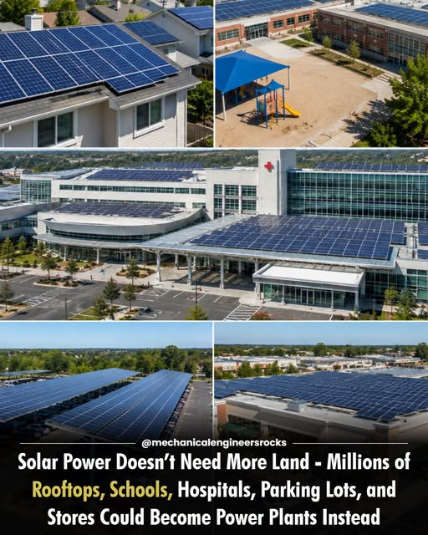
Rooftops, schools, hospitals, parking lots, and commercial properties can host solar generation. Image supplied for this article.

The Opportunity Is Already Built
Look across any American city. There are millions of roofs above homes, schools, hospitals, warehouses, shopping centers, government offices, and factories. There are enormous parking lots exposed to sunlight every day. These are not empty spaces: they are built assets that could serve a second purpose—producing electricity. Why should we always begin by asking where to build a new power plant when so many possible sites are already above our heads?

One Building at a Time, One Community at a Time
A home can use rooftop photovoltaic panels to offset part of its electricity demand. A school can generate power during sunny hours and use its installation to teach students about energy. Hospitals can combine solar generation with batteries and appropriately designed backup systems to improve resilience. Warehouses and big-box stores often have expansive roofs, while parking canopies can produce electricity and shade vehicles. Not every roof is suitable: structural capacity, roof condition, shading, fire access, and electrical connections all matter.

Parking Lots as Power Stations
A solar canopy above a parking lot can do more than produce electricity. It can provide shade, support electric-vehicle charging, and make productive use of already paved land. Solar carports cost more than simple ground-mounted arrays because of their supporting structures, but they can deliver multiple benefits in one location. Large retailers, universities, airports, and municipal facilities could evaluate these systems as part of normal capital planning.

Less Land Competition, More Local Generation
Utility-scale solar farms remain essential because they can produce large quantities of electricity at competitive costs. But rooftop and canopy systems complement those farms by using developed sites and placing generation closer to homes and businesses. This can reduce some transmission needs and conflicts over farmland or habitat, though local distribution grids may still require upgrades. The future is not rooftop solar versus solar farms. It is a coordinated combination of both.

Storage, Smart Grids, and Reliability
Solar power is variable: panels do not generate at night, and output changes with weather. Batteries, demand management, improved grid connections, flexible generation, and other energy sources are needed for a dependable system. Buildings that host solar panels are not automatically protected during a blackout; safe islanding controls, storage, and proper electrical design are necessary for backup power. A serious national program must address these engineering realities rather than promising effortless energy independence.

The Economic Case
Solar installations require upfront investment, maintenance, insurance, and eventual equipment replacement. Their value depends on sunlight, electricity rates, incentives, financing costs, utility rules, and the physical condition of the site. For suitable properties, on-site solar can reduce purchased electricity and offer more predictable long-term energy costs. Public agencies can evaluate life-cycle savings, while community solar and shared financing can extend benefits to renters and people whose roofs cannot host panels.

A National Rooftop Solar Initiative
Imagine a nationwide effort to map suitable rooftops and paved areas; prioritize public schools, libraries, hospitals, and community facilities; standardize permitting where safe; expand workforce training; modernize distribution networks; and finance installations with transparent performance standards. Cities could publish inventories of eligible municipal properties. Utilities could identify locations where local generation offers the greatest system value. Procurement could favor durable equipment, safe labor practices, and responsible recycling.

From Abundance to Access
The Terra Nova philosophy begins with a simple question: What do we already have that we are failing to use? In this case, we have sunlight and enormous amounts of developed surface area. The task is to connect engineering, investment, public policy, and community participation so that more of this potential becomes useful electricity. Solar power will not eliminate every energy cost or replace every other energy source. It can, however, become a major part of a more affordable, resilient, and cleaner energy system.

The Work Ahead
We do not need to cover every acre of undeveloped land to expand solar energy. We can begin with the roofs above our homes, the schools our children attend, the hospitals that care for us, and the parking lots we use every day. The infrastructure of tomorrow may already be standing. We simply need to put it to work. Abundance is already here. Let us learn to harvest the sunlight above our heads.
Terra Nova Development • There is no them. There is only us.

