TERRA NOVA DEVELOPMENT | ARTICLE #081

The Negative Aspects of the Current U.S. Healthcare System
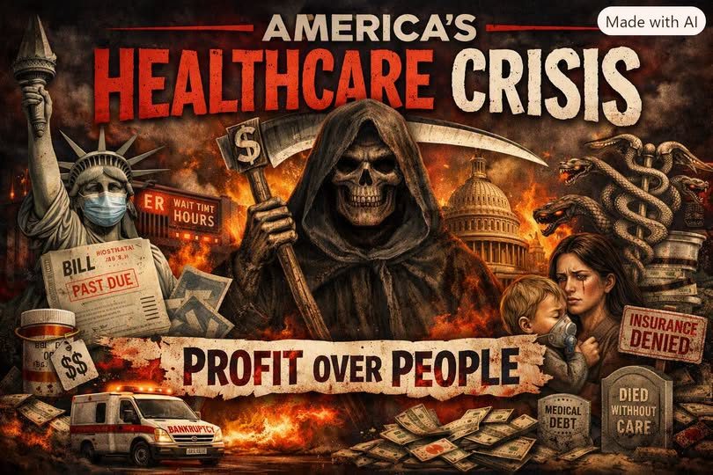

1. It’s the most expensive system on Earth — and still underperforms
We spend over $4.5 trillion per year on healthcare.
That’s twice as much per person as other wealthy nations.
Yet our outcomes — life expectancy, infant mortality, chronic disease rates — are worse than countries that spend far less.
This is the definition of inefficiency.

2. Medical debt is a uniquely American crisis
Over 100 million Americans carry medical debt.
Medical bills are the #1 cause of personal bankruptcy.
Even insured people fall into debt because deductibles and copays are sky-high.
No other wealthy nation has this problem at this scale.

3. Millions are uninsured or underinsured
Around 26–27 million Americans have no insurance.
Tens of millions more have insurance they cannot afford to use.
People delay care, skip medications, or avoid doctors entirely.
Insurance exists on paper — but not in practice.

4. Care is tied to employment
Lose your job → lose your insurance.
Get sick → lose your job → lose your insurance.
It’s a vicious cycle that traps families in fear.

5. Administrative waste is astronomical
The U.S. spends hundreds of billions on billing departments, coding specialists, insurance paperwork, prior authorization battles, claim denials, appeals, and network management.
Hospitals often employ more billing staff than nurses.
This is money that could be spent on actual care.

6. Prior authorization delays and denies care
Insurers routinely deny medically necessary treatments, delay surgeries, block specialist referrals, and reject prescriptions.
Doctors spend hours fighting insurance companies instead of treating patients.

7. Networks restrict where you can go
‘In-network’ vs. ‘out-of-network’ is a uniquely American nightmare:
You can be charged 10× more for the same procedure.
You can be hit with surprise bills even when you go to an in-network hospital.
Ambulances often take you out-of-network without your consent.
Your health depends on a corporate network map, not medical need.

8. Prescription drug prices are the highest in the world
Americans pay 2× more for insulin, 3× more for common medications, and 10× more for specialty drugs.
Why? Because the U.S. allows drug companies to set any price they want.

9. Seniors face complexity instead of simplicity
Medicare is split into Part A, Part B, Part C (Advantage), Part D, Medigap, and supplemental plans.
Each has different rules, networks, premiums, and exclusions.
It’s a maze — not a system.

10. Rural hospitals are collapsing
Over 180 rural hospitals have closed or are at risk of closing due to low reimbursement rates, high administrative costs, dependence on employer insurance, and lack of Medicaid expansion in some states.
Millions of Americans lose access to emergency care.

11. Racial and economic disparities are baked into the system
Black, Latino, Indigenous, and low-income communities experience higher mortality, worse access, fewer specialists, more chronic disease, and lower insurance coverage.
The system amplifies inequality.

12. Fragmentation creates chaos
The U.S. doesn’t have one system — it has hundreds: employer insurance, marketplace plans, Medicaid, Medicare, Medicare Advantage, VA, TRICARE, COBRA, short-term plans, charity care, and private supplemental plans.
Each has different rules, networks, and coverage gaps.
It’s not a system — it’s a patchwork.

13. Profit motives distort care
Hospitals, insurers, and drug companies are incentivized to maximize billing, minimize payouts, deny claims, upsell procedures, and prioritize revenue over outcomes.
Healthcare becomes a business first, a service second.

14. The human cost is enormous
Because of this system, people die from treatable conditions, families go bankrupt, chronic illness worsens, mental health declines, preventive care is skipped, stress skyrockets, and life expectancy falls.
The U.S. is the only wealthy nation where people fear getting sick because of the financial consequences.

Bottom Line
The U.S. healthcare system is the most expensive, the most complex, the most financially dangerous, the most inequitable, the most administratively bloated, and one of the least effective among wealthy nations.
It’s not broken — it’s working exactly as designed: to extract profit, not deliver care.
Editorial note: This article expresses the author’s perspective. Figures and categorical statements are reproduced from the submitted text and have not been independently verified; some may require qualification or updating.

