TERRA NOVA DEVELOPMENT | ARTICLE #115

The World Will Only Know Peace When Truth, Justice, and Love Become the Only Real Commodities of Value
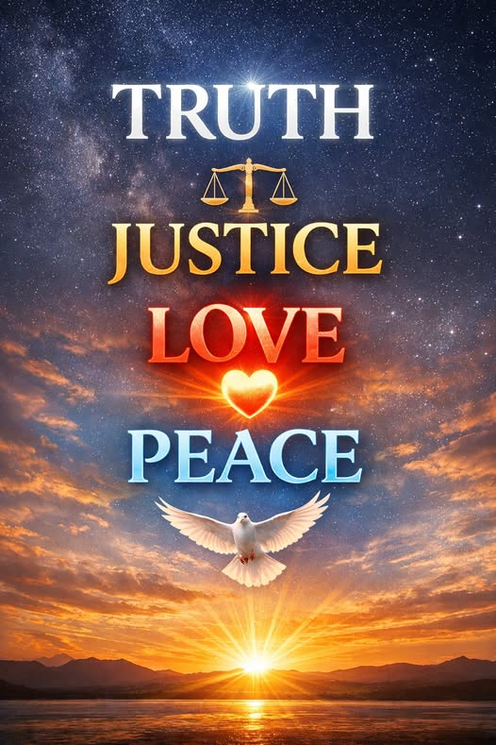
Peace has never been the natural byproduct of power, wealth, or military strength. History shows us that nations can be wealthy and still be restless, powerful and still be afraid, technologically advanced and still spiritually impoverished. Peace is not created by what humanity currently values. It is created by what humanity ought to value. And until Truth, justice, and love become the only real commodities of worth, peace will remain an aspiration rather than a reality.
Truth is the foundation. Without truth, every institution becomes fragile, every promise becomes conditional, and every relationship becomes transactional. Lies create fear, and fear creates conflict. When truth is optional, manipulation becomes profitable. But when truth becomes the most valuable commodity in society—more valuable than money, influence, or status—then clarity replaces confusion, trust replaces suspicion, and cooperation replaces division. A world built on truth is a world where people can finally see one another clearly, without distortion or deception.
Justice is the structure. Truth alone is not enough; it must be paired with fairness. Justice is the mechanism that ensures truth is honored and protected. It is the guarantee that every person, regardless of origin or circumstance, is treated with dignity. Justice is not punishment—it is balance. It is the recognition that peace cannot exist where exploitation thrives, and harmony cannot exist where inequality is ignored. When justice becomes a universal value, systems stop serving the powerful and begin serving the people. Justice transforms truth into action.
Love is the purpose. Truth provides clarity, justice provides structure, but love provides meaning. Love is the only force capable of dissolving hatred without violence, healing wounds without revenge, and inspiring unity without coercion. Love is not sentimental; it is transformational. It is the recognition that every human life carries equal worth, and that compassion is not weakness but wisdom. When love becomes the highest value, nations stop competing and start cooperating. Communities stop dividing and start uplifting. People stop fearing one another and start seeing one another as reflections of themselves.
Peace is not the absence of conflict; it is the presence of truth, justice, and love working together. Peace is what happens when humanity finally decides that these three values are worth more than territory, more than wealth, more than ideology, and more than pride. Peace is the natural consequence of a world where truth is spoken, justice is practiced, and love is lived.
The world will only know peace when these values become our currency—when truth is the measure of leadership, justice is the measure of society, and love is the measure of humanity. Only then will peace stop being a dream and become our shared reality.

