The Bounty and the Barrier
Why Humanity Lives in Abundance Yet Experiences Scarcity — and Why New Systems Must Rise
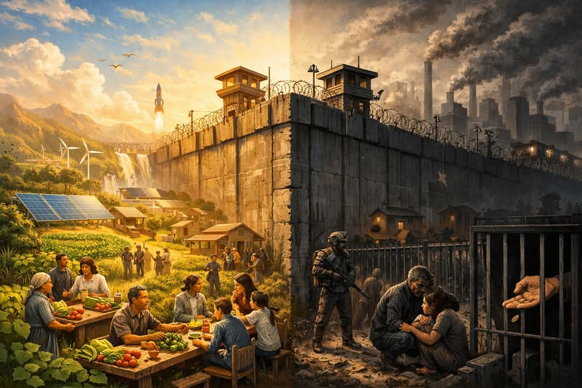

I. The Great Paradox of the Modern World
Humanity stands in a moment that should be its golden age.
We produce more food than at any point in history. We generate more energy, more knowledge, more tools, more medicine, more technology, and more capacity for comfort and flourishing than any civilization that has ever existed.
The Earth is not barren.
The world is not poor.
The human species is not incapable.
By every measurable standard, we live in a world of bounty.
And yet, the lived experience of billions is not abundance — it is struggle.
It is scarcity.
It is limitation.
It is the quiet, grinding pressure of systems that do not reflect the reality of what humanity can provide.
This is the paradox of our age: we have abundance, but we do not have access.

II. The Inheritance of Scarcity-Based Systems
To understand this contradiction, we must look not at nature, but at the systems humanity inherited.
The institutions that govern modern life — economic, bureaucratic, financial, and social — were built in eras defined by genuine shortage. They were designed to ration, to allocate, to restrict, to control. They were built to manage a world where there was not enough for everyone.
Those systems made sense in their time.
But humanity no longer lives in that world.
We live in an age where:
- food production exceeds global need
- automation can multiply labor exponentially
- digital networks can distribute knowledge instantly
- logistics can move goods across continents in hours
- medicine can prevent or cure diseases that once devastated populations
- technology can elevate human capability beyond previous limits
Yet the systems remain the same.
They continue to behave as if scarcity is the natural state of humanity.
They continue to enforce limitations that no longer reflect reality.
They continue to gatekeep the bounty that humanity itself creates.
This is not a natural condition.
It is an engineered one.

III. Artificial Scarcity: The Quiet Architecture of Control
Scarcity today is not the result of nature failing.
It is the result of systems succeeding — at the wrong purpose.
Across nations and cultures, the same patterns appear:
- Food is destroyed to stabilize markets.
- Homes sit empty while families sleep in cars.
- Medicine exists but is withheld behind price barriers.
- Education is abundant but access is restricted.
- Technology that could liberate billions is used to reinforce hierarchy.
- Wealth pools upward while opportunity drains downward.
This is not accidental.
It is structural.
These systems were built to manage shortage, and so they continue to manufacture shortage — even when abundance is available.
The tragedy is not that humanity lacks resources.
The tragedy is that humanity is governed by frameworks designed for a world that no longer exists.

IV. The Failure of Reform
Many believe these systems can be reformed.
They cannot.
You cannot retrofit abundance into structures built for scarcity.
You cannot patch fairness into frameworks designed to gatekeep.
You cannot modernize institutions whose foundational logic is outdated.
Reform is the attempt to teach an old system new tricks — but the system’s purpose remains the same.
A scarcity-based system will always produce scarcity.
A hierarchy-based system will always produce inequality.
A control-based system will always produce dependency.
To build a world that reflects the reality of human capability, we must build new systems, not repair old ones.

V. The Moral Imperative of Renewal
When a system stands between humanity and its own potential, that system becomes an obstacle — not a foundation.
The moral question of our era is not whether abundance exists.
It does.
The moral question is whether we will continue to accept systems that deny it.
Humanity has reached a point where:
- the tools exist
- the knowledge exists
- the resources exist
- the capacity exists
to guarantee every person a life of dignity, security, and opportunity.
The only thing missing is the structure.
The only thing missing is the system.
The only thing missing is the courage to discard what no longer serves us.

VI. The Architecture of a New Era
A world of abundance requires systems built for abundance.
Systems that:
- distribute rather than restrict
- empower rather than constrain
- elevate rather than exploit
- unlock potential rather than suppress it
- treat dignity as a design requirement, not a luxury
- treat clarity as a structural principle, not an afterthought
- treat community as infrastructure, not sentiment
These are not utopian ideals.
They are engineering principles.
Humanity has the capability to build systems that reflect the world we actually live in — a world where abundance is real, where technology is powerful, and where human potential is vast.
The question is not whether it is possible.
The question is whether we will choose to do it.

VII. The End of the Old World and the Beginning of the New
Every civilization reaches a moment when its inherited systems no longer match its reality.
When its structures no longer serve its people.
When its frameworks no longer reflect its capabilities.
Humanity is at that moment now.
The old systems cannot carry us forward.
They cannot unlock the future.
They cannot deliver the dignity, security, and opportunity that abundance makes possible.
They must be replaced — not with chaos, but with design.
Not with destruction, but with renewal.
Not with nostalgia, but with vision.
The world of bounty is already here.
The only barrier is the system.
And when the system stands between humanity and its own potential, the system must be discarded.

