  - TERRA NOVA DEVELOPMENT | ARTICLE #117

The Age of Unlimited Energy: How Abundance Breaks the Logic of Scarcity
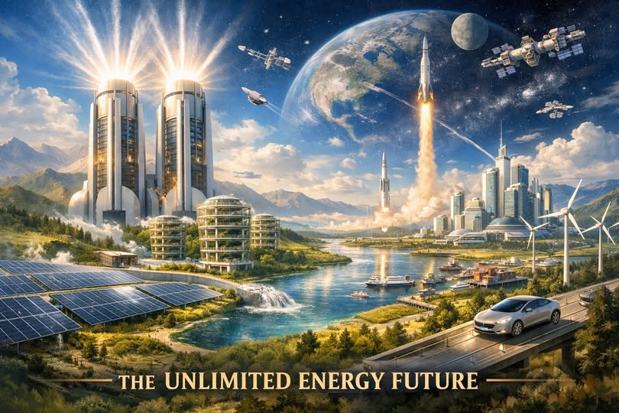
For most of human history, every system we built — economic, political, and social — was designed around one assumption: there is not enough to go around. Scarcity wasn’t just an economic principle; it was the architecture of civilization. It shaped who held power, who stayed poor, and what people believed was possible. Energy, in particular, was the bottleneck behind every bottleneck. Food, transportation, manufacturing, housing, water, medicine — all of it ultimately ran on the same limiting factor: how much energy we could extract, burn, or harness.
But the moment humanity unlocks unlimited, clean, near-zero-cost energy, that ancient architecture collapses. The world doesn’t just get “better.” It becomes unrecognizable.

Energy Is the Master Resource
Every resource we call “scarce” is really just energy in disguise.
- Water scarcity? It disappears when desalination becomes cheap enough to run everywhere.
- Housing scarcity? Vanishes when materials can be produced, transported, and assembled with negligible energy cost.
- Food scarcity? Ends when vertical farms, synthetic proteins, and climate-controlled agriculture run on abundant power.
- Transportation costs? Collapse when energy is no longer the limiting factor in moving goods or people.
Unlimited energy doesn’t solve one problem — it solves the root of all the others.

Artificial Scarcity Loses Its Grip
Today’s scarcity isn’t natural. It’s engineered.
High prices, limited supply, and economic gatekeeping are often the result of systems designed to protect profit, not maximize abundance. When energy becomes effectively free, those systems lose their leverage. The cost of producing almost anything drops toward zero, and the old logic of “who can afford what” stops making sense.
A world of abundant energy is a world where:
- Wealth is no longer defined by access to resources.
- Nations can’t be held hostage by fuel supplies.
- Corporations can’t control markets through scarcity.
- Entire industries built on limitation — from utilities to logistics to real estate — must reinvent themselves or disappear.
The power structures of the 20th century simply don’t survive the physics of abundance.

A Reversal of the Wealth Pyramid
Right now, wealth flows upward because scarcity pushes value toward those who control the bottlenecks. But when the bottlenecks dissolve, the pyramid flips.
If energy is unlimited:
- The cost of creating value plummets.
- The cost of living collapses.
- The average person gains access to capabilities once reserved for the elite.
Imagine a world where anyone can manufacture goods locally, grow food year-round, power their home independently, or run AI systems that today require massive data centers. Wealth stops being a privilege and becomes a baseline.
This isn’t utopian — it’s mechanical. When the cost of production approaches zero, the value of human creativity, innovation, and collaboration skyrockets. People become rich not because they hoard resources, but because resources no longer need to be hoarded at all.

The End of Energy Wars, Resource Wars, and Zero-Sum Thinking
Unlimited energy dissolves the logic behind conflict. Nations fight over oil, minerals, water, and arable land because these things are scarce. But when energy is abundant:
- Water can be created from air.
- Food can be grown anywhere.
- Materials can be synthesized instead of mined.
- Climate control becomes trivial.
The geopolitical map redraws itself. Power shifts from those who control extraction to those who control innovation.

A Civilization That Finally Gets to Dream
When survival is no longer the primary occupation of humanity, the entire species gets to redirect its attention. Art, science, exploration, philosophy, and community become the center of life rather than the luxury of the few.
Unlimited energy means:
- Cities designed for beauty, not efficiency.
- Transportation networks that erase distance.
- Medical breakthroughs powered by limitless computation.
- Space exploration that becomes routine instead of heroic.
It is the first time in history where the average person can live a life defined not by constraint, but by possibility.

Conclusion: Abundance Is the Real Revolution
Unlocking unlimited energy doesn’t just change the future — it ends the past. It breaks the logic of scarcity that shaped every empire, every economy, and every inequality we inherited. It creates a world where wealth is not extracted but generated, not hoarded but shared, not limited but multiplied.
The greatest revolution of the coming century won’t be political or technological. It will be philosophical: the moment humanity realizes that abundance is not a dream — it’s a design choice.
And once energy is unlimited, everything else becomes unlimited too.

