Why the Richest Corporate CEOs Will Ultimately Support Medicare for All
Terra Nova Development · Article #069 · November 13, 2026
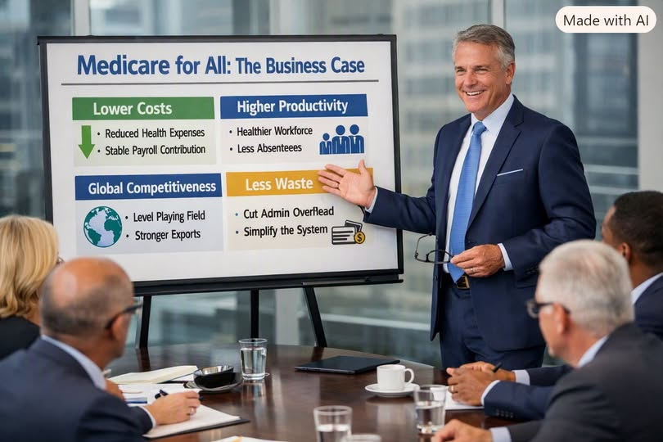
America’s wealthiest corporate leaders are not driven by ideology. They are driven by margins, competitive advantage, long-term stability, and shareholder value. When Medicare for All is evaluated through that lens — not as a political slogan, but as a structural economic reform — the conclusion becomes obvious: the richest CEOs would back it if they fully understood what it means for their business.
This is not a moral argument. It’s a profit argument.

I. Employer-Sponsored Health Insurance Is a Massive Private Tax on Business
Right now, American companies pay $15,000–$20,000 per employee per year for health coverage. That is not a benefit. It is a private tax — one that rises faster than wages, faster than inflation, and faster than revenue.
For Fortune 100 companies, this “tax” reaches into the billions annually.
And unlike actual taxes, this one buys nothing:
no predictability
no long-term cost control
no bargaining power
no stability
Medicare for All replaces this runaway private tax with a predictable, far smaller payroll contribution. CEOs get cost stability — something they currently do not have and cannot buy.

II. The Hidden Costs Are Even Larger — and CEOs Feel Them Every Quarter
Premiums are only the visible cost. The invisible costs are even bigger:
presenteeism (workers showing up sick and underperforming)
absenteeism
unmanaged chronic conditions
delayed care due to deductibles
stress-related illness
disability claims
These hidden costs add $4,000–$7,000 per employee per year in lost productivity.
Multiply that across tens or hundreds of thousands of workers, and you get:
millions of lost productive hours
billions in preventable drag on output
weaker performance across every department
Medicare for All eliminates the financial barriers that cause workers to skip care. Healthier workers mean:
higher productivity
fewer errors
fewer medical leaves
fewer catastrophic claims
No private insurance redesign can replicate this. Only universal, barrier-free access can.

III. Healthcare Inflation Is the Single Greatest Threat to Corporate Planning
Every CEO fears structural inflation in a major cost category.
Healthcare is the worst offender.
Employer premiums have risen over 300% since the late 1990s. This is not a cycle. It is a structural feature of a fragmented, profit-driven system.
The current system cannot become deflationary. Every major actor profits from rising prices:
insurers
hospitals
pharmaceutical companies
PBMs
private equity
Medicare for All flips the incentives:
unified negotiating power
Medicare-level rates
international reference pricing
elimination of administrative waste
This creates actual downward pressure on healthcare costs — something CEOs have never seen in their lifetimes.
Deflation in healthcare means:
rising real wages without raising nominal wages
lower labor costs
stronger consumer purchasing power
higher demand across every industry
For CEOs, this is not ideology. It is macro-economic oxygen.

IV. Global Competitiveness: U.S. CEOs Are Competing With One Arm Tied Behind Their Back
Foreign competitors do not carry the burden of employee health insurance. Their governments absorb the foundational cost of keeping workers healthy.
American CEOs know this. They see it in:
thinner margins
higher prices
slower expansion
weaker export competitiveness
Medicare for All removes a structural disadvantage that no tax cut, no deregulation, and no innovation can overcome.
It is the single largest pro-business competitiveness reform available to the United States.

V. Administrative Waste Is a Trillion-Dollar Drag on Corporate Efficiency
The U.S. healthcare system is drowning in administrative waste:
thousands of insurance plans
millions of denied claims
armies of billing clerks
duplicated overhead across every insurer
This waste costs hundreds of billions annually.
Medicare for All eliminates most of it. CEOs understand efficiency. They understand scale. They understand that a system with 1,600 billing clerks at one hospital versus 7 in a single-payer system is not built for performance.

VI. Labor Mobility and Entrepreneurship Explode Under Universal Coverage
Job lock suppresses innovation and talent mobility.
Workers stay in jobs they hate because they fear losing health insurance. They avoid starting companies. They avoid taking risks. They avoid moving to better opportunities.
Medicare for All unleashes:
more startups
more innovation
more skilled workers willing to change jobs
more competition that drives productivity
CEOs benefit from a more dynamic labor market.

VII. The Richest CEOs Will Support Medicare for All Because It Makes Them Richer
This is the part no one says out loud — but every CEO understands.
Medicare for All:
lowers labor costs
increases productivity
reduces absenteeism
increases consumer spending
stabilizes long-term cost projections
strengthens the entire economy
For the richest CEOs, this is not charity.
It is profit.
It is shareholder value.
It is strategic advantage.
It is economic rationality.

Conclusion: Once CEOs See the Numbers, They Will Lead the Charge
The math is not ambiguous.
The richest CEOs do not need ideology to recognize a trillion-dollar efficiency gain. They do not need politics to recognize a structural competitive advantage. And they do not need persuasion to recognize that the greatest gift America could give its businesses is the one every other advanced economy already enjoys: universal, efficient, predictable healthcare financing.
Medicare for All is not a partisan dream.
It is a CEO’s dream — once they understand it.

