The Courage to Stand in What You Claim
Faith, Fear, and the Integrity of a Life Lived Honestly
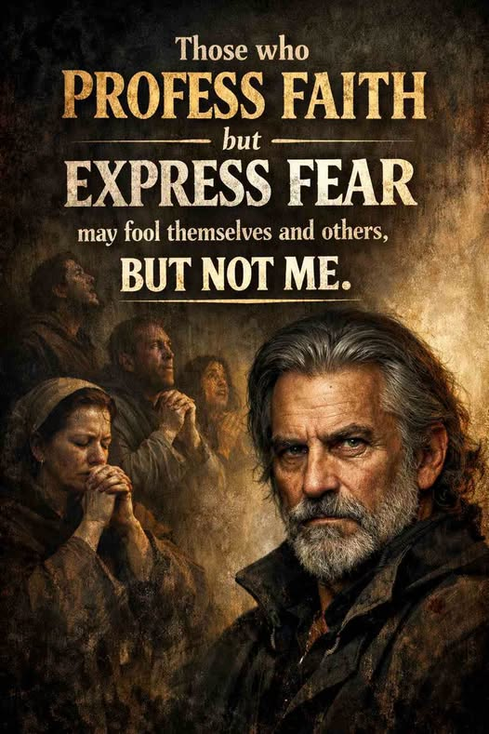

The Difference Between Saying and Being
Anyone can say they have faith. Words are cheap, especially when life is calm and nothing is being tested. But the moment pressure arrives, the truth steps forward. What we profess with our mouths and what we express with our actions don’t always match — and that gap is where character is revealed.

Fear Isn’t the Enemy — Pretending Is
Feeling fear doesn’t make someone weak. It makes them human. The real problem is when people hide behind spiritual language while avoiding spiritual courage. That’s when faith becomes performance instead of practice. You can fool a crowd, you can fool a friend, and you can even fool yourself for a while — but reality never buys the act.

Where Real Faith Actually Shows Up
Real faith doesn’t shout. It doesn’t need to. It shows itself in quieter places:
- In the way someone stands when everything around them shakes
- In the decisions they make when nobody is watching
- In the calm that settles in their eyes when others panic
Faith isn’t proven by noise. It’s proven by steadiness.

Honesty Over Image
The world doesn’t need more people who talk about belief. It needs people who embody it — imperfect, honest people who acknowledge their fear, face it, and move anyway. Courage isn’t the absence of fear; it’s refusing to let fear have the final word.

The Life That Speaks for Itself
In the end, faith is not measured by declarations but by consistency. By integrity. By the quiet strength that doesn’t need applause.
Those who live from that place don’t need to convince anyone. Their lives do the talking.

