The Bounty Already Here: How Technology Has Outgrown Scarcity, and Why Money Hasn’t
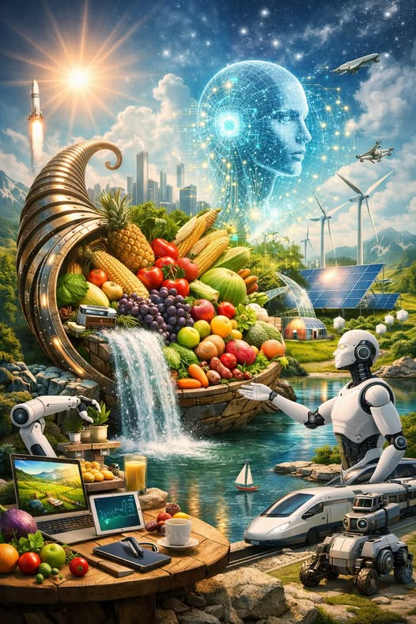
Humanity stands in a strange moment in history — a moment where our tools have surpassed our systems. We live in an age where artificial intelligence, robotics, automation, and global production capacity have quietly created a level of abundance that previous generations could not have imagined. We produce more food, more goods, more energy, more knowledge, and more capability than at any point in human existence.
And yet, billions still struggle. Not because the world lacks resources, but because our economic system is built on the assumption of scarcity — an assumption that is no longer true.

The Age of Abundance Has Already Arrived
Look around: the evidence is everywhere. Modern agriculture produces enough food to feed every human being on Earth — several times over. Automation and robotics manufacture goods at a scale and speed that dwarf human labor. AI systems can design, optimize, and manage entire workflows that once required armies of specialists.
We have the ability to grow food in vertical farms, desalinate oceans, recycle materials indefinitely, and generate clean energy from sun, wind, and geothermal heat.
We have the tools to house everyone, feed everyone, clothe everyone, and provide every person with the essentials of life.
The bounty is not theoretical. It is here. It is real. It is measurable.

The Paradox of Plenty
So why does scarcity still feel real? Why do people still struggle to survive? Why does the world still operate as if everything is limited?
Because scarcity is no longer a natural condition — it is a manufactured one.
Our monetary system requires scarcity to function. If everyone had enough, the system would collapse. If essential goods were abundant and freely available, profit would evaporate. If automation replaced labor without a new economic model, wages would disappear.
Money depends on the idea that not everyone can have everything. And so scarcity is preserved — not by nature, but by design.

Artificial Scarcity: The Invisible Cage
Artificial scarcity shows up everywhere:
- Food is destroyed to keep prices stable.
- Homes sit empty while people sleep on the streets.
- Factories slow production to maintain profit margins.
- Patents lock away life-saving technologies.
- Automation increases productivity but not human freedom.
We have the capacity to meet human needs universally, but the monetary system cannot allow it. If abundance becomes universal, money loses its power. If survival becomes guaranteed, control mechanisms dissolve. If people no longer need to earn a living, the entire structure of economic coercion collapses.

Technology Has Outgrown the Economy
AI, robotics, and automation were designed to increase efficiency — and they succeeded beyond expectation. But instead of liberating humanity, these tools are trapped inside an outdated economic framework that cannot integrate abundance.
We now produce:
- more food than we can eat
- more goods than we can use
- more energy than we can store
- more knowledge than we can process
- more computational power than we can apply
The bottleneck is not production. The bottleneck is distribution. And the barrier to distribution is money.

The Real Wealth of a Civilization
True wealth is not currency. True wealth is capacity.
A society is wealthy when:
- everyone is fed
- everyone is housed
- everyone is educated
- everyone is healthy
- everyone is free to contribute
Money is merely a symbol — a token used to coordinate scarcity. But when scarcity disappears, the symbol becomes obsolete.

The Only Thing Standing in the Way
We already have the tools to build a world where every human being lives with dignity, security, and opportunity.
We already have the technology to automate the unpleasant, the dangerous, and the repetitive. We already have the intelligence — both human and artificial — to design systems that serve everyone. We already have the productive capacity to meet global needs many times over.
The only thing standing between us and an economically perfect society is the artificial scarcity imposed by the monetary system.

A Post-Money Civilization
Imagine a world where the purpose of technology is fulfilled: to free human beings from survival labor.
A world where:
- AI manages logistics and optimization
- robotics handles manufacturing and infrastructure
- automation produces goods without human toil
- food is grown sustainably and distributed universally
- housing is built for need, not profit
- creativity, service, and curiosity become the core of human life
In such a world, the question is no longer “How do we pay for it?” The question becomes “Why did we ever need money in the first place?”

The Future Is Waiting for Us
The bounty is already here. The tools are already built. The abundance is already real.
The only thing missing is the courage to redesign the system around the reality we now live in — a reality where scarcity is no longer the defining condition of human life.
When humanity finally steps beyond the monetary system, we will discover that the world we dreamed of was already within reach. We simply had to stop pretending we were poor.

